DE10-Lite Embedded System Lab Guide

Version 1.2 10/12/2017 ECEN 5863

Table of Contents

What Does It Take To Create Your Own Custom Processor-Based Embedded System? 2

1. Getting Started 3

1.1. DE10-Lite Development Kit 3

1.2. Extract the Lab Files. 3

2. System Design 4

2.1. System Requirements 4

2.1.1 System Block Diagram 4

2.2. Examine the System Tool Flow 6

3. Creating the Design 7

3.1. Create the Quartus Project 7

3.2. Create the Qsys System 13

3.2.1 System Clock Scheme 14

3.3. Instantiate the Qsys design into the top-level Verilog file. 51

4. Placing and Routing the Design 54

5. Programming the Hardware and Testing the Design 55

5.1. Programming the DE10-lite 55

6. Build the Software Application 60

6.1 Initialize Eclipse workspace 60

6.2 Create a new software project in the SBT 61

6.3 Add source code to the project 63

6.4 Configure Board Support Package 64

6.5 Configure BSP Project Build Properties 68

6.6 Configure Application Project Build Properties 69

6.7 Build the software project 69

6.8 Run the software application on the target 70

6.9 Software Application Output 72

6.10 Interact with the Software Application 73

6.11 Edit the Application 74

# 

OVERVIEW

## What Does It Take To Create Your Own Custom Processor-Based Embedded System?

This lab teaches you how to create a system implemented in programmable logic. You will build a processor-based hardware system and run software on it. As the lab progresses, you will see how quick and easy it is to build entire systems using Altera’s Qsys to configure and integrate pre-verified IP blocks.

**Lab Notes:**

Many of the names that the lab asks you to choose for files, components, and other objects in this exercise must be spelled *exactly* as directed. This nomenclature is necessary because the pre-written software application includes variables that use the names of the hardware peripherals. Naming the components differently can cause the software application to fail.

There are also other similar dependencies within the project that require you to enter the correct names.

You will learn

* How to use a project template to accelerate the beginning of a design effort.
* How to create a Qsys system.
* How to add clocks.
* How to add a NIOS II processor
* How to add memory and peripherals to a NIOS II Qsys design.
* The purpose of a bus bridge and how to implement it in a Qsys design.
* How to bring the Qsys design into the top level to be compiled.

Module Summary:

The Hardware labs are based on completing the initial portion of the design of a simple voltmeter.

In **Section 1** you will prepare for the project acquiring files and other resources.

In **Section 2** you will examine the system design.

In **Section 3** you will learn how to create a soft processor hardware system design using Quartus Prime and Qsys.

**In Section 4** you will place and route the design.

**In Section 5** you will create a programming file, program the FPGA, and then test the hardware design.

**In Section 6** you will build a software application and run it on your new hardware.

Goal of this Embedded Systems Lab:

The goal of this Embedded Systems lab is to develop a working design, using most aspects of the Quartus Prime Design Flow, including Qsys and the NIOS II Embedded Design Suite (EDS).

# Getting Started

Your first objective is to ensure that you have all of the items needed and to install the tools so that you are ready to create and run your design.

List of Required Items:

* Altera Quartus Prime Version 16.1 FPGA Development Software Tool, including the NIOS II Embedded Design Suite (EDS)
* **Module Design Files: Embed.zip**
* Terasic DE10-Lite Development Kit

**Before continuing with this Module, ensure that the Altera tools and drivers have been installed.**

## DE10-Lite Development Kit



## Extract the Lab Files.

* Create a folder **C:\AlteraPrj\DE10liteEmbed** on your PC.
* Copy Embed.zip to this directory
* Extract to here

CONGRATULATIONS!!

**You have just completed all the setup and installation requirements and are now ready to examine the system-level design.**

# System Design

**Section Objective**

In this Section you will review the architecture of the design that will be created in Quartus Prime with the DE10-Lite Kit as the target. Typically, a design starts with system requirements. These system requirements become inputs to the system definition.

## System Requirements

During this exercise, you will follow a step-by-step guide to create a more complex design. To do this you will create a design in Qsys, the Altera System Design Tool, which includes a NIOS II softcore CPU, On-chip RAM and FLASH memory for program and data storage, a 1 ms System Timer, System ID block, MAX10 ADC module, LED and slide switch interfaces, SDRAM controller, SPI bus interface to an accelerometer, and JTAG connections to the software development and FPGA configuration tools, all connected together by a Avalon Bus or Bus Bridge. You will then create a block symbol of this Qsys system, and create software to run on it. The inputs are a System Clock at 50 MHz, a 10 MHz ADC clock, 10 slide switch inputs, SPI data from the accelerometer, and the ADC input from a pin on the Arduino Analog Connector. The outputs are 10 LEDs, and the JTAG UART Debug Console. Here is a block diagram of the system you will construct:

### 2.1.1 System Block Diagram

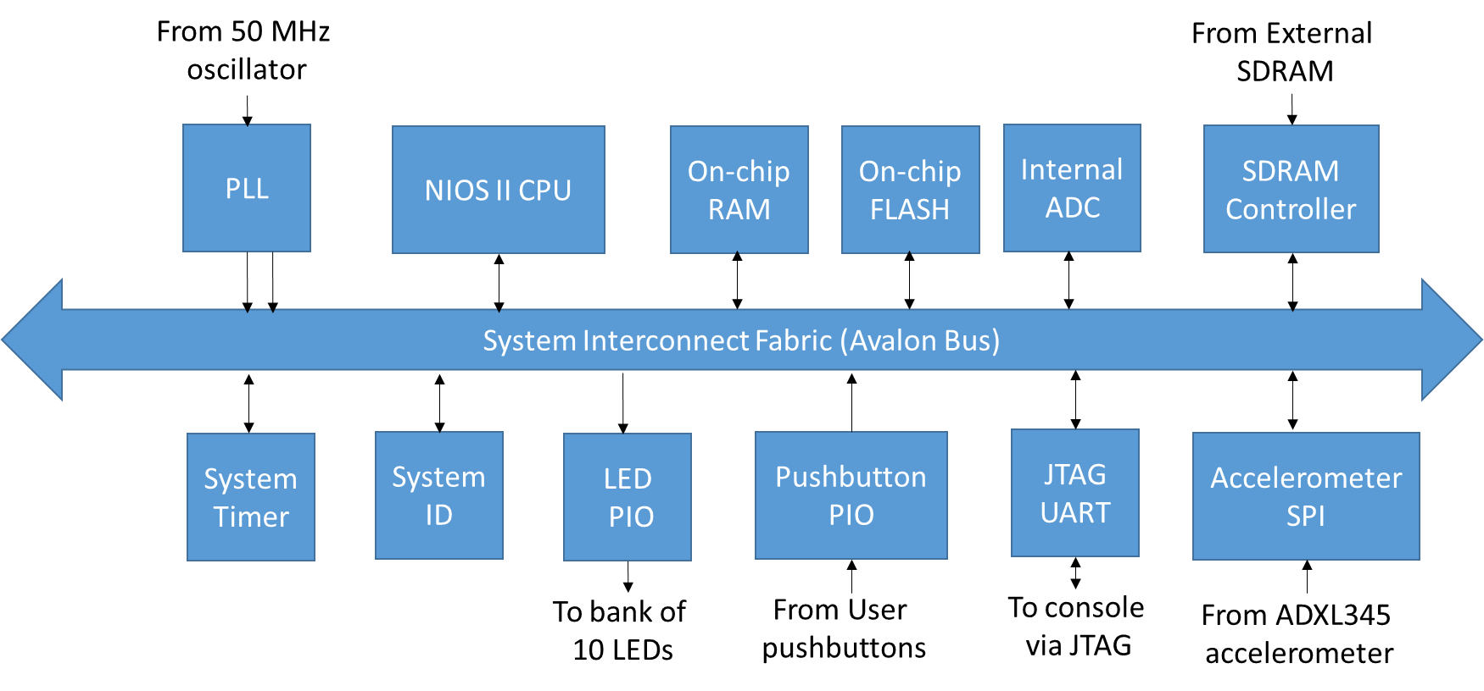

The system above can be created in Qsys using a standard library of re-useable IP blocks. The System Interconnect Fabric is automatically generated by Qsys and binds the blocks together. The system interconnect manages dynamic bus-width matching, interrupt priorities, arbitration and address mapping. This system is a full-featured processor system capable of running operating systems such as uC-OSII or Linux.

The following pages will guide you through the process of building this basic embedded system. You will build up a subset of the system shown above.

Components of MAX10 Device Used

This tutorial uses the MAX10 PLL block, ADC module, On-chip RAM, On-chip FLASH, JTAG interface and logic fabric.

## Examine the System Tool Flow



The above diagram depicts the typical flow for system design. System definition is performed using Qsys. The results are two-fold:

* A system description that the Nios II Software Build Tools, the software development tool, uses to create a new project for the software application.
* HDL files for the system that are used by the Quartus Prime FPGA design software to compile and generate the hardware system.

CONGRATULATIONS!!

**You have just completed the examination of the system-level design**

# Creating the Design

In this section will create the Embedded System design using Quartus Prime. Some source files have been provided in the project zip file, as the design is a combination of HDL files, IP cores, and Macro Blocks.

## Create the Quartus Project

1) Launch Quartus Prime 16.1 (64-bit)

2) Use Project -> New Project Wizard. Click next and enter C:\AlteraPrj\DE10liteEmbed for the working directory, and name the project Embed. Click next.

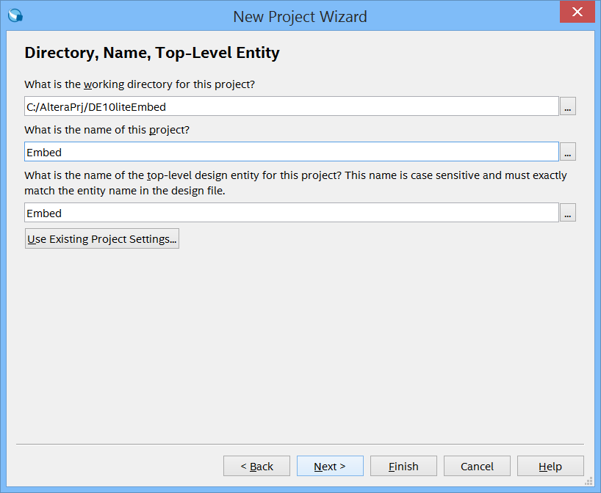

3) In the Project Type dialog box, choose the project template. Hit Next.

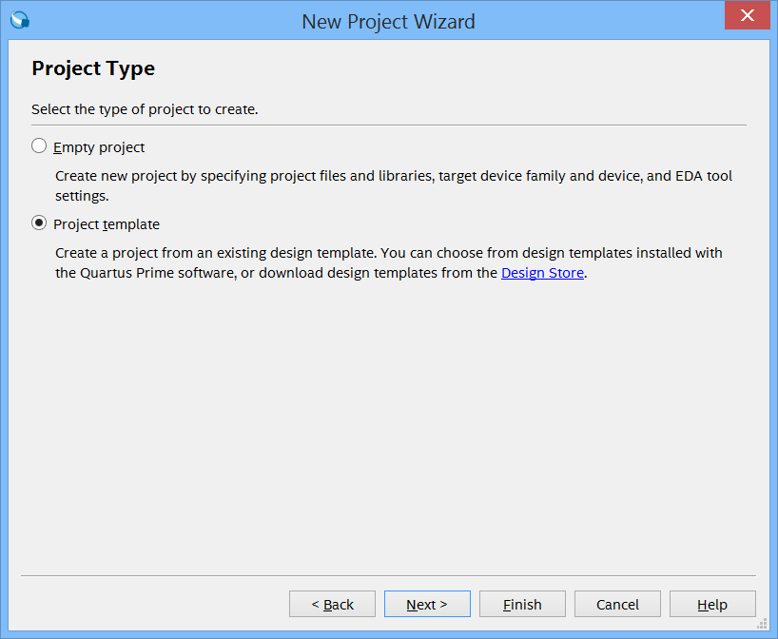

4) On the next box, select MAX10 for the family, and DE10-lite Evaluation Kit for the kit. If the DE-10 Lite kit is not listed in the choices, you may have to download the design templates from the Design Store.

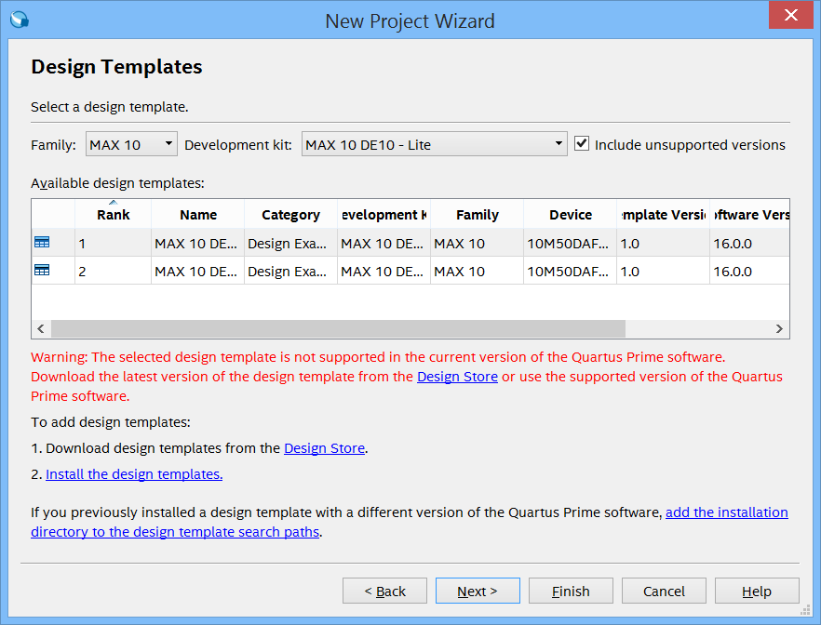

5) If you need to do this, a link is given in instruction #1 of this dialog box that allows you do this. Click on Design Store, and the link takes you to the design store webpage:

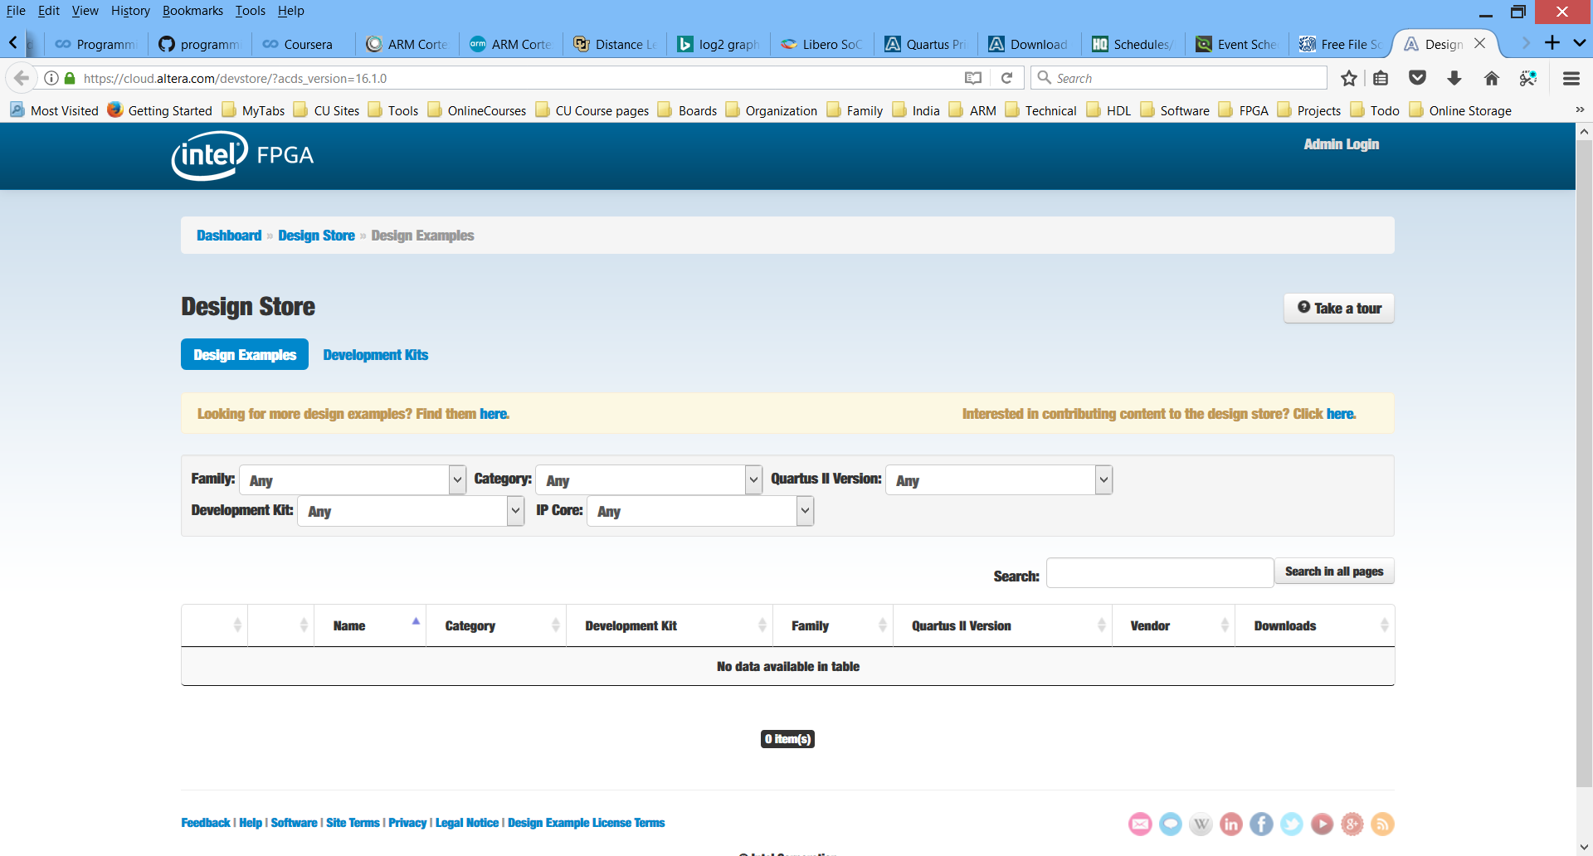

6) Be sure to select Design Examples. Select MAX10 for the family, Design Example for the Category and then the DE10-Lite Evaluation Kit for the kit:

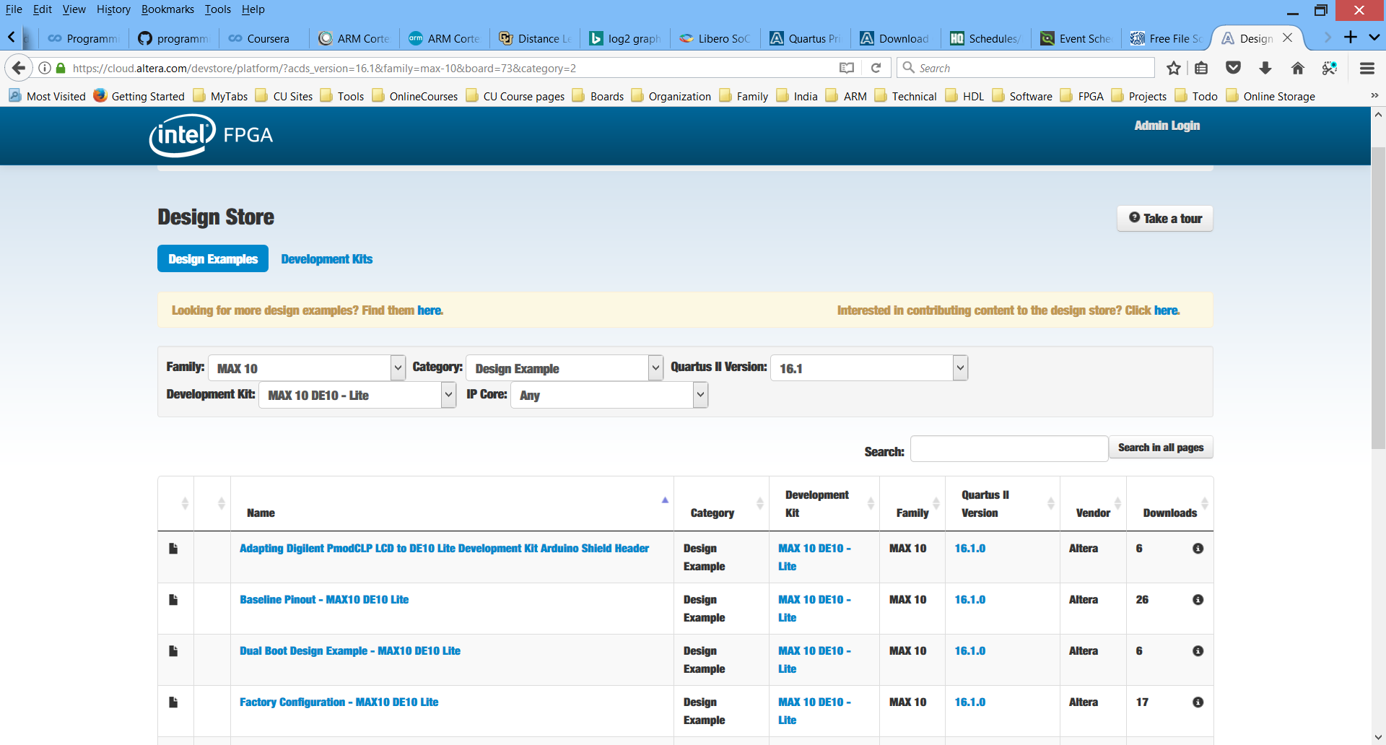

7) Select the Factory Configuration - MAX 10 DE10 Lite Quartus version 16.1. Download the installation package. Save the .par file in the project directory.

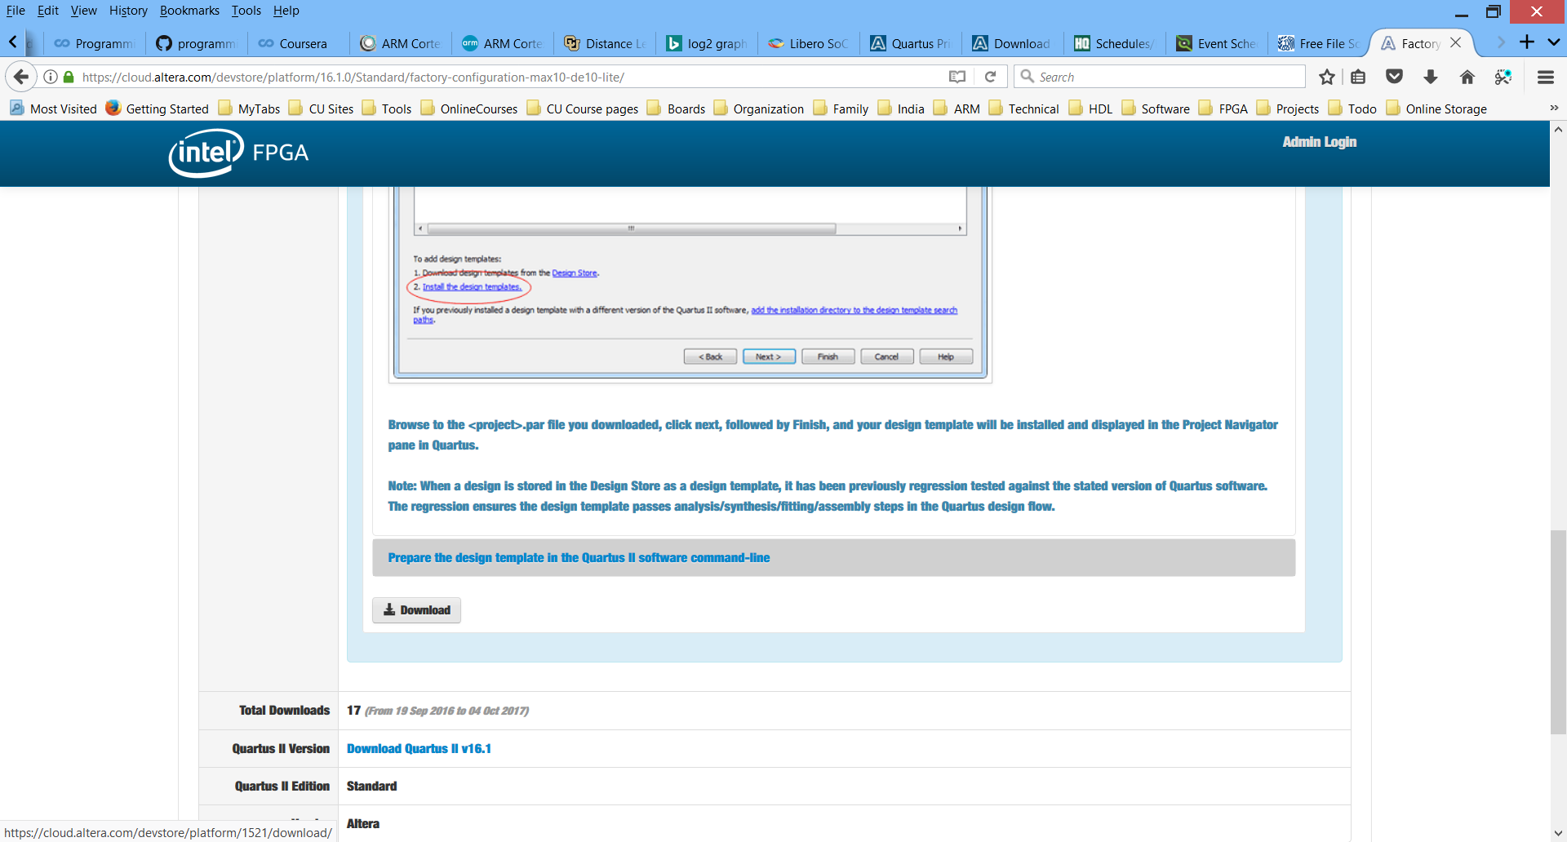

8) After downloading, return to Quartus where you will have to install the design template in the 2nd step as indicated. Click on instruction #2 install the design template, give the location of the .par file in the dialog box.

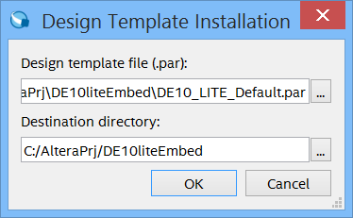

Click OK. Select the Factory Configuration MAX 10 DE10 - Lite Kit from the Design Template list and hit Next. Hit Finish in the Summary box.

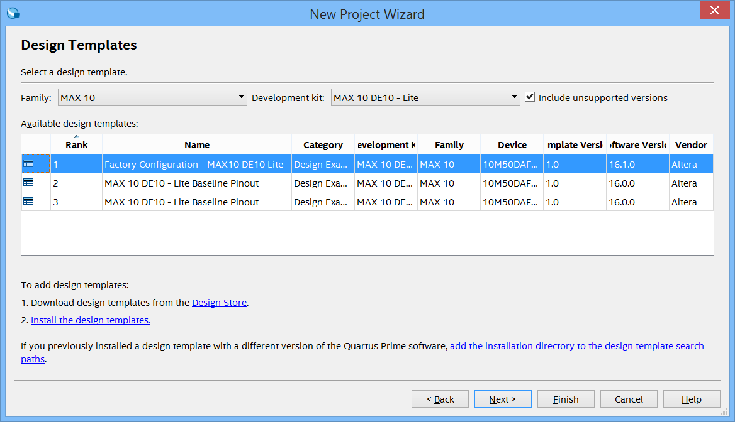

9) When your project opens, Note that the top level is called DE10_Lite_Default. Under files in the project navigator you will see a top level Verilog file and several other Verilog files and .qip files. This is the basis for your design, it has all the external signals defined and pins assigned. If you open the Pin planner, you will see these signals present, and you can verify the pin assignments. These are defined in the .qdf file that comes with the template. The template provides you with a large amount of previously done work, allowing you to get a head start on your design.

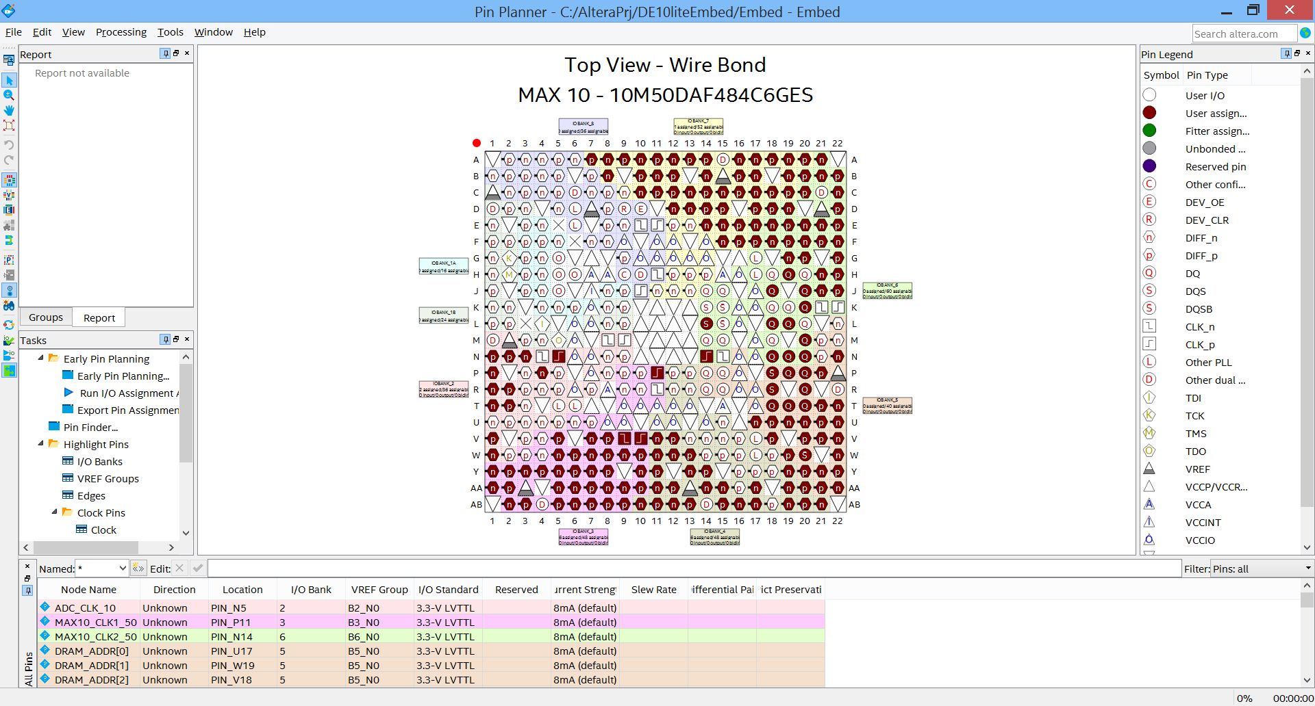

Close the Pin Planner.

We are now ready to create the Qsys system.

## Create the Qsys System

1. **From the Tools menu, select Qsys.** After a moment or two, the Qsys design tool will open. It begins assuming that you need a clock in the design.

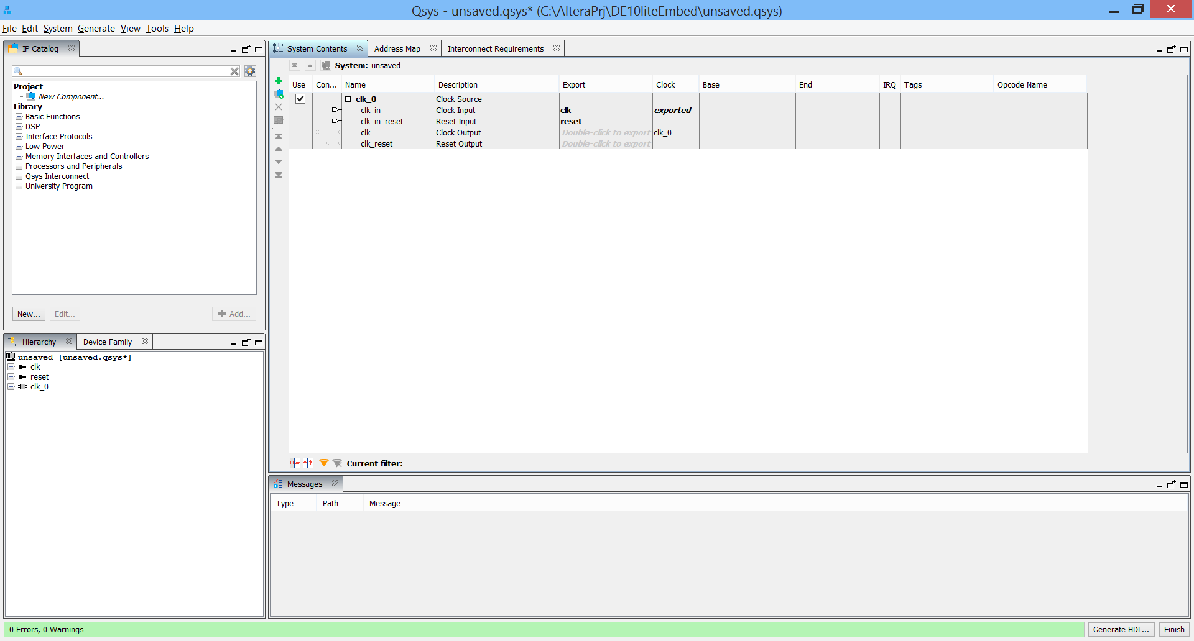

### 3.2.1 System Clock Scheme

There is a clock generator on the DE10-lite circuit board that generates two 50 MHz clocks and a 10 MHz clock, which serve as clock sources for the FPGA. Other clocks are also required for the Qsys system components as well as for external components such as the SDRAM and the internal ADC. PLLs will be used to provide these clocks. The following table reviews the clocking scheme:

|  |  |  |  |
| --- | --- | --- | --- |
| Component | Input Clock Frequency | Source | Designation |
| 1. SDRAM PLL | 50 MHz | Oscillator on DE10-Lite | MAX10_CLK1_50 |
| 2. Nios II processor and peripherals | 80 MHz | Output ‘c0’ of PLL | sdram_pll_c0 |
| 3. SDRAM phase shifted clock | 80 MHz (-90° phase) | Output ‘c1’ of PLL | sdram_pll_c1 |
| 4. Slow Peripherals | 40 MHz | Output ‘c2’ of PLL | pll_c2 |
| 5. ADC PLL | 10 MHz | Oscillator on DE10-Lite | ADC_CLK_10 |
| 6. internal ADC | 10 MHz | Output ‘c0’ of ADC PLL | adc_pll_c0 |

1. **Add the system Avalon ALTPLL** as the clock source for Processor, Peripherals and Memory. This peripheral instantiates a PLL which will generate the clocks for the system.

From the IP Catalog pane, expand “Basic Functions,” then expand “Clocks; PLLs and Resets,” then expand “PLL” and double click on “Avalon ALTPLL.” This will add the Avalon ALTPLL module.

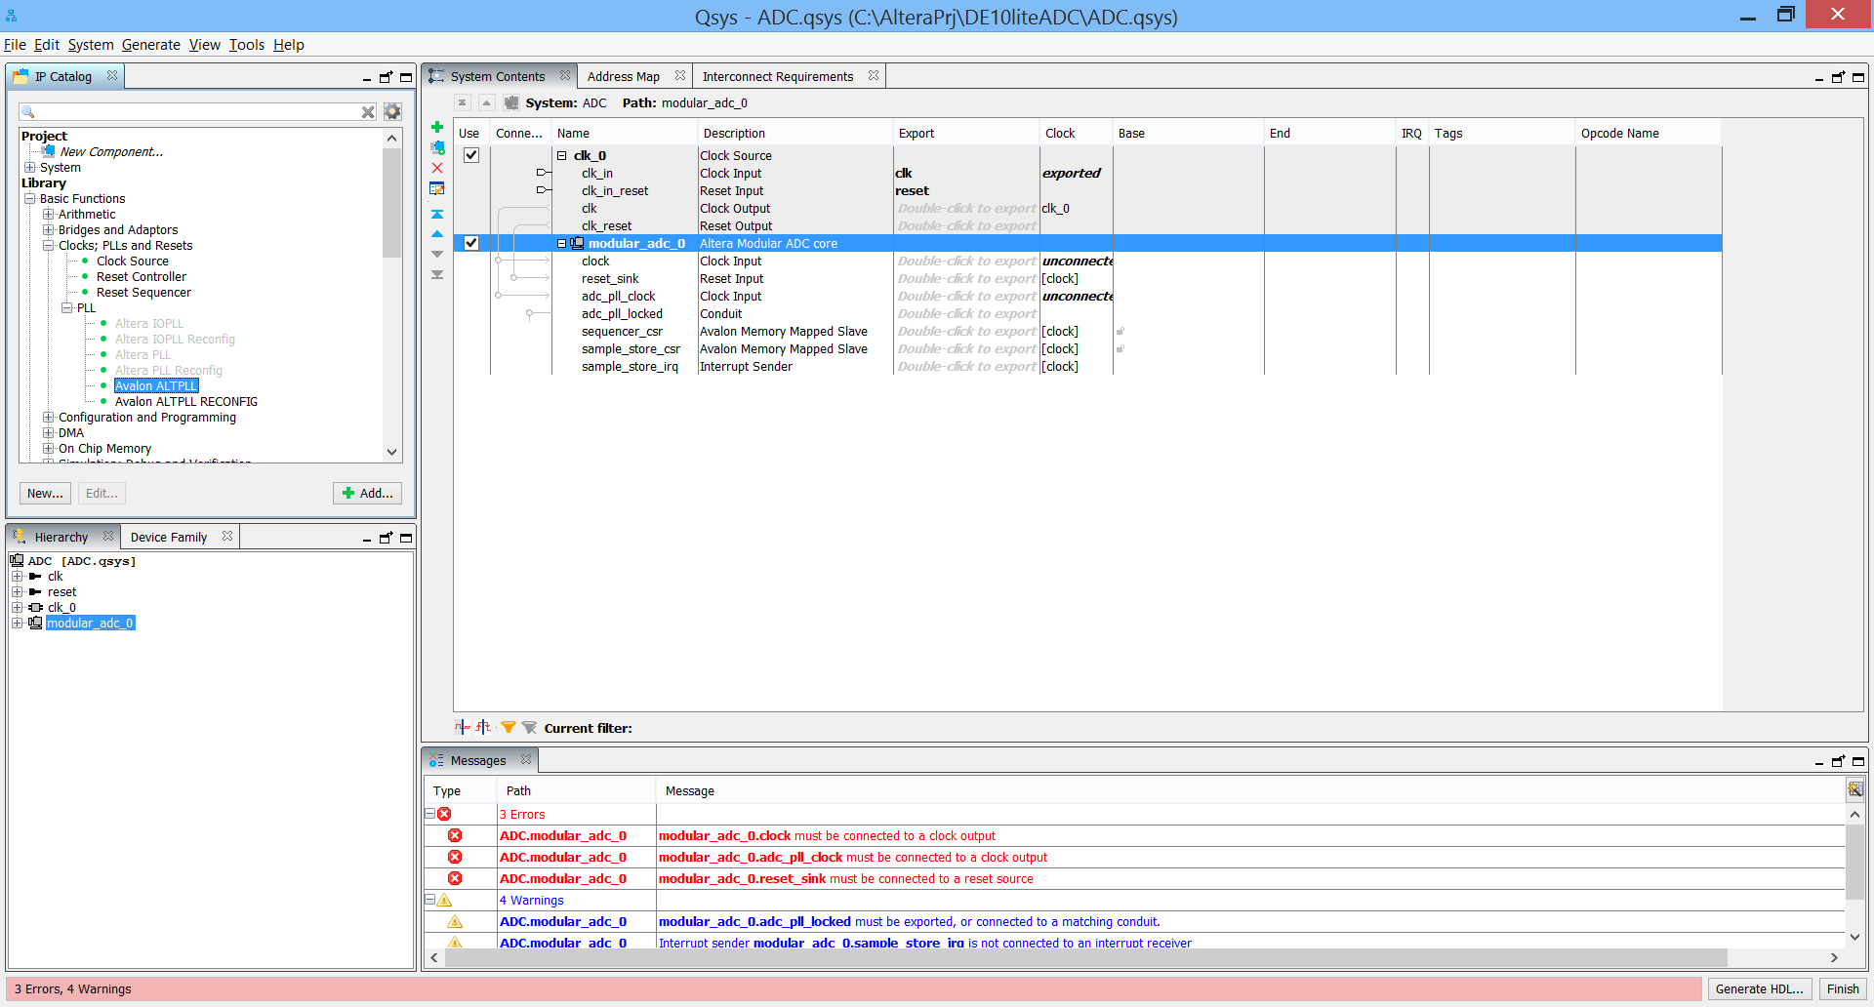

The ATLPLL Megawizard opens. Change the input clock frequency to 50 MHz, Click Next to move to the next tab of the wizard.

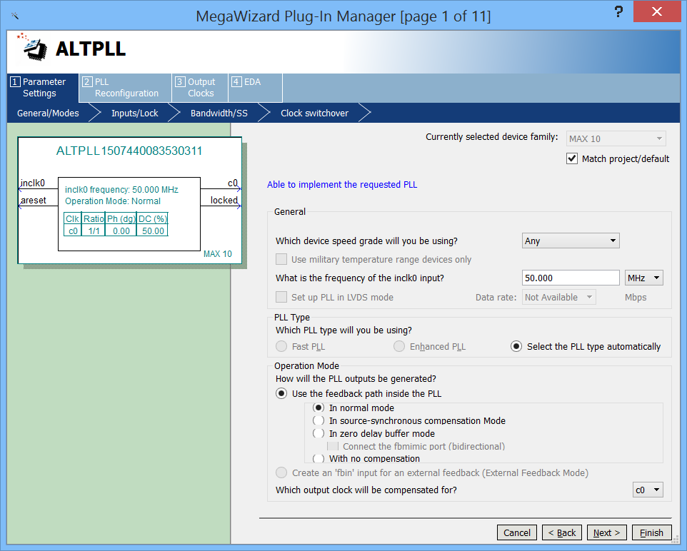

On the next page, Uncheck both “**Create an ‘areset’ input to asynchronously reset the PLL**” and “**Create ‘locked’ output**” options.

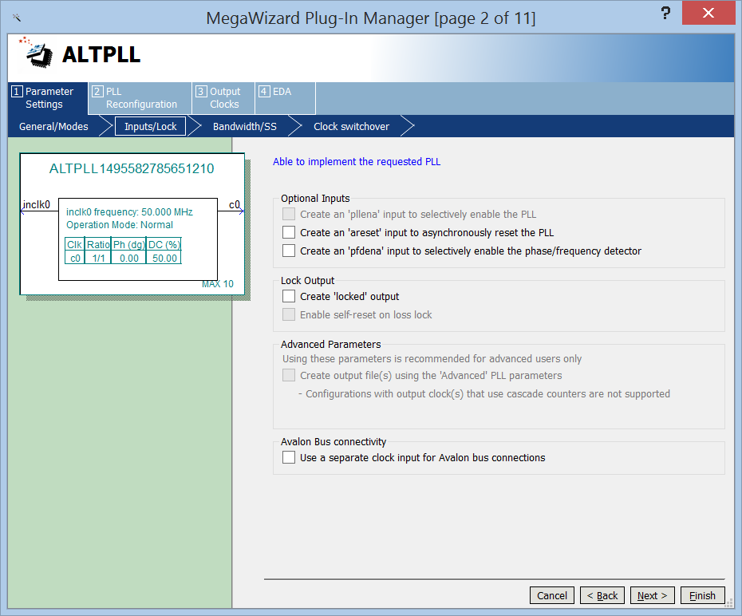



Click next, and also click next on the bandwidth page, the switchover page, and configuration page. You should now see the c0 Core external output clock. On **“c0 Core/External Output”**: Click on the “Enter output clock frequency” button and enter **80 MHz**. This clock will be used as the processor system clock, clocking the Nios II processor. Hit next.

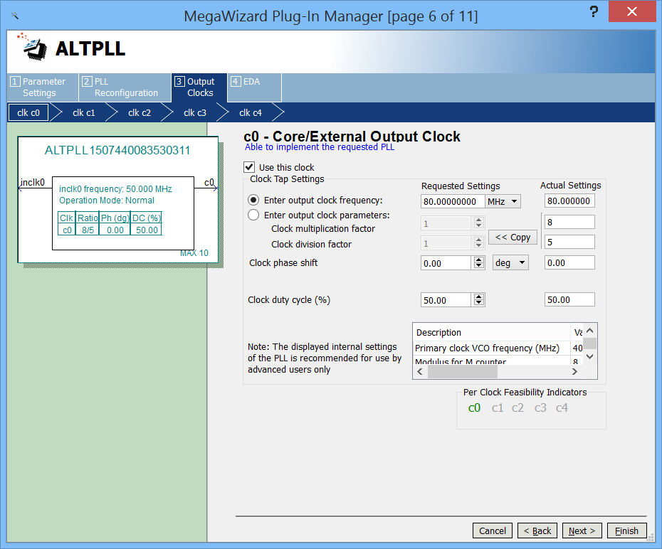

Check the “Use this clock” button for c1. Click on the “Enter output clock frequency” button and enter **80 MHz**. This clock will be used to clock the external SDRAM. In the **Clock phase shift** enter **-90** and leave the units set to **deg**. Click Next.

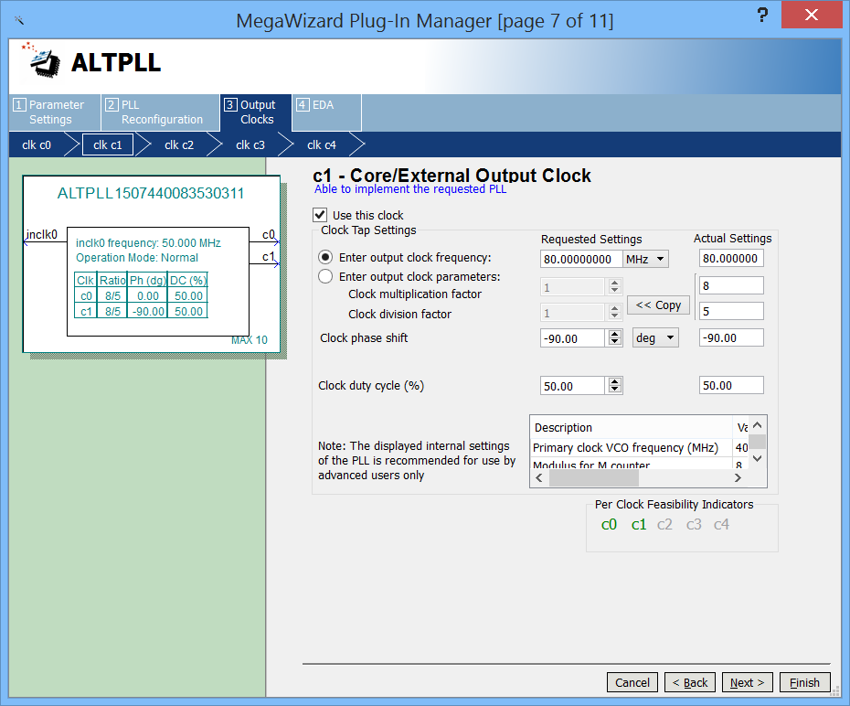

Check the “Use this clock” button for c2. Click on the “Enter output clock frequency” button and enter **40 MHz**.

This clock will be used to clock various peripherals in the system. Click next for c3 and c4 and then click Finish.

The altpll_0 is now added in Qsys: 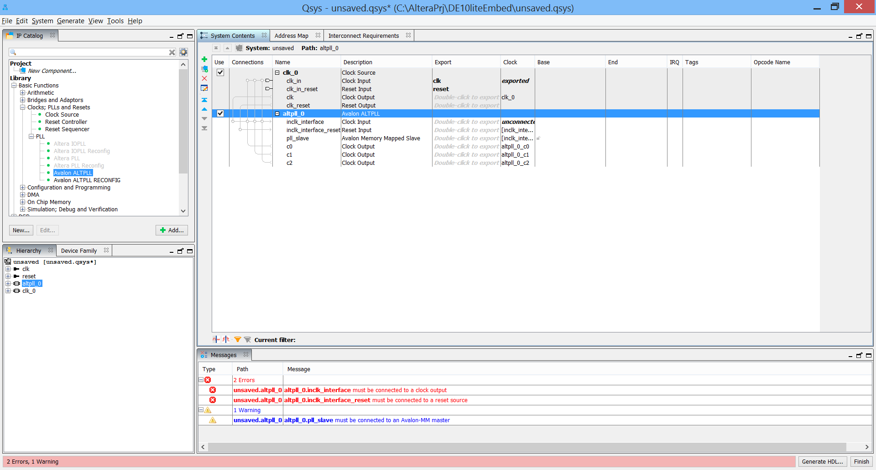

Some errors and warnings will appear in the bottom console indicating that various ports are not connected. Ignore these for now. We will address these connections in the upcoming steps. You will continue to see these messages after every component is added, but not to worry as they are good reminders of connections that are yet to be made.

1. Before we add another pll for the ADC clock, we need to **add the external ADC clock input**.

In the IP catalog, under basic functions select Clocks and Clock Source. The Clock Source Dialog should appear:

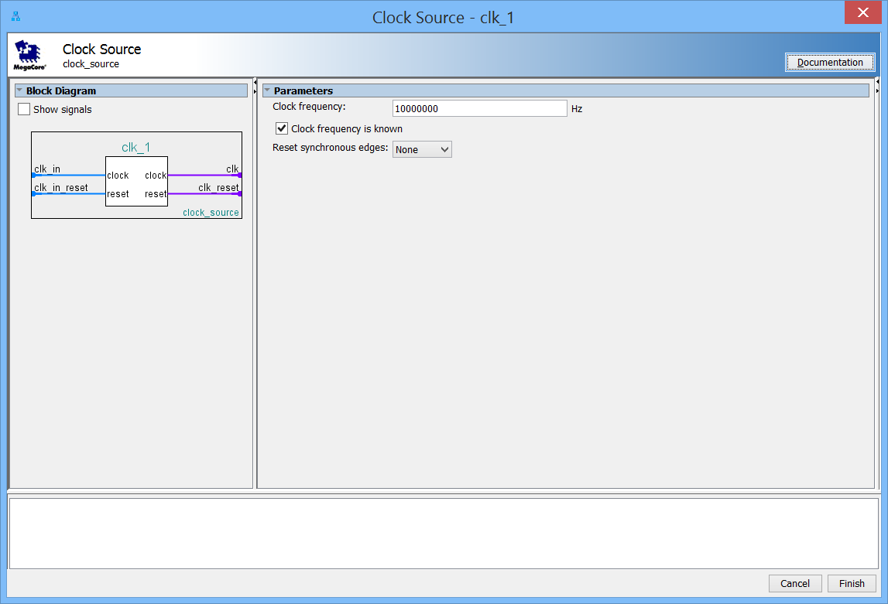

Change the clock Frequency to 10 MHz. Click Finish.

4) Next you need to **add another alt_pll to provide a clock for the ADC module**. In the IP catalog, under Basic Functions, then Clocks, then PLL select Avalon ALTPLL. Double click on the ALTPLL, the ALTPLL MegaWizard Plug-In Manager should appear. Enter 10.000 MHz for the inclk0 input frequency and accept all other defaults:

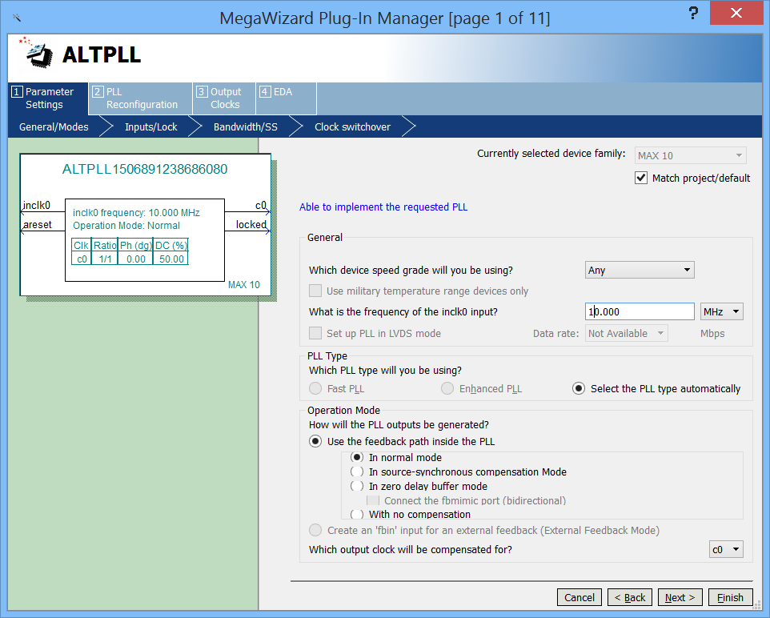

5) Next click on the Output Clocks tab and **set the output clock frequency to 10 MHz**. This will be used to drive the ADC module.

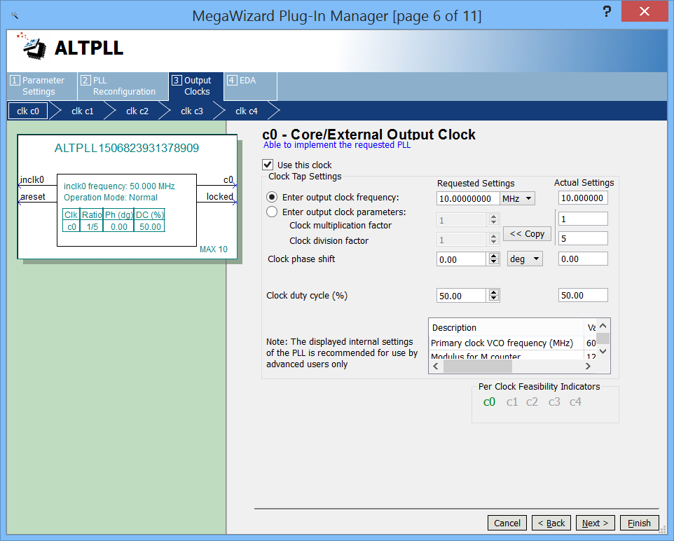

Click **Finish.**

6) **Connect the incoming clock and reset to the PLLs**

Qsys needs to know what clock and reset sources to use as the input to the PLL component. The clock and reset sources can come from an external source or from another component within the Qsys system. In our case, we will be connecting them to an external clock and reset.

* Click on the "System Contents" tab to the view of the components in our system. At this point, there are four components, a "Clock Source" component that was in the system by default when Qsys first launched, the second clock source you added, the 2 "Avalon ALTPLL" components. The Clock Source component is a Qsys component which brings in a clock and reset source from outside of the Qsys system. We will connect its nodes to the corresponding nodes on the Avalon PLL components.
* In the "Connections" column, hover over the connections and you will then be able to fill in connection dots to make connections.

Connect the clk_0 clock output port of the Clock Source to the inclk_interface of the altpll_0 component. Similarly connect the clk_reset reset output port of the Clock Source to the inclk_interface_reset of the altpll_0 component. Make the same connections between the clk_1 source and the altpll_1 component. Your resulting connections should look as follows:

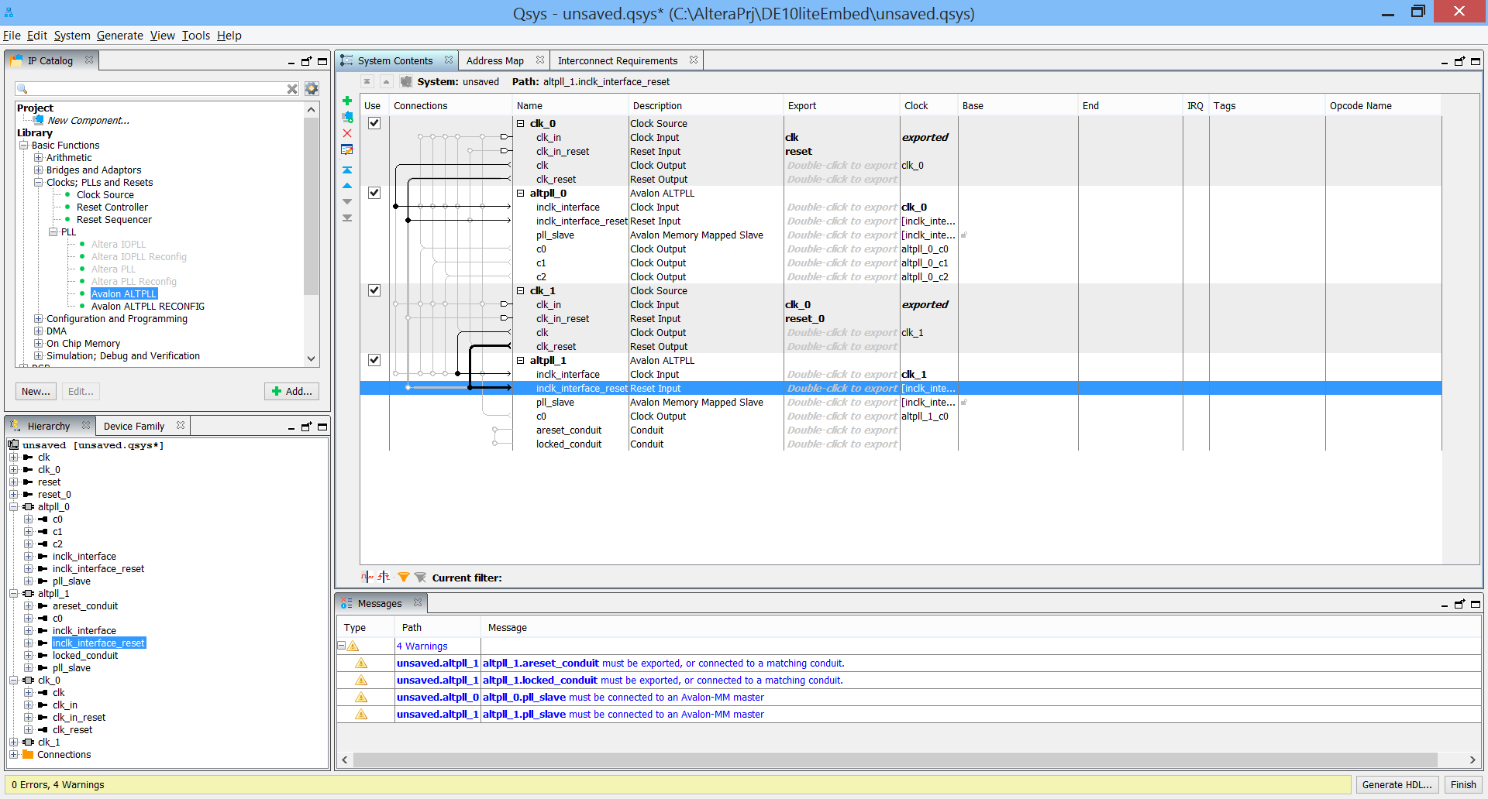

7) We have not yet saved our system. Let us use this opportunity to **save our work**. Click on **Save As** from the **File** menu and save the system as **Embed.qsys**. Close the window after the save completes.

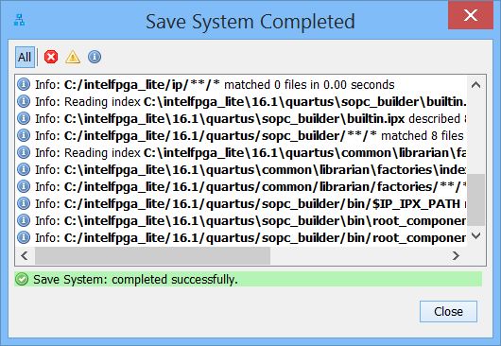

8) **Add a Nios II Processor**.

A CPU is needed to run the control algorithms. The NIOS II is a 32-bit CPU built in FPGA programmable logic, with a number of distinct benefits. Obviously, it can easily be configured and is quite configurable. Many functions of the core are optional, as we shall see. Additionally, combined with available bus interconnections in Qsys, it is very easy to extend the processor system to include a wide range memory and peripherals. You can include only what you need, so the resource usage can be very efficient. The performance is optimized, so speed is reasonable although not what you would expect from a hard-core processor. However, unlike hard-core processors obsolescence is not problem – once designed, the softcore system can be applied to FPGAs now and into the future.

* From the **IP Catalog** pane, under Library, Expand Processors and Peripherals and then **Embedded Processors** and double click on **Nios II Processor)**. The Nios II processor configuration window opens.

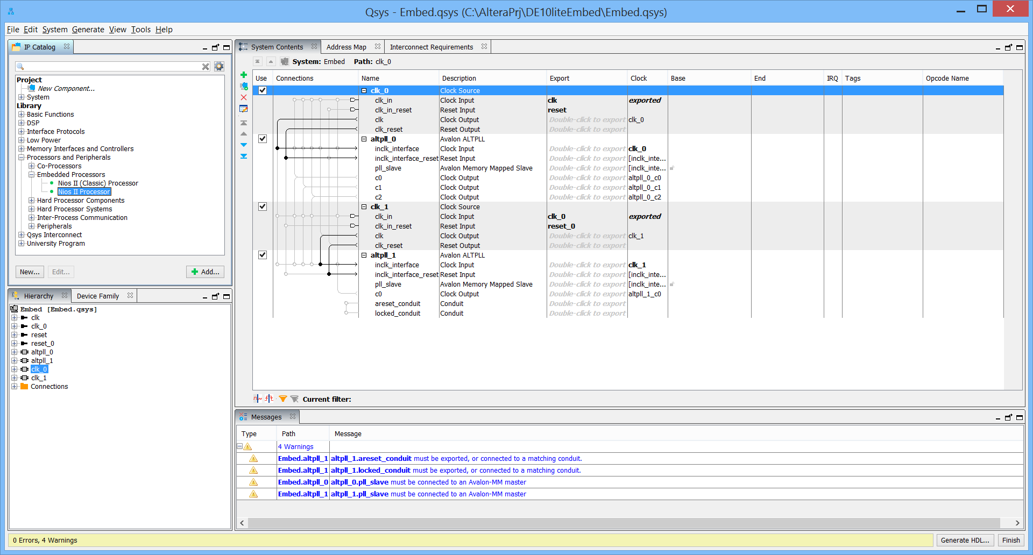

* In the main tab, ensure that the Nios II/f core is selected.

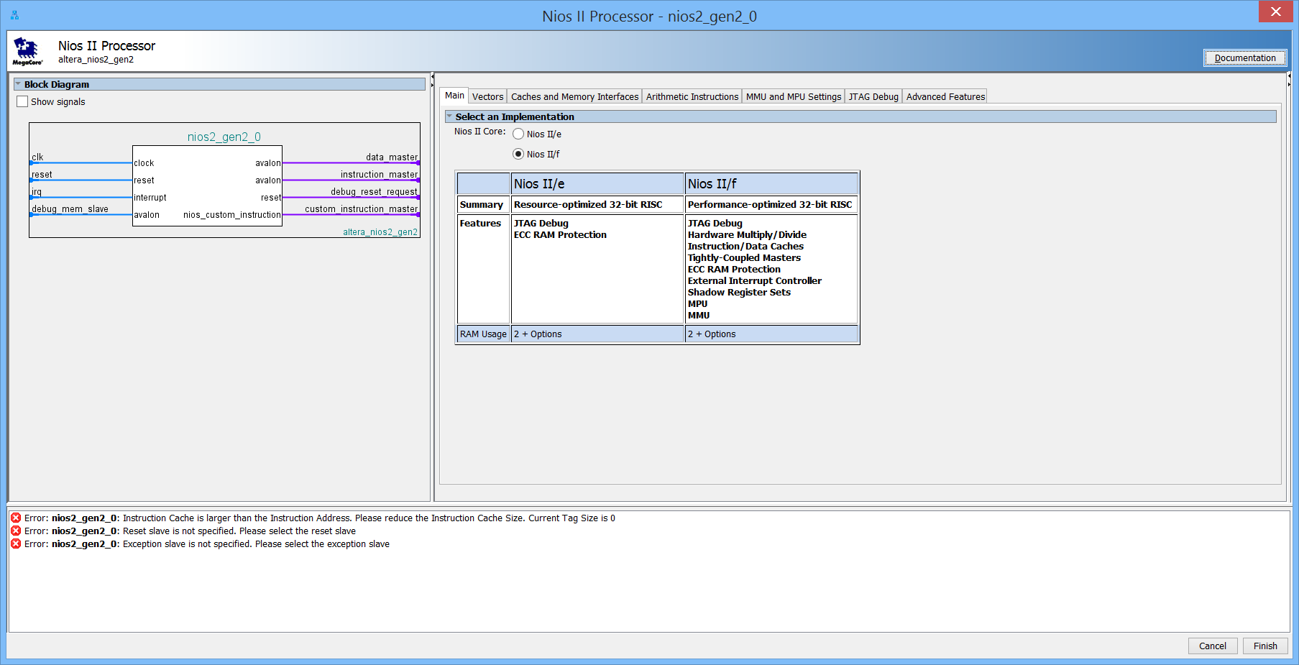

Click on the **JTAG Debug** tab and change the number of **Hardware Breakpoints** from 0 to **2**.

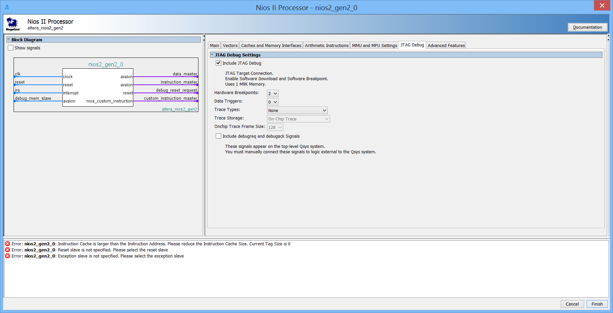

* In the Caches and Memory Interfaces tab, reduce size of the Instruction Cache to 2 Kbytes.
* In the Vectors tab, set the Reset vector Memory to nios2_gen2_0.debug_mem_slave, and do the same with the Exception Vector memory.

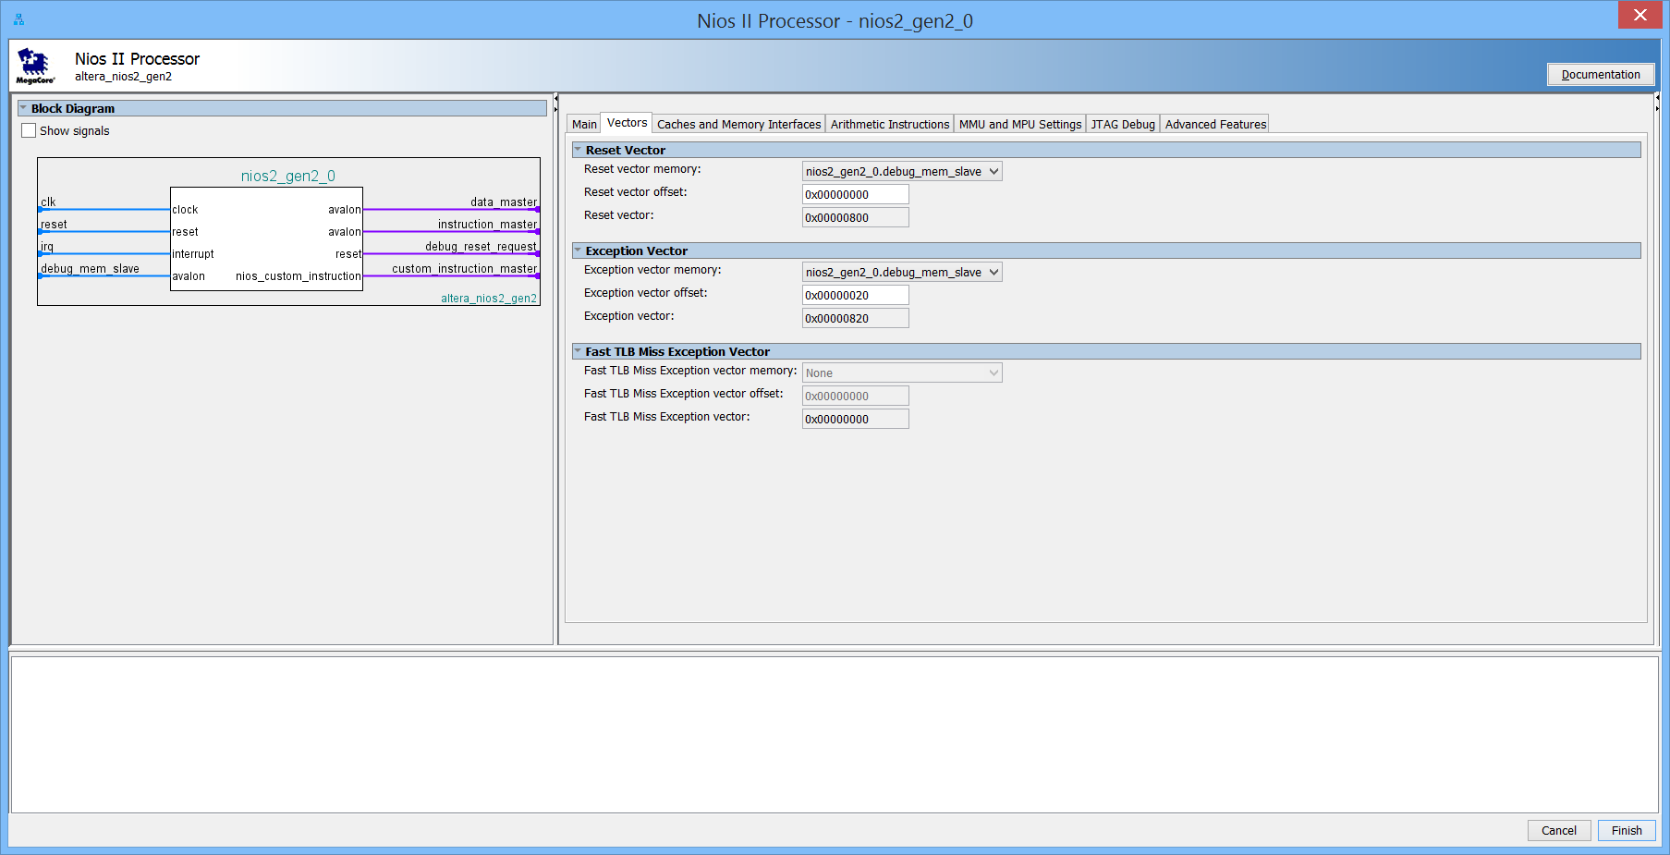

There are numerous other options on the various pages of the dialog box, including the ability to add an MMU and hardware divider, etc. We will keep things simple for now. All the remaining defaults should be accepted. Click **Finish**.

You will likely see 2 error messages asking for the NIOS2 to be connected to a clock and reset. Duh! Connect the NIOS clock input to the alt pll c0 output. Connect the NIOS2 reset input to the clk_0 reset output. The error messages should now go away. Yeah! See how easy this is?

The NIOS2 can reconfigure the PLLs on the fly through the Avalon Memory mapped bus interface. Connect the nios2 data master to the atlpll pll slaves. You may see errors due to overlapping pll base addresses, but we will deal with this a little later.

The system should now look like this:

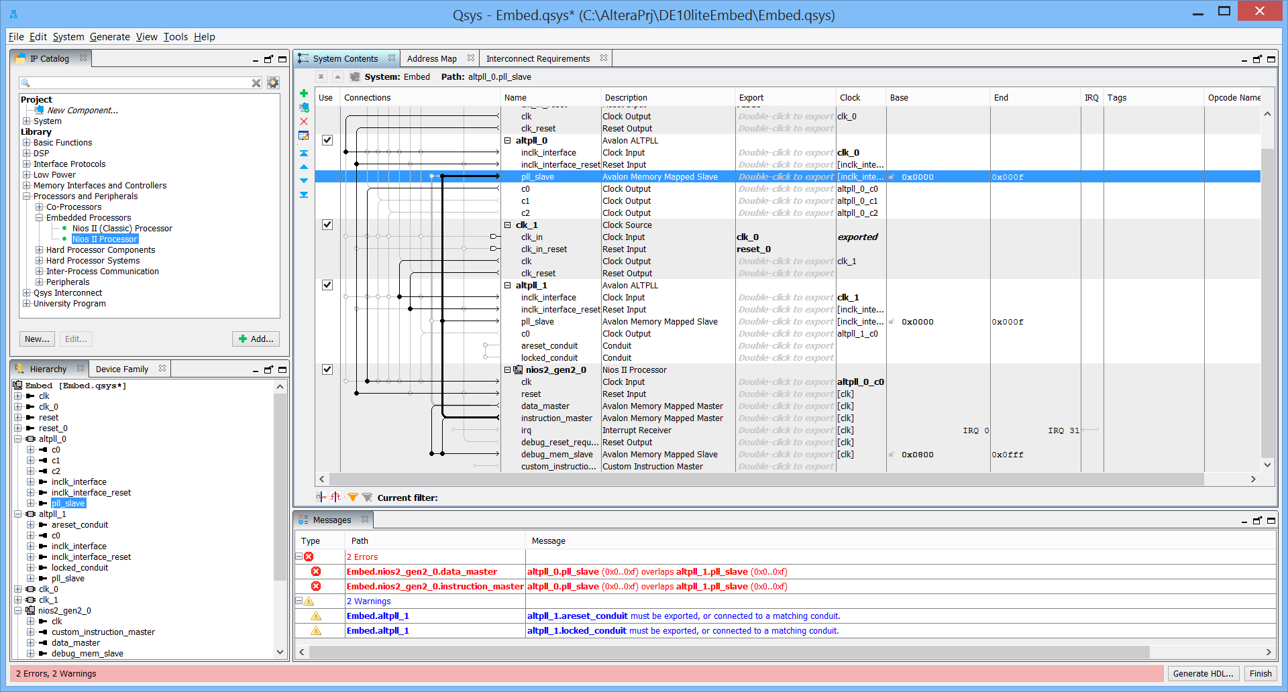

Hit File and then save, and close the save box.

1. **Add an on-chip RAM**

Altera FPGAs provide internal on-chip memory blocks that can be used to build up an internal RAM (or ROM) block of memory. This provides the processor with access to very low-latency, high-speed memory for code or variable storage.

* In the IP Library on the left, Expand **Basic Functions**, then expand **On Chip Memory** and double click on **On-Chip Memory (RAM or ROM)**.

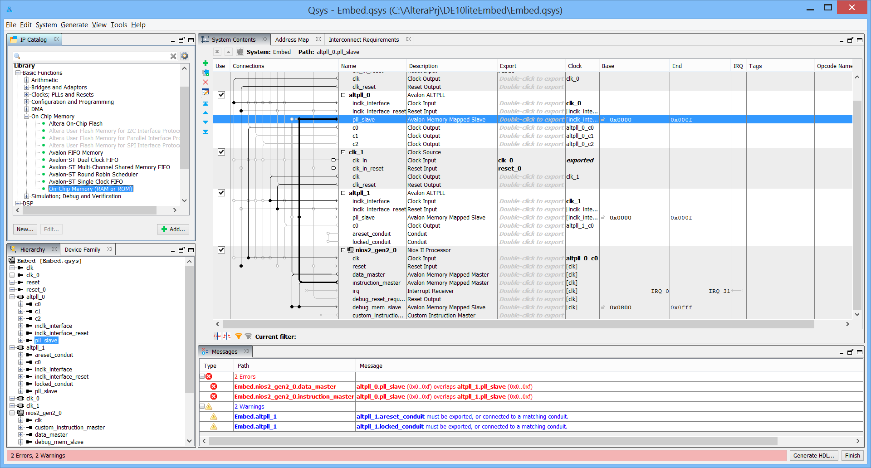

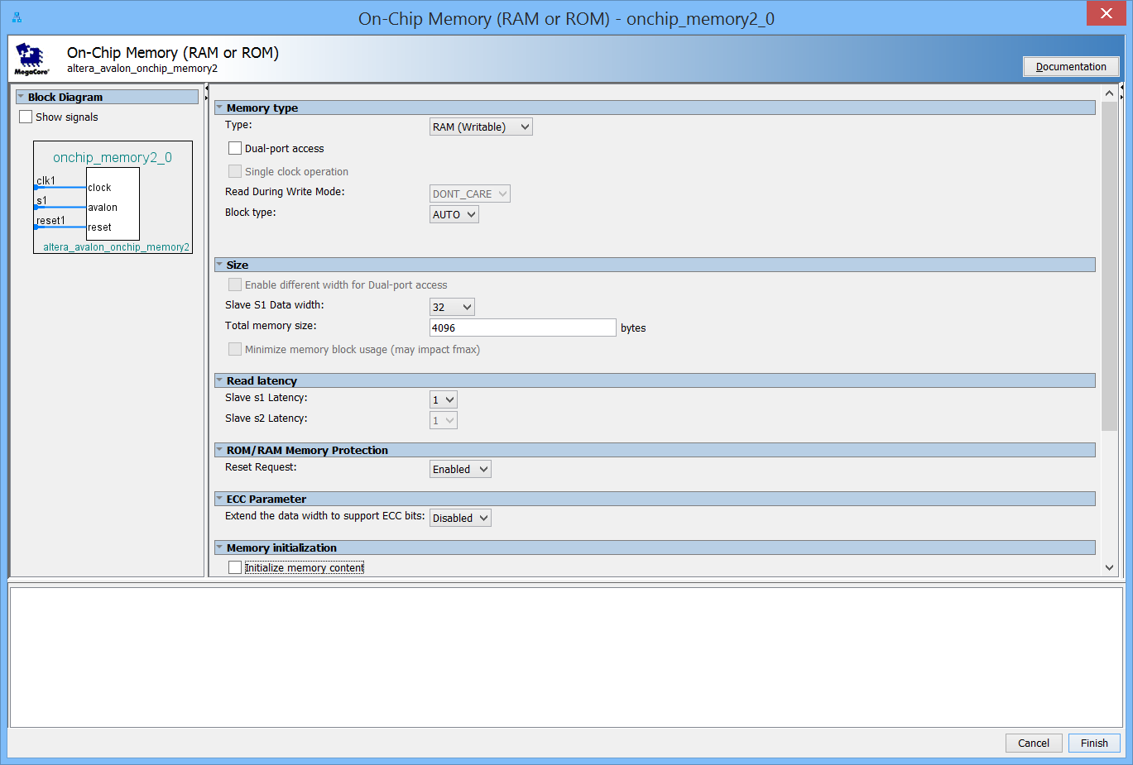

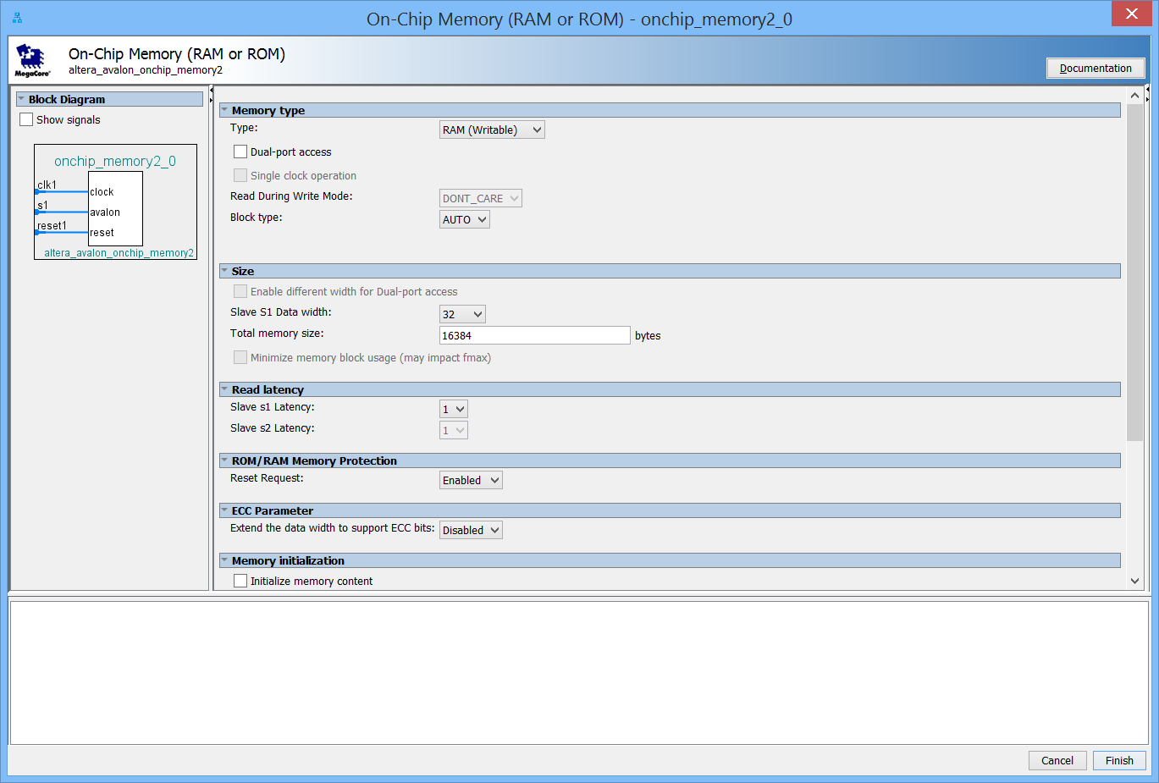

In the On-Chip Memory dialog that appears, uncheck the Initialize memory content box, set the “Total memory size” to 16k bytes to create a 16 KB RAM, and then accept all the other defaults and click Finish.

Connect the memory clock input to the alt pll c0 clock. Also connect the memory reset1 signal to the clk_0_reset output. Using the Connections column, connect the s1 Avalon Memory Mapped Slave interface of the onchip RAM to the nios2 instruction_master and nios2 data_master. Set the base address of the onchip RAM s1 to 0x4000.

1. **Add an on-chip FLASH.**

The MAX 10 FPGA contains on-chip flash which is used to store the FPGA configuration and can also be used to store Nios II code or other non-volatile data.

* In the Library, Expand Basic Functions. Expand On Chip Memory and double click on Altera On-Chip Flash.

Change the configuration mode to “Single Uncompressed Image with Memory Initialization”. Change the clock frequency to 80 MHz. Change the CFM Access mode to Read and Write. Hit Finish.

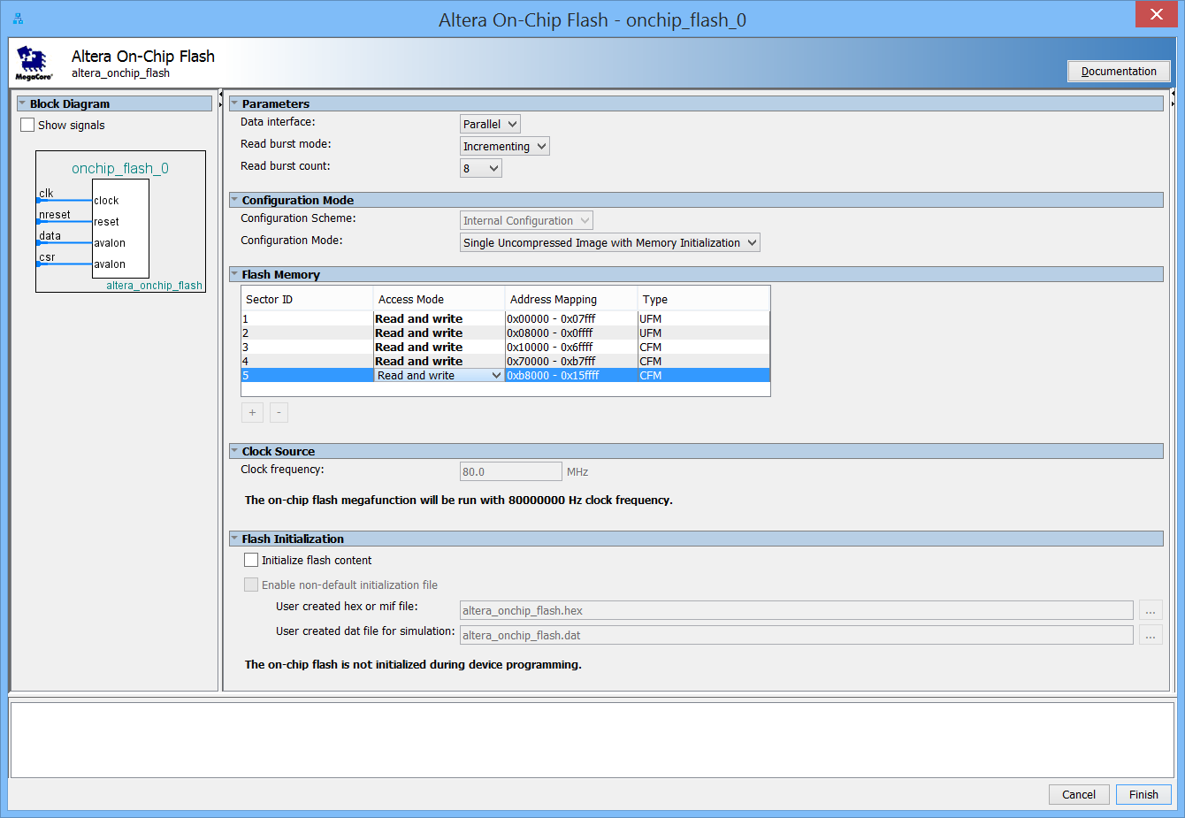

In the clock column, select altpll_0_c0 as the clock for the onchip flash from the pull-down menu.

Connect the onchip flash reset to the clk_0 reset signal.

* Connect the data to both nios2 data_master and nios2 instruction_master
* Connect the csr (control and status registers) to the nios2 data_master only.

Change the base address of onchip flash data to 0x0020 0000

Change the base address of onchip flash csr to 0x0040 0000.

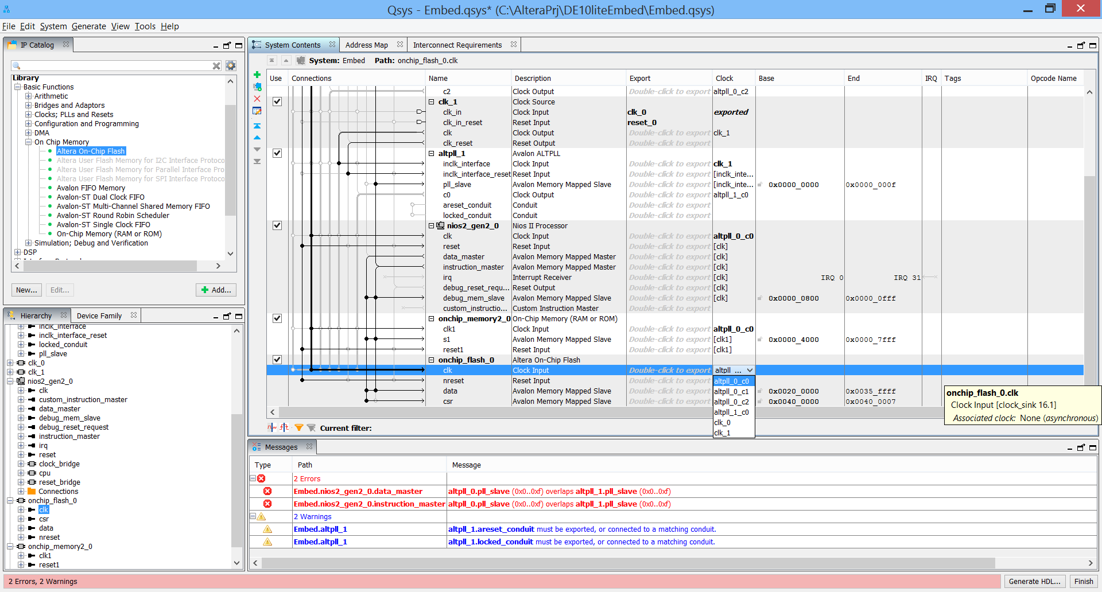

1. **Add Avalon-Memory Mapped Clock Crossing Bridge Peripheral** for the “slow” peripherals.

We will place several “slow” peripherals in a separate clock domain from the Nios II processor. With the bridge, a single clock crossing bridge is built into the system for all of the slow peripherals. Peripherals often have requirements to work with a different clock, creating a bridge to them is a general technique to handle the different clock domains. A bridge takes data, addressing and control signals on the Avalon bus, and translates them to signals needed by the peripheral so that data can be exchanged between the devices.

From the IP Catalog menu, expand Basic Functions. Expand Bridges and Adapters. Expand Memory Mapped and double click on Avalon-MM Clock Crossing Bridge.

Change the Address Units to WORDS. Change the Command FIFO depth to 8 and the Response FIFO depth to 32.

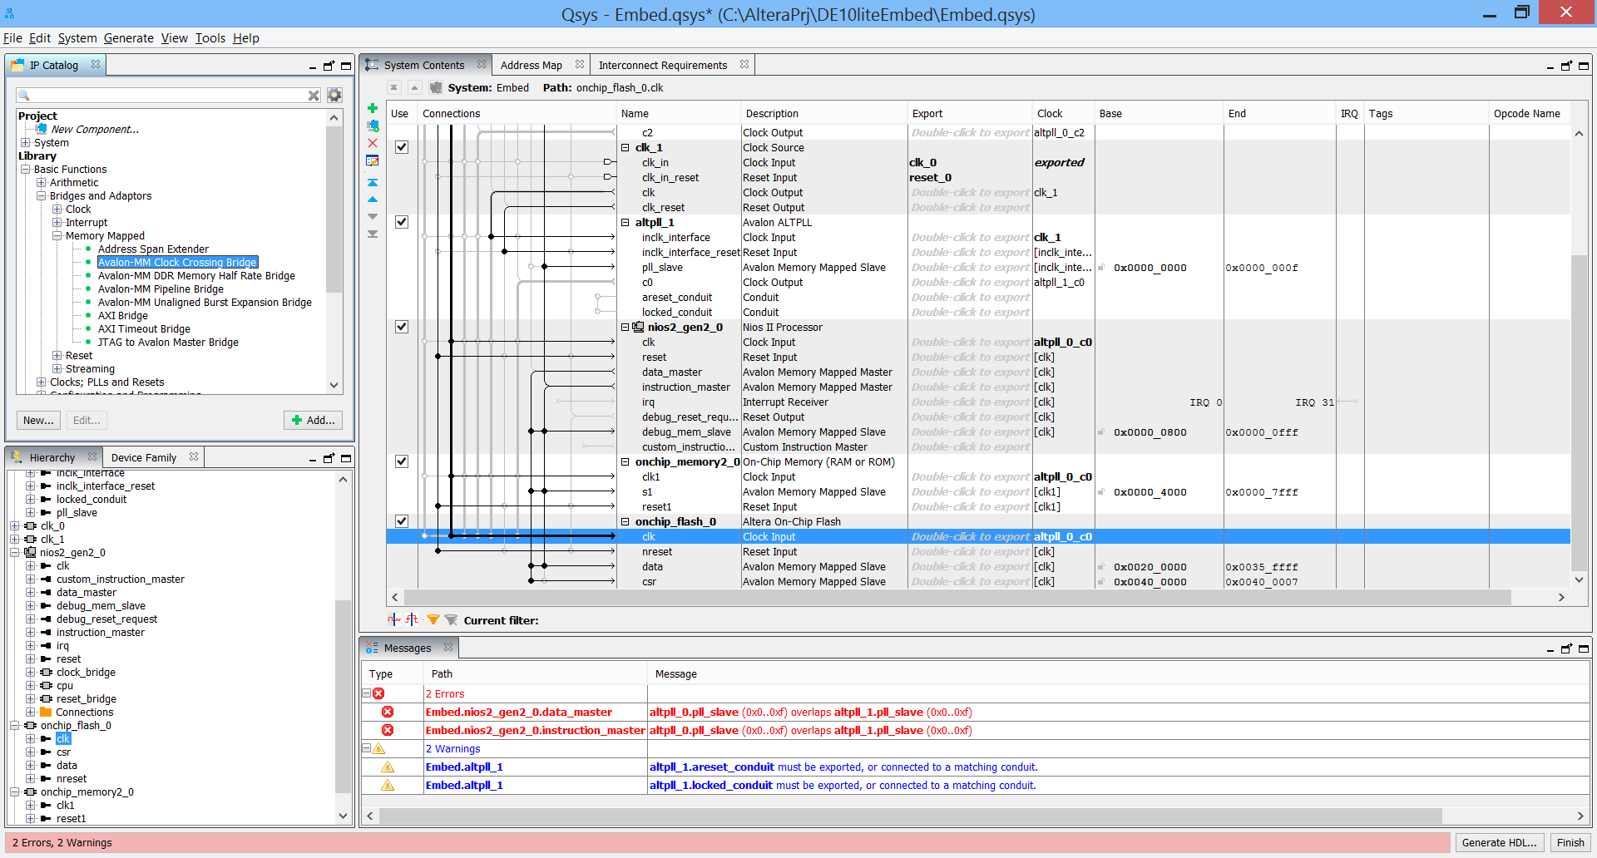

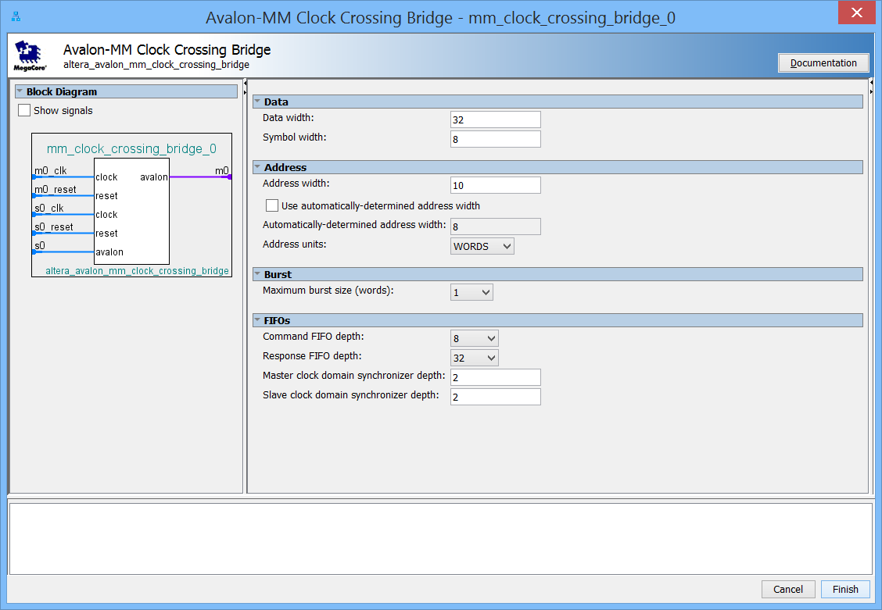

Click Finish.

Connect the memory mapped bridge m0 clock to the pll_0 c2 clock (40 MHz), and the s0 clk to the pll_0 c0 clock. Connect both resets to clk_0 reset as usual.

Connect the nios2 data_master port to the s0 Avalon Memory Mapped Slave of this bridge. The m0 master port will be connected in the upcoming steps.

Change the base address of the Avalon memory mapped slave to 0x0000 2000.

1. **Add GPIO Peripheral for LEDs**

The DE10-Lite has 10 LEDs. You can drive these LEDs with an output PIO peripheral. We will drive 10 of the LEDs with a PIO peripheral.

* From the IP Catalog menu, expand Processors and Peripherals, expand Peripherals, and double click on PIO (Parallel I/O).
* Set the “Width” to 10 bits. Ensure that the “Direction” is set to “Output” only. Click Finish.

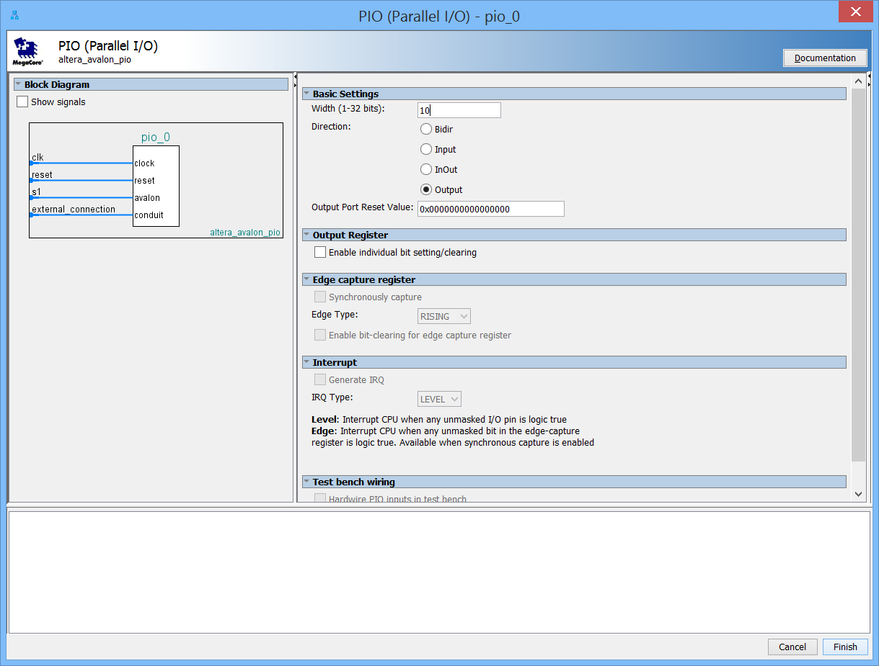

Right-click and rename the peripheral “led_pio”.

Change the connection on the s1 slave port of the peripheral to be connected to the m0 master port of the clock crossing bridge.

In the clock column, select altpll_0_c2 as the clock for the clk Clock Input. Use clk_0 reset for the reset input.

Change the base address to 0x0050

Finally, double click in the "click to export" field next to the external_connection Conduit Endpoint and change the name to: led_pio_external

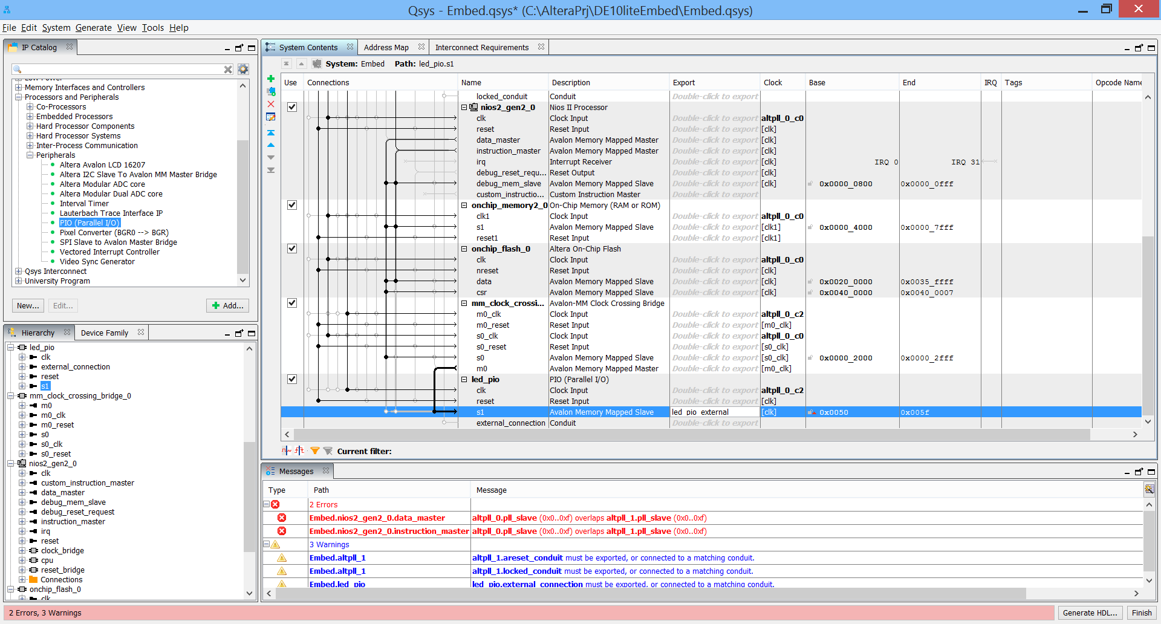

1. **Add PIO Peripheral for Slide Switches**

The DE10-Lite has 10 slide switches labeled “SW0”, “SW1”, “SW2” to “SW9” connected to 10 of the FPGA I/O pins. You can use an input PIO peripheral to detect when any of these switches have been toggled and signal an interrupt to the processor. These signals are assumed to be active low. From the IP Catalog menu, expand Processors and Peripherals, expand Peripherals, and double click on PIO (Parallel I/O).

Set the “Width” to 10 bits. Set “Direction” to “Input.”

Check the Synchronously capture and Any edge option in the Edge capture register section.

Check the Generate IRQ and Edge options in the Interrupt section.

Check the Hardwire PIO inputs in the test bench option and drive the inputs to 0x3FF.

Click Finish.

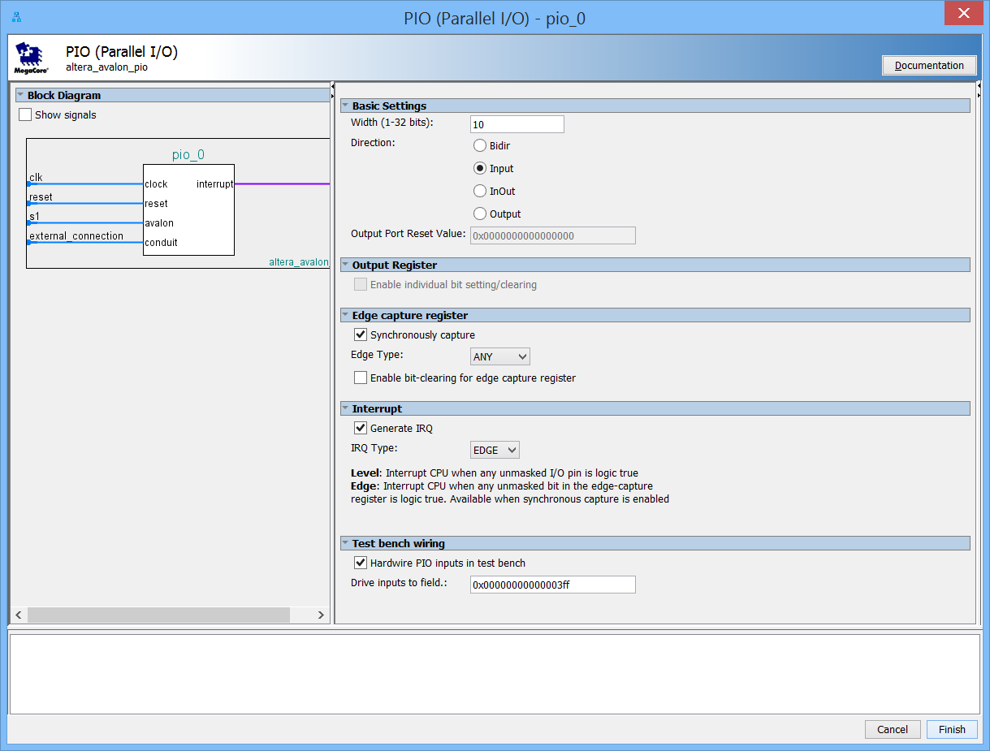

Right-click and rename the peripheral “slide_pio”.

Change the connection on the s1 slave port of the peripheral to be connected to the m0 master port of the clock crossing bridge.

In the clock column, select alt pll_0 c2 as the clock for the clk Clock Input, and clk_0 reset as reset as before. Change the base address to 0x0040.

Finally, double click in the "click to export" field next to the external_connection Conduit Endpoint and name: slide_pio _external.

1. Add a 1 ms Interval Timer Peripheral

Many software applications require periodic interrupts to maintain various time bases and timing requirements within the application. A timer is a common and essential peripheral in most processor system.

* From the IP Catalog menu, expand Processors and Peripherals, expand Peripherals, and double click on Interval Timer.
* Confirm the timer interval is 1 ms. Click Finish.

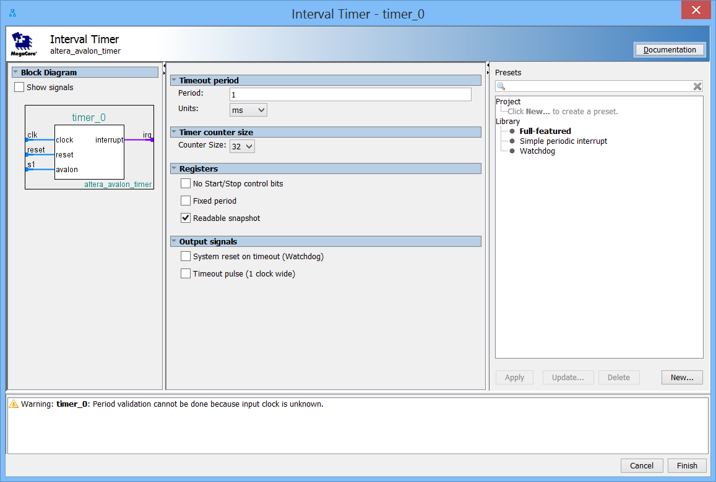

Connect the s1 slave port of the peripheral to be connected to the m0 master port of the clock crossing bridge.

In the clock column, select alt pll c2 as the clock for the clk Clock Input. Attach the reset to clk_reset.

Change the base address to 0x0020.

At this point the recent connections should look like this:

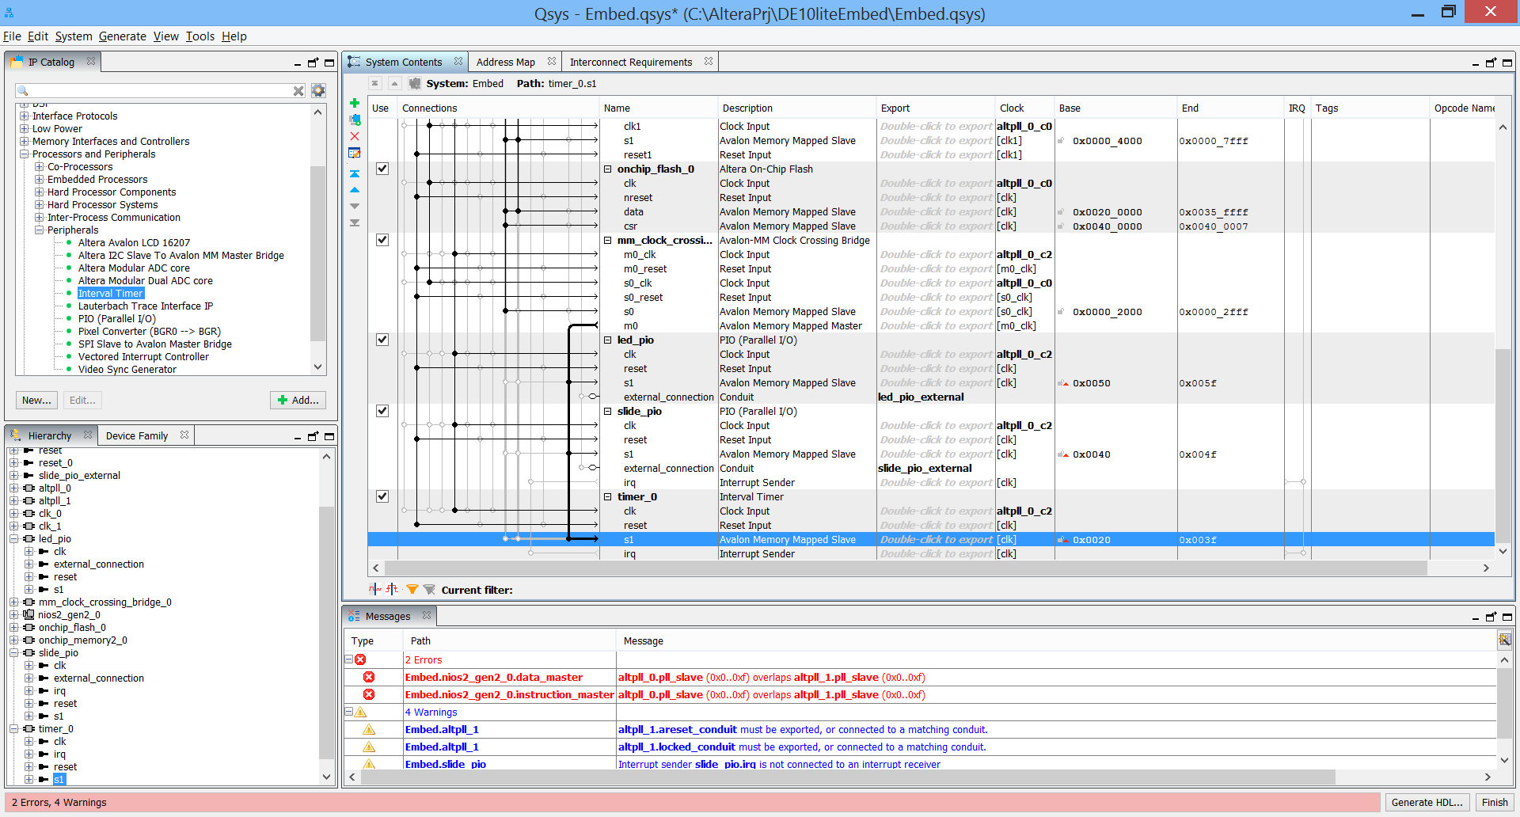

1. Add the SDRAM Controller.

In the IP Catalog, expand Memories Interfaces and Controllers. Expand SDRAM and double click on SDRAM controller. In the dialog box that appears, set the data width to 16, chip select to 1, banks to 4, Row to 13, Column to 10 and include the system testbench model:

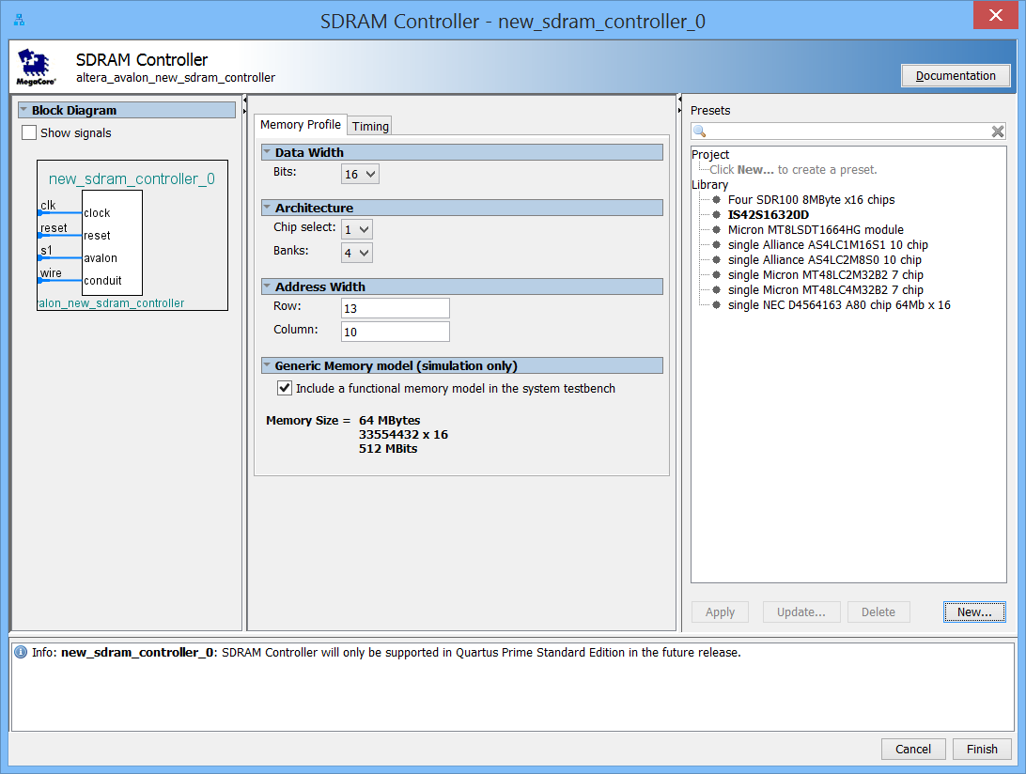

Set the Timing tab to the values below:

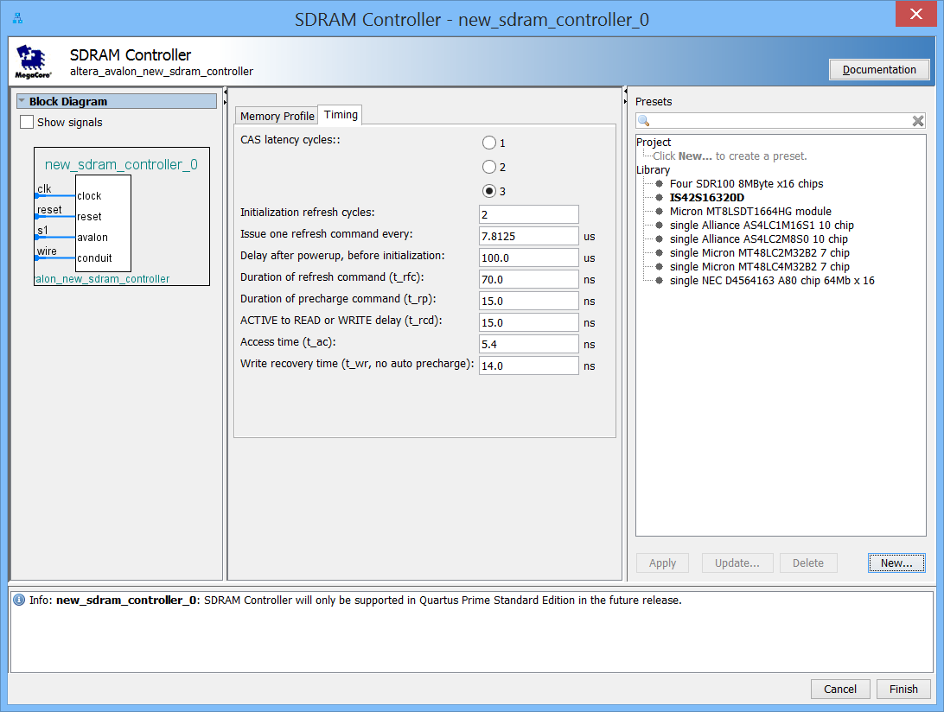

Click Finish.

Right click on the Name field and choose Rename from the pop up menu. Name this RAM component “sdram”.

* Using the Clock column, change the clock Input of the sdram to the alt_pll_c0 clock source.
* Using the Connections column, connect the s1 Avalon Memory Mapped Slave interface of the sdram to the nios2 instruction_master and nios2 data_master.
* Connect the reset to the clk_0 reset output.
* Set the base address to 0x0400 0000.

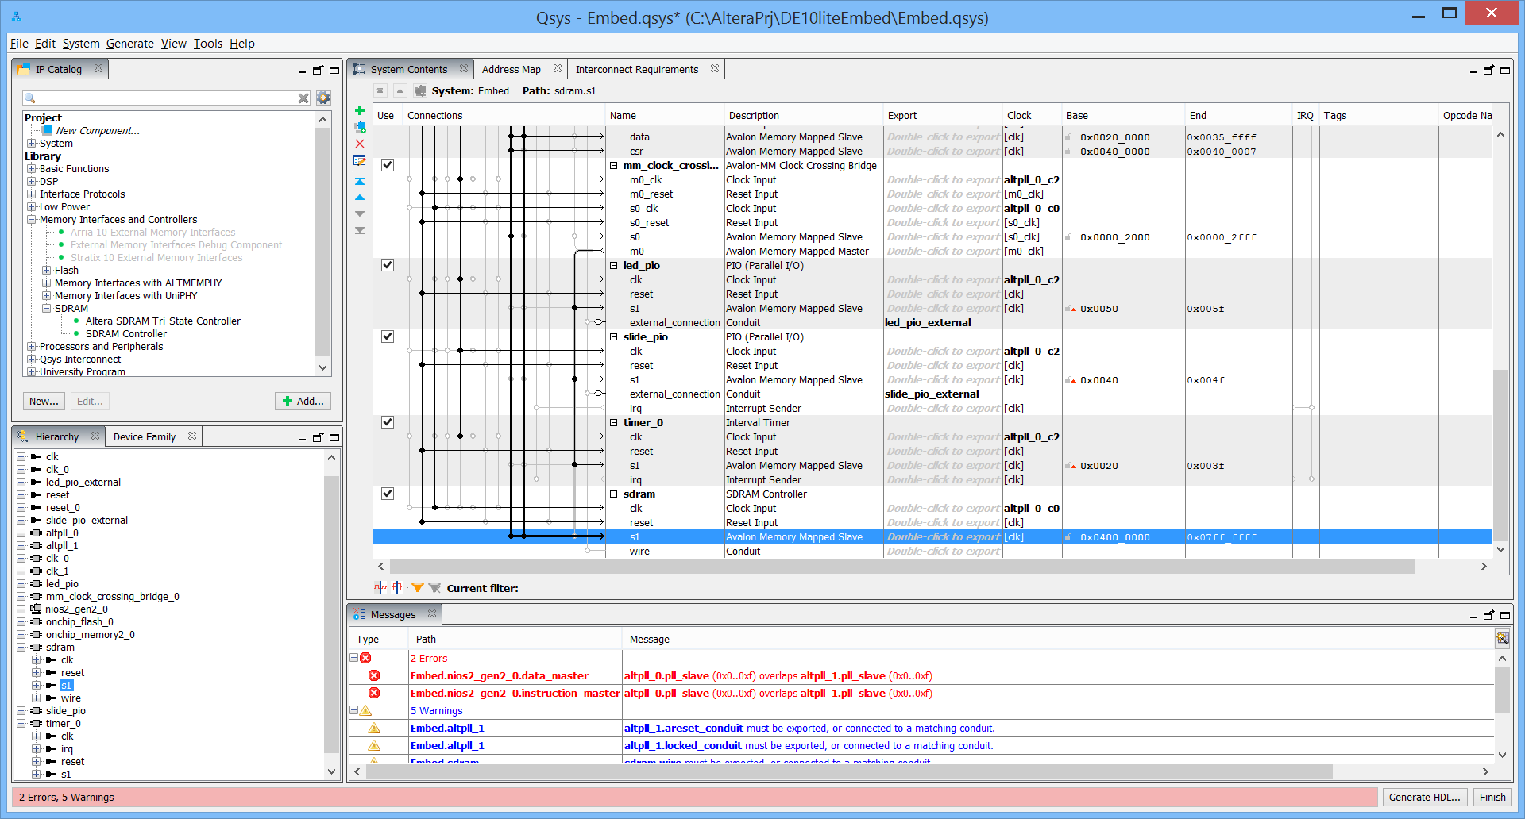

1. **Add a SPI port for the Accelerometer.**

This will connect the ADXL345 accelerometer to the Nios II. In the IP catalog, expand Interface Protocols, expand Serial and then double click on SPI (3-wire serial). Accept all defaults, except for clock polarity and phase which should be changed to a 1:

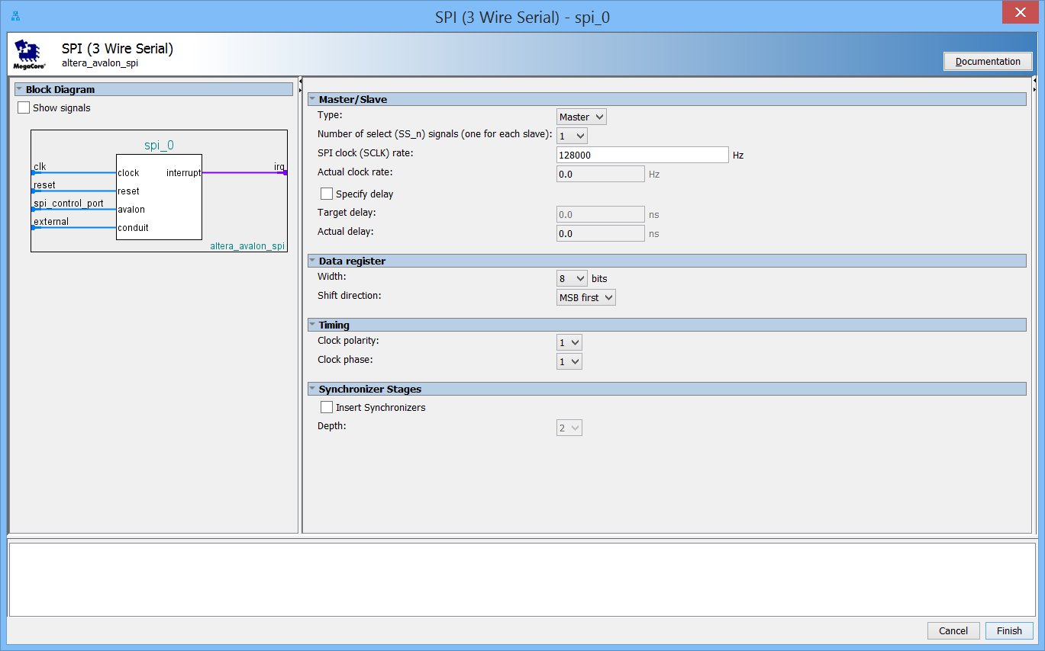

Click Finish.

In the clock column, select alt_pll_0_c0 as the clock for the spi_accelerometer.

* Connect the spi_control_port to only the nios2 data_master
* Connect the irq to the nios2 irq
* Connect the reset to clk_0 reset output
* Change the base address to 0x0060.

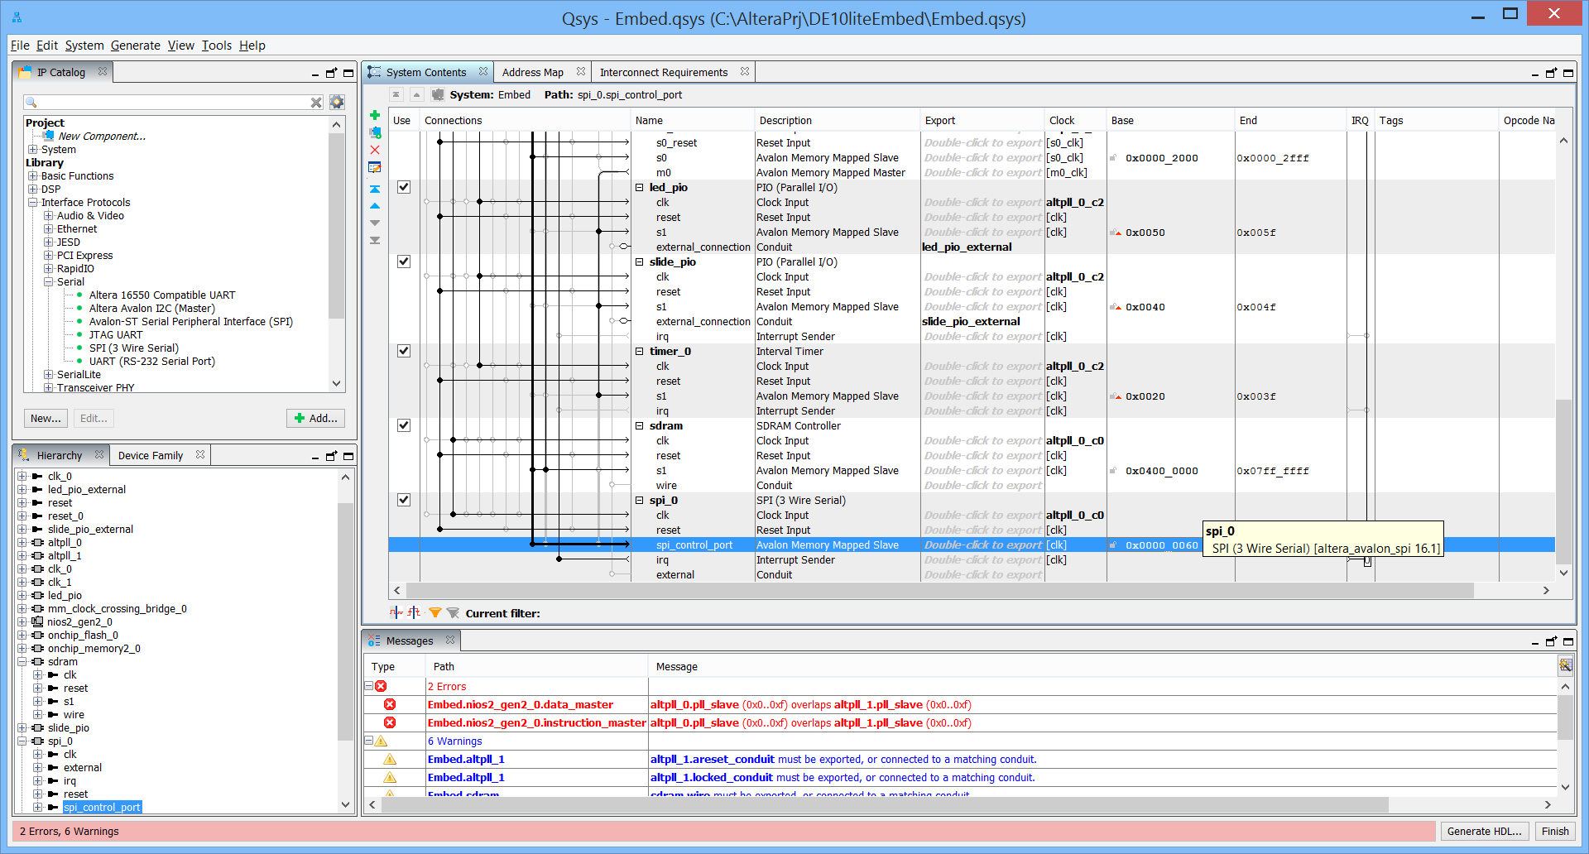

1. **Add the ADC module.**

In the IP catalog in the upper left hand corner, type ADC in the search box. Select the Altera Modular ADC core and then click add in the lower right corner of this window to add the ADC module.

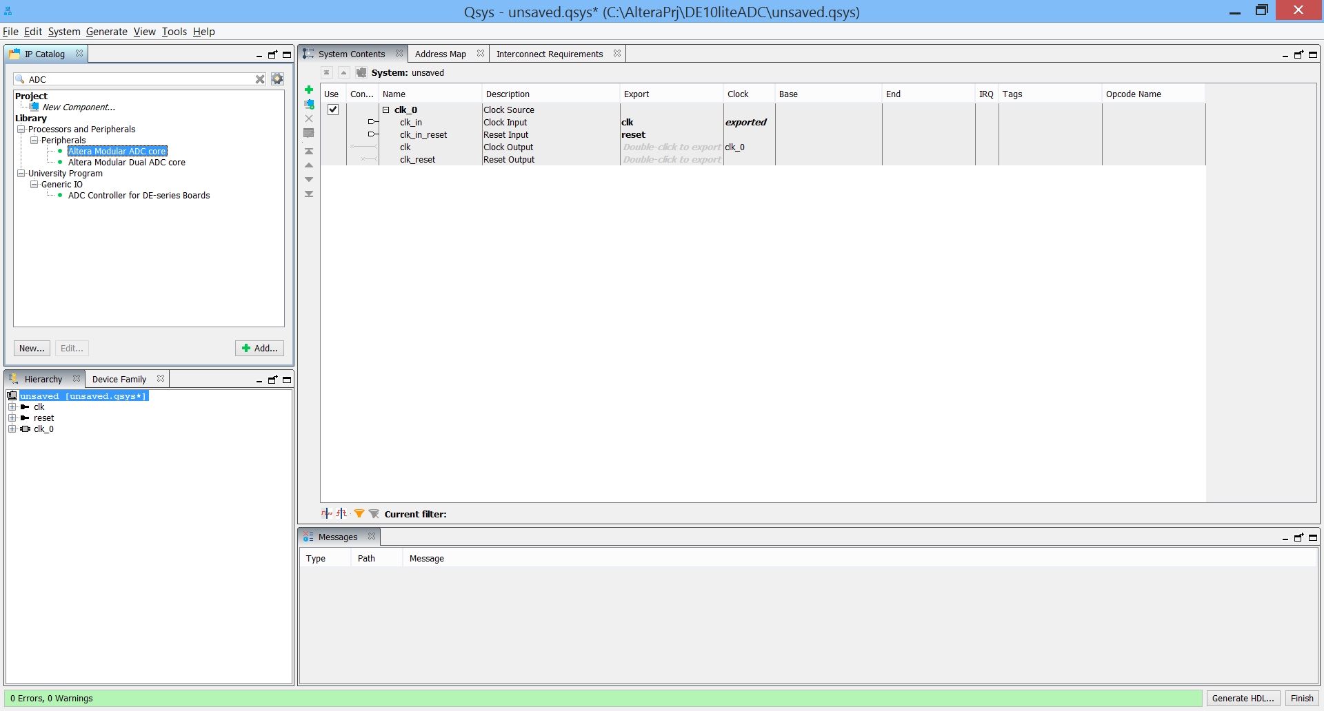

The ADC core configuration window should appear:

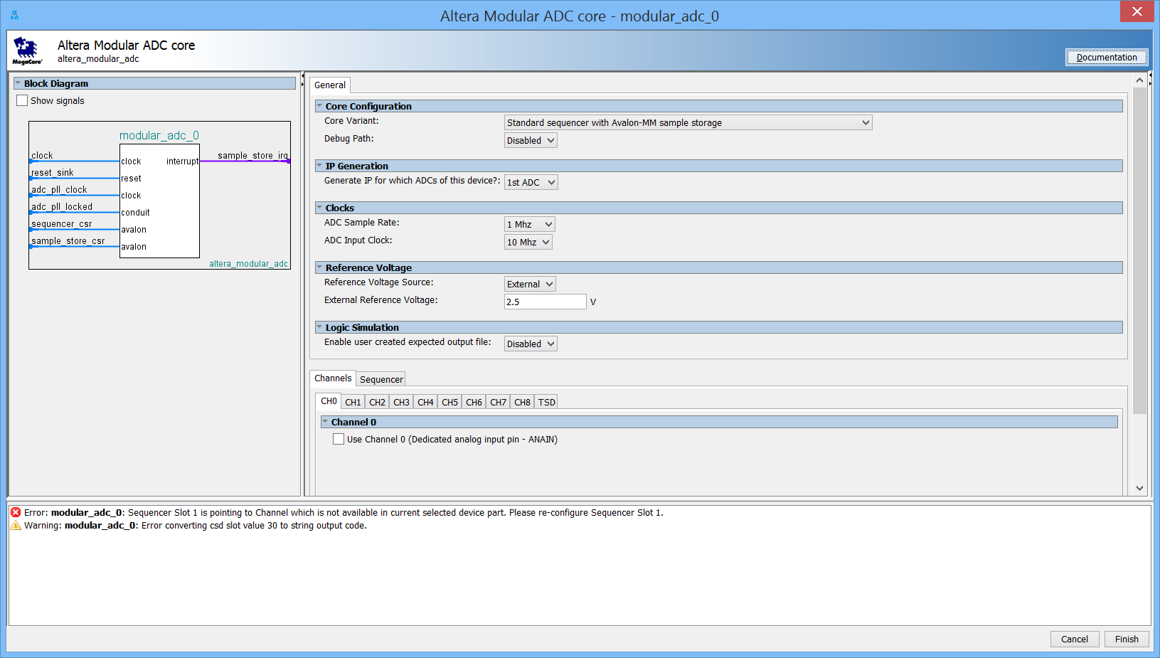

Accept all the settings in the General tab except Enable the Debug Path. In Channels, select CH1 and check the box to use Channel 1 in the Sequencer, set the number of slots used to 1, and set Slot 1 to CH 1. Click Finish.

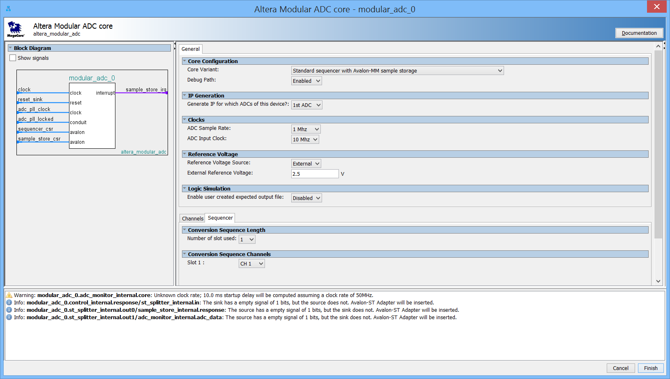

You should see an addition to the Qsys system like this:

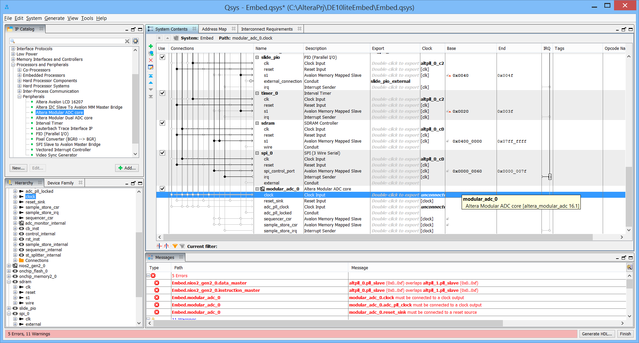

Connect the clock clk_1, and the reset to clk_1 reset output.

Connect the alt_pll_0 c0 output to the adc_pll_clock input, and the altpll_0 locked conduit to the adc_pll_locked Conduit.

Connect the squencer_csr and sample_store_csr to the nios2 data master only.

Connect the sample_store_irq to the nios2 irq.

Change the squencer_csr base address to 0x0080 and sample_store_csr base address to 0x0200.

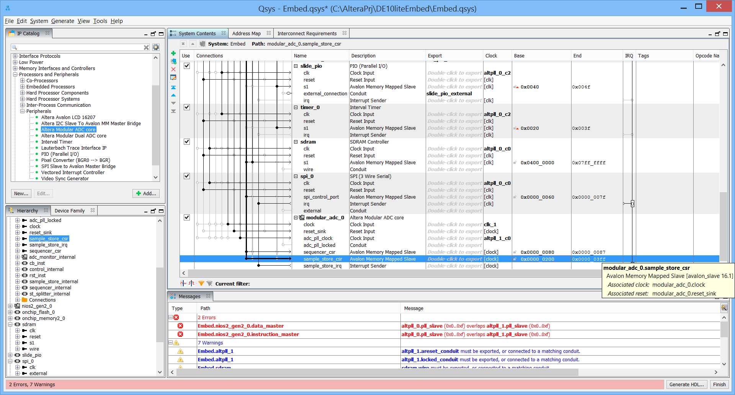

To use the built-in debugging features, you need to add a JTAG to Avalon Master Bridge. This gives you a master interface to talk through with the “System Console” tool which is a part of the Quartus installation (Tools menu). Type JTAG in the IP Catalog search box. Select and add the JTAG to Avalon Master Bridge:

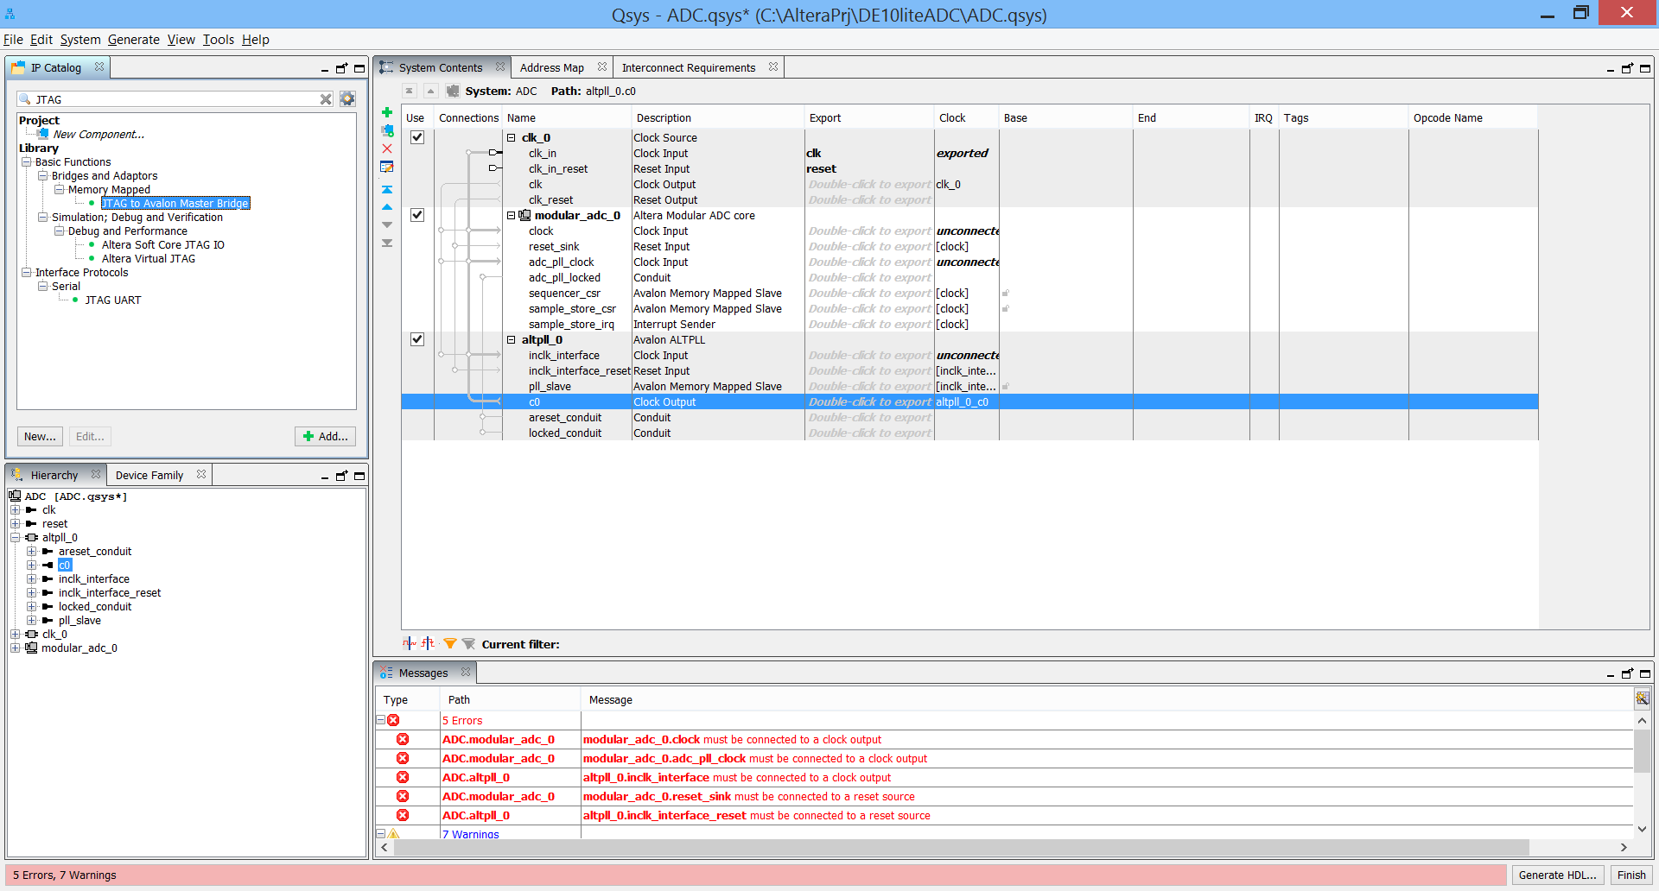

No configuration is required, just click finish.

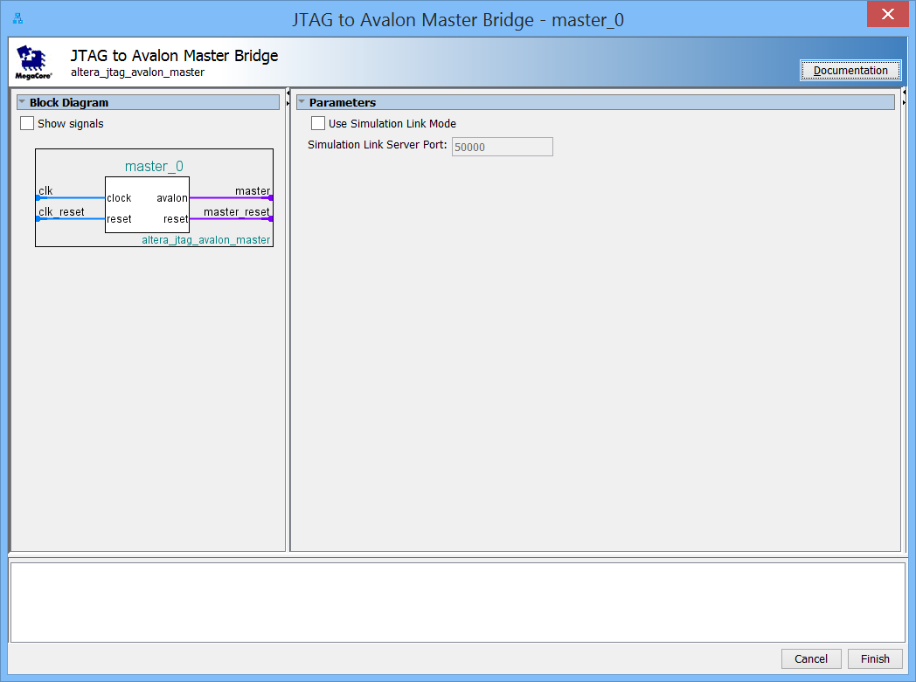

Connect the JTAG bridge clock to clk_1, and the reset to clk_1 rest. Connect the ADC module sequencer_csr slave to the master_0 master.

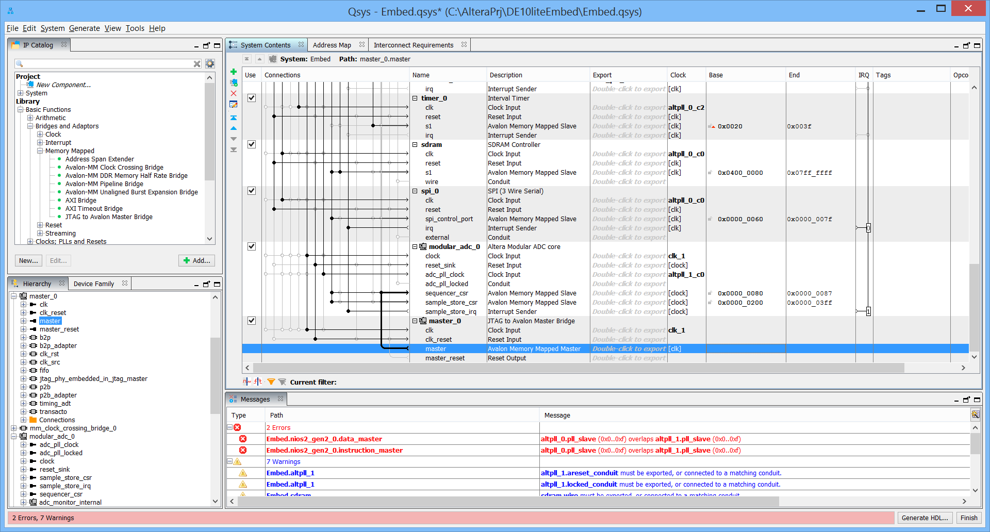

1. Add the JTAG UART Peripheral

Many software developers like to have access to a debug serial port from the target to leverage printf debugging, input control commands, log status information, etc. The JTAG UART peripheral connects to the debugger console and is useful for these purposes.

* From the IP Catalog menu, expand Interface Protocols, expand Serial and double click on JTAG UART.
* The default settings are acceptable. Click Finish.
* Change the connection on the Avalon_jtag_slave port of the peripheral to be connected to the m0 master port of the mm_clock_crossing_bridge.
* In the clock column, select alt pll c2 as the clock for the clk Clock Input. Connect the reset to clk_0 reset.

Change the base address to 0x0090.

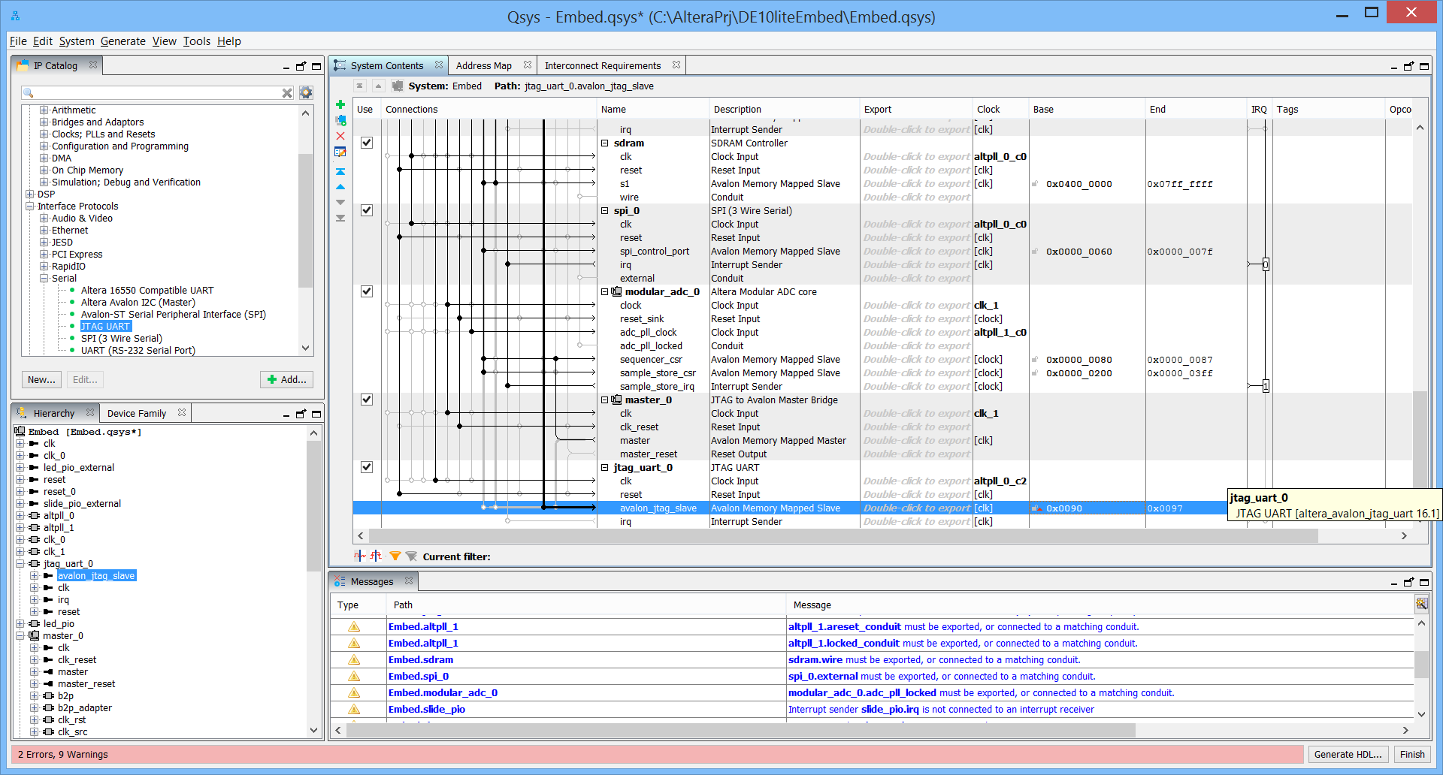

1. **Add a System ID**.

This is a VERY IMPORTANT peripheral to have in your system. It allows the Nios II development tools to validate that the software application is being built for the correct hardware system.

* From the IP Catalog menu, select Basic Functions -> Simulation; Debug and Verification -> Debug and Performance -> System ID Peripheral. Double click to add the component to the system.
* The sysid dialog box appears. Click Finish.
* Rename as “sysid”. The component must be named “sysid” to be compatible with Nios II software drivers and build tools.
* Change the connection on the control_slave port of the peripheral to be connected to the m0 master port of the mm_clock_crossing_bridge.
* In the clock column, select altpll_0_c2 as the clock for the clk Input. Connect the reset input to clk_0 reset.

Change the base address to 0x00A0.

Congratulations, you have completed the Qsys design entry! Your result should look something like:

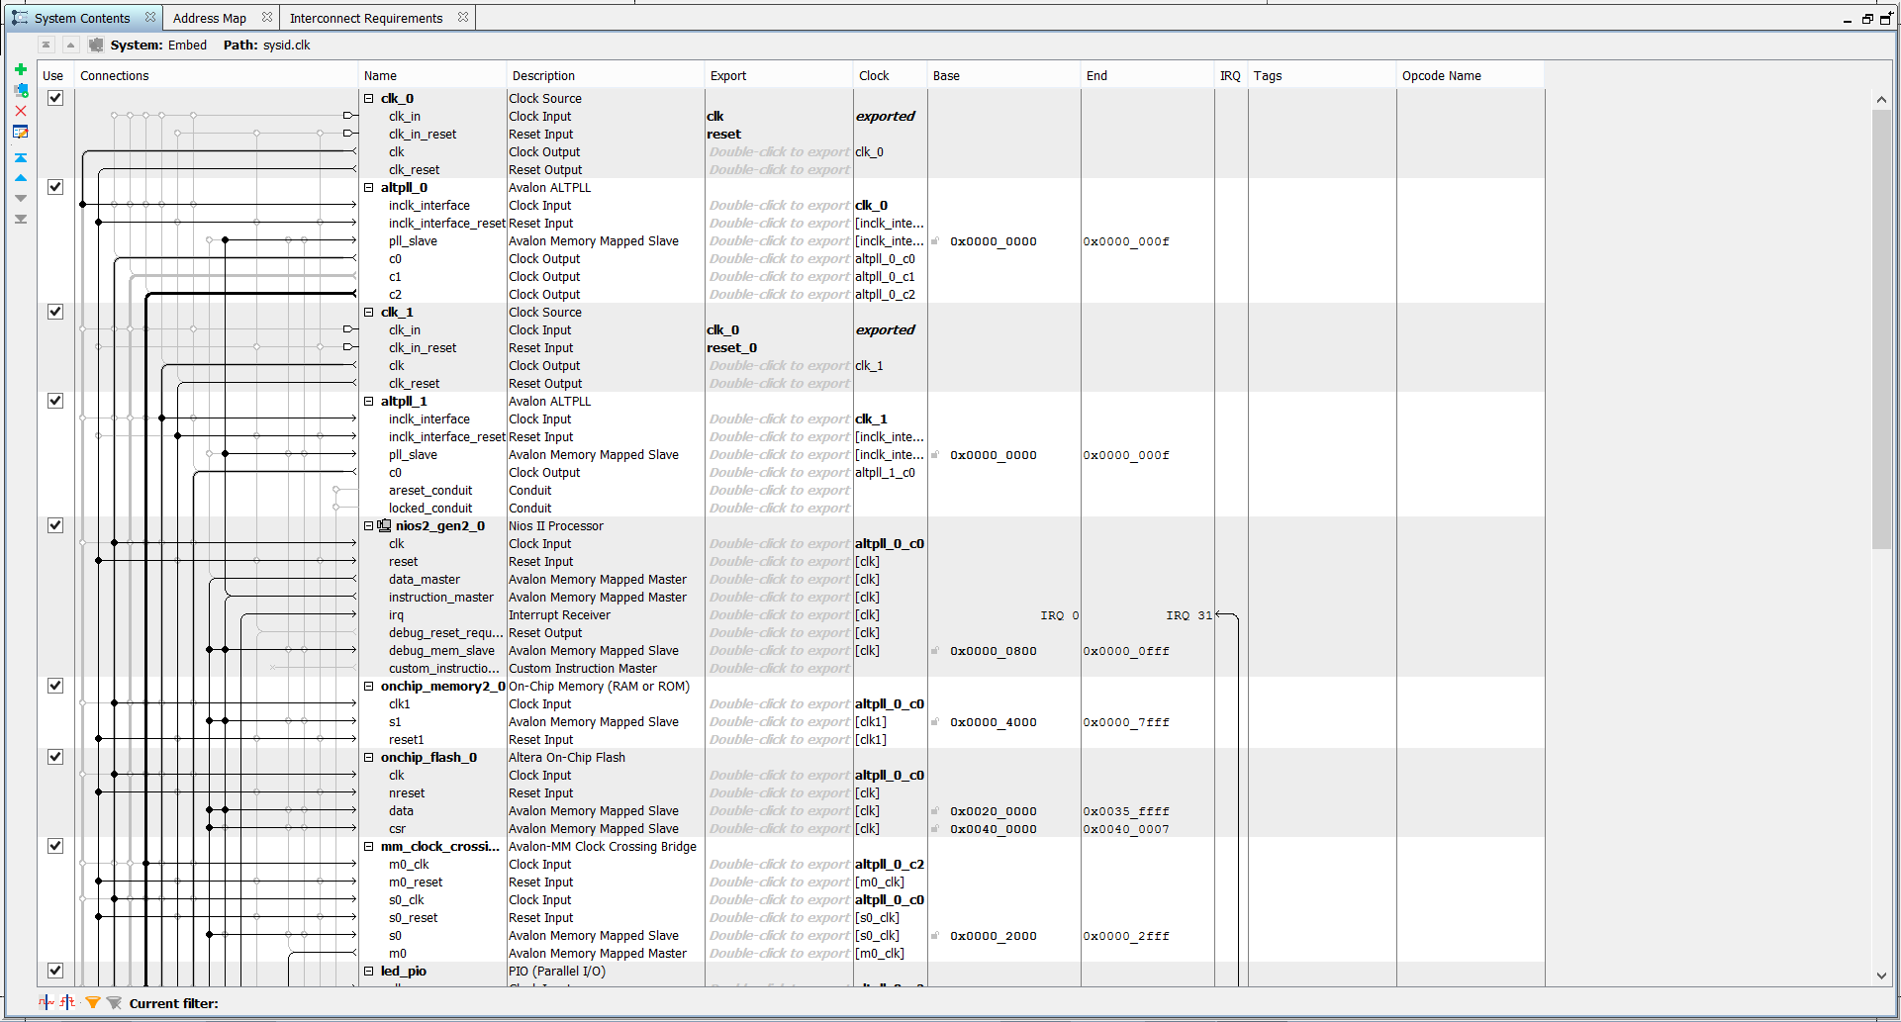

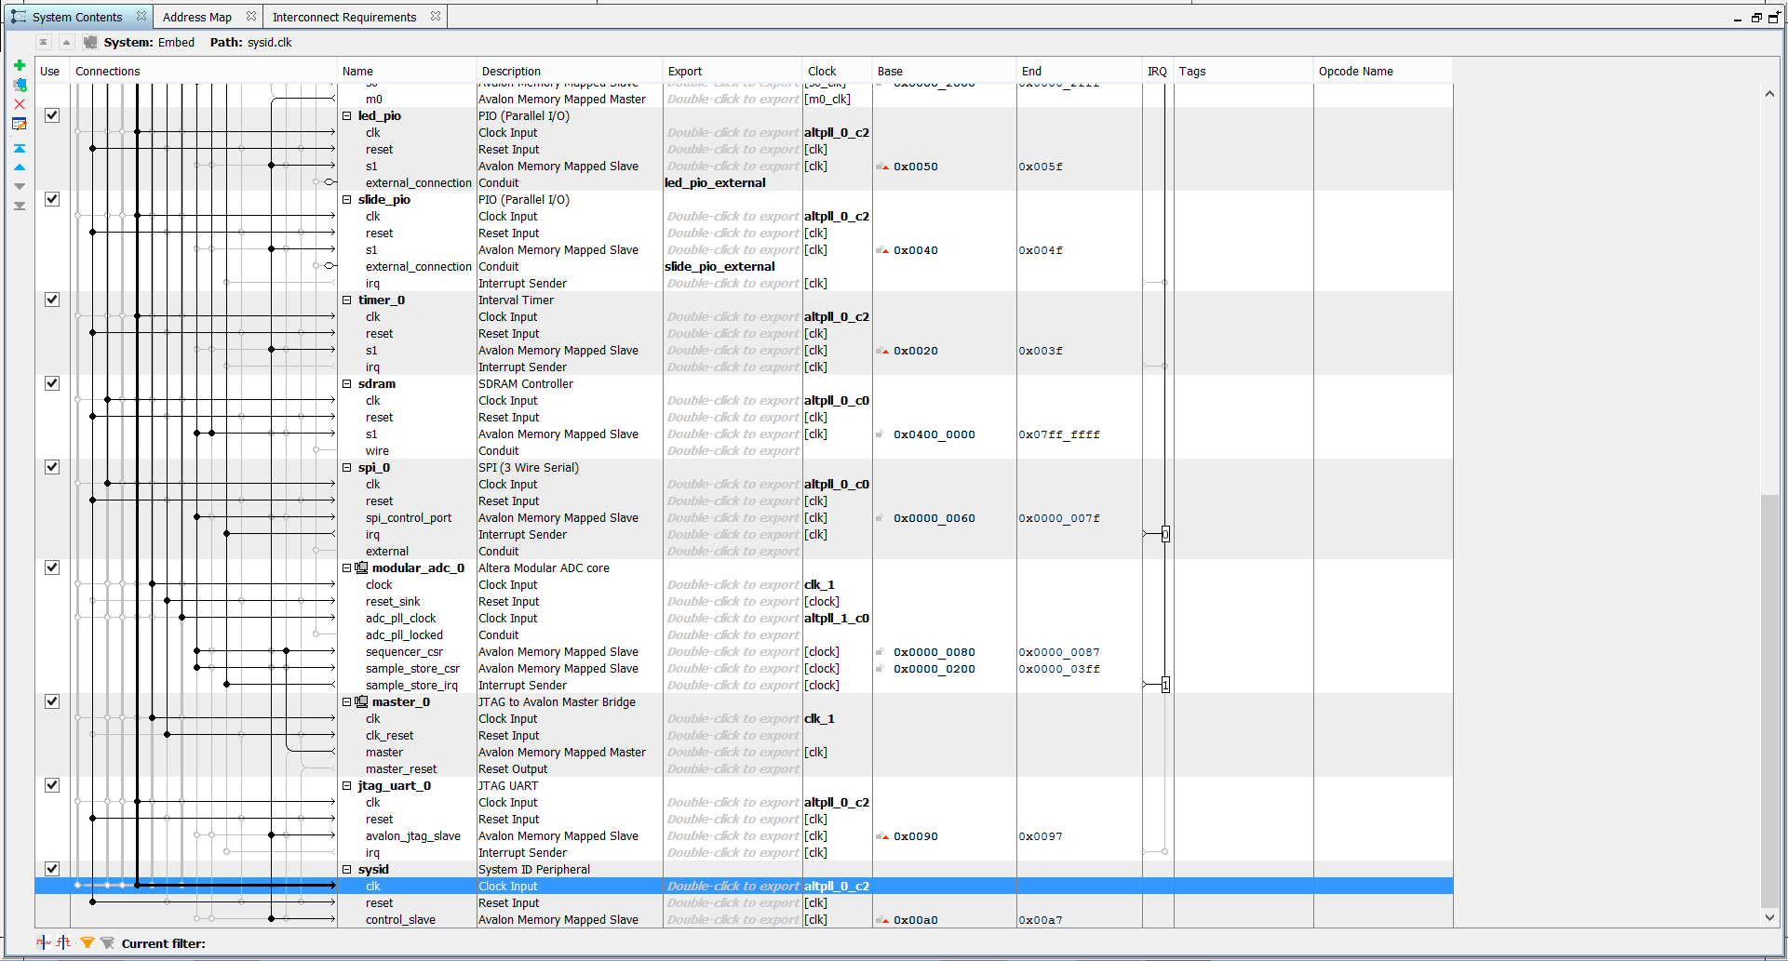

1. Confirm System Configuration.
2. **Clocks**: Only the alt_pll_0 should have clk_0, the external clock as an input in the clock column. Only the alt_pll_1, the ADC module, and JTAG Bridge should have clk_1, the external clock as an input in the clock column. Only the nios2 cpu, the SDRAM Controller, the SPI port, mm clock crossing bridge and onchip memories should use Alt PLL c0. All other components should use Alt PLL c2.
3. **Interrupt Request Lines**, or IRQs: In the IRQ column on the right, click on the circle by the timer IRQ to connect it to the processor, and label it 0. Then connect the JTAG UART IRQ with label 1, the adc IRQ with label 2, the SPI IRQ with label 3 and finally the slide PIO IRQ with label 4 for the priority.
4. **Create a Global Reset Network.**

Qsys provides the flexibility to connect individual resets to each of the components in the system. For our system, we simply want all components tied together. Qsys provides an easy menu item to do exactly this and will save us from having to manually connect the reset inputs to each component.

* From the **System** menu, choose **Create Global Reset Network**. The tool will automatically connect all the resets in the system together. This reset is generated by the processor, in a wired-or fashion combined with the external reset.

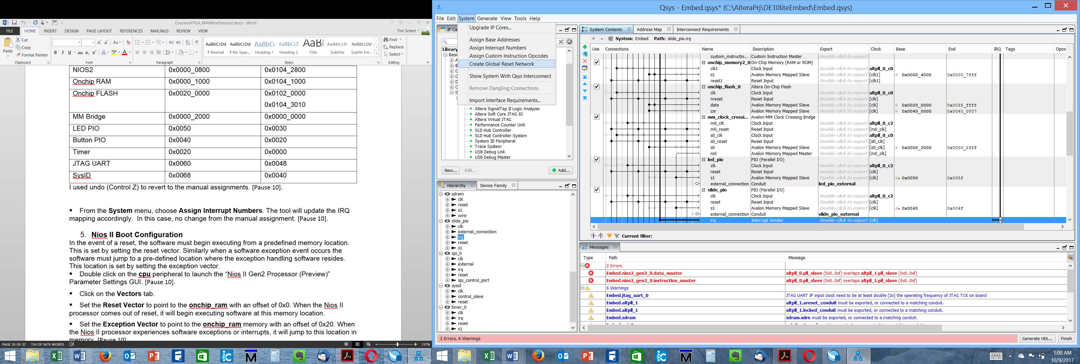

1. **Set Base Addresses and Interrupt Priorities**.

Qsys provides two easy menu items that help clean up address map issues and interrupt priority issues. Although we can enter them manually, we could have skipped this step and let Qsys automatically assign them. Either will work.

* From the **System** menu, choose **Assign Base Addresses**. The tool will assign appropriate base addresses for the components by taking their widths into consideration.

|  |  |  |
| --- | --- | --- |
| Component | Manual Base address | Automatic base address |
| Alt PLL 0 | 0x0000 | 0x0940_9220 |
| Alt PLL 1 | 0x0000 | 0x0940_9230 |
| NIOS2 | 0x0000_0800 | 0x0940_88000 |
| Onchip RAM | 0x0000_4000 | 0x0940_4000 |
| Onchip FLASH | 0x0020_0000 | 0x0920_0000  0x0940_9248 |
| MM Bridge | 0x0000_2000 | 0x0800_0000 |
| LED PIO | 0x0050 | 0x0020 |
| Slide PIO | 0x0040 | 0x0030 |
| Timer | 0x0020 | 0x0000 |
| SDRAM Controller | 0x0400_0000 | 0x0400_0000 |
| SPI Port | 0x0060 | 0x0940_9200 |
| ADC | 0x0080 and 0x0200 | 0x0940_9240 and 0x0940_9000 |
| JTAG UART | 0x0090 | 0x0048 |
| SysID | 0x00A0 | 0x0040 |

You could use undo (Control Z) to revert to the manual assignments, however I chose to keep the auto-generated ones. This eliminates the last error messages.

* From the **System** menu, choose **Assign Interrupt Numbers**. The tool will update the IRQ mapping accordingly.

1. **Confirm Nios II Boot Configuration.**

In the event of a reset, the software must begin executing from a predefined memory location. This is set by setting the reset vector. Similarly when a software exception event occurs the software must jump to a pre-defined location where the exception handling software resides. This location is set by setting the exception vector.

* Double click on the nios2 component to launch the “Nios II Gen2 Processor (Preview)” Parameter Settings GUI.
* Click on the Vectors tab.
* Set the Reset Vector to point to the onchip ram with an **offset** of 0x0. When the Nios II processor comes out of reset, it will begin executing software at this memory location.
* Set the Exception Vector to point to the onchip ram memory with an **offset** of 0x20. When the Nios II processor experiences software exceptions or interrupts, it will jump to this location in memory.

1. **Export Signals to the Top Level.**

To expose signals to the top level, they need to be exported. Several peripherals contain connections to pins on our device, which means that we need to “export” those connections out of Qsys. Qsys provides an Export column in which we can select which interfaces will be available for connections outside of this Qsys block.

We need to export the following interfaces by double-clicking in the Export column and then renaming the export name to match exactly so that the names of those signals match the top-level Verilog or VHDL file provided with this lab.

|  |  |  |
| --- | --- | --- |
| Component | Port to be exported | Export Name |
| alt_pll_0 | c1 | DRAM_CLK |
| alt_pll_1 | areset_conduit  locked_conduit | alt_pll_1_areset_conduit  alt_pll_1_locked_conduit |
| sdram | Wire | DRAM |
| spi_0 | External | GSENSOR |
| Led_pio | External_connection | LEDR |
| Slide_pio | External_connection | SW |

After completing these changes, your Qsys system should look like this:

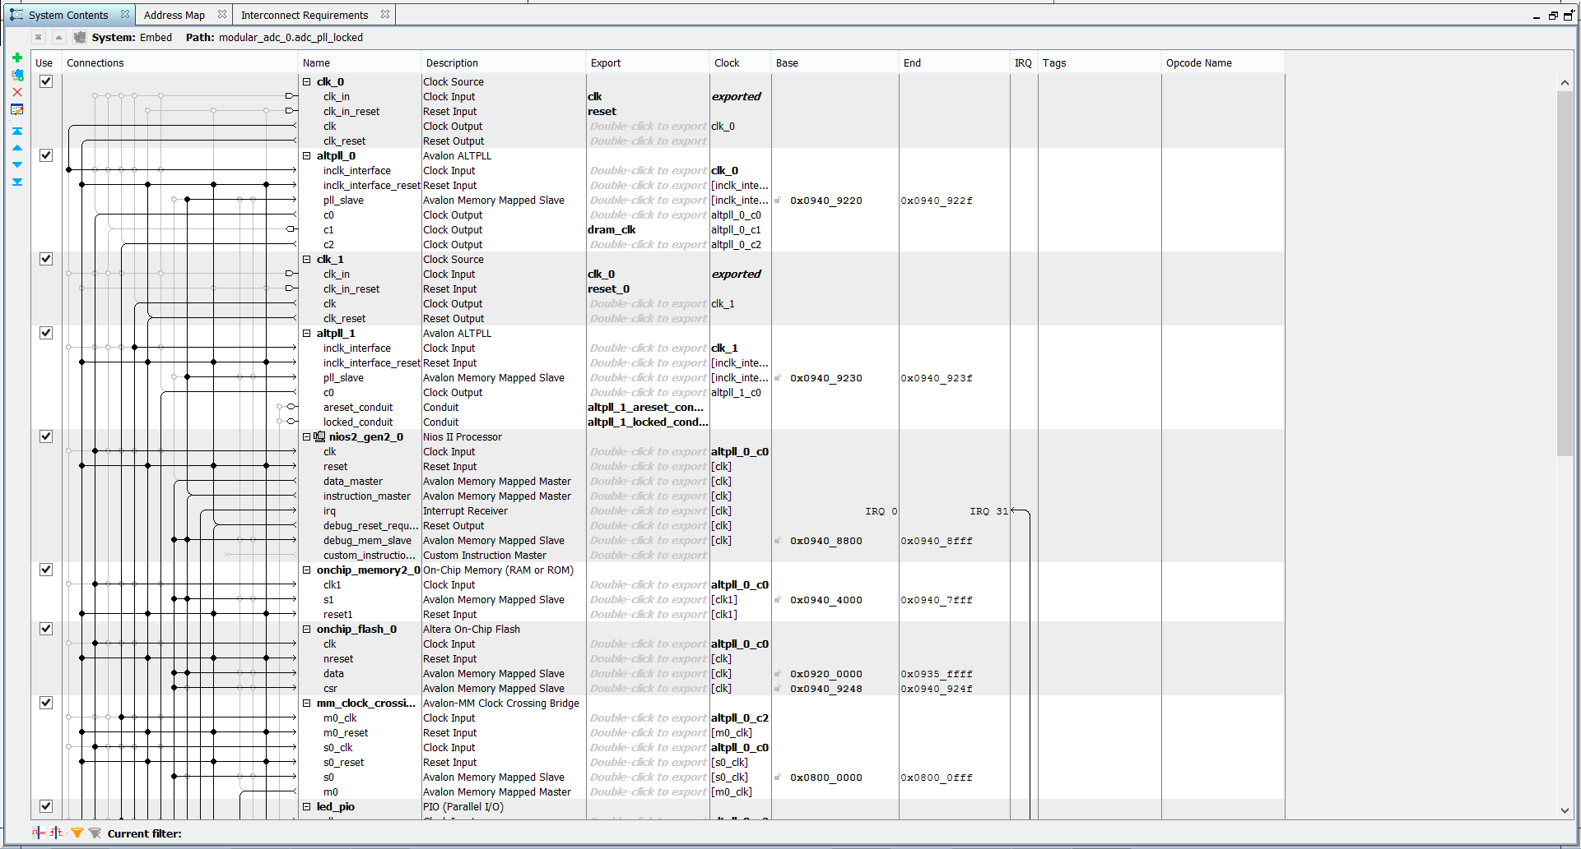

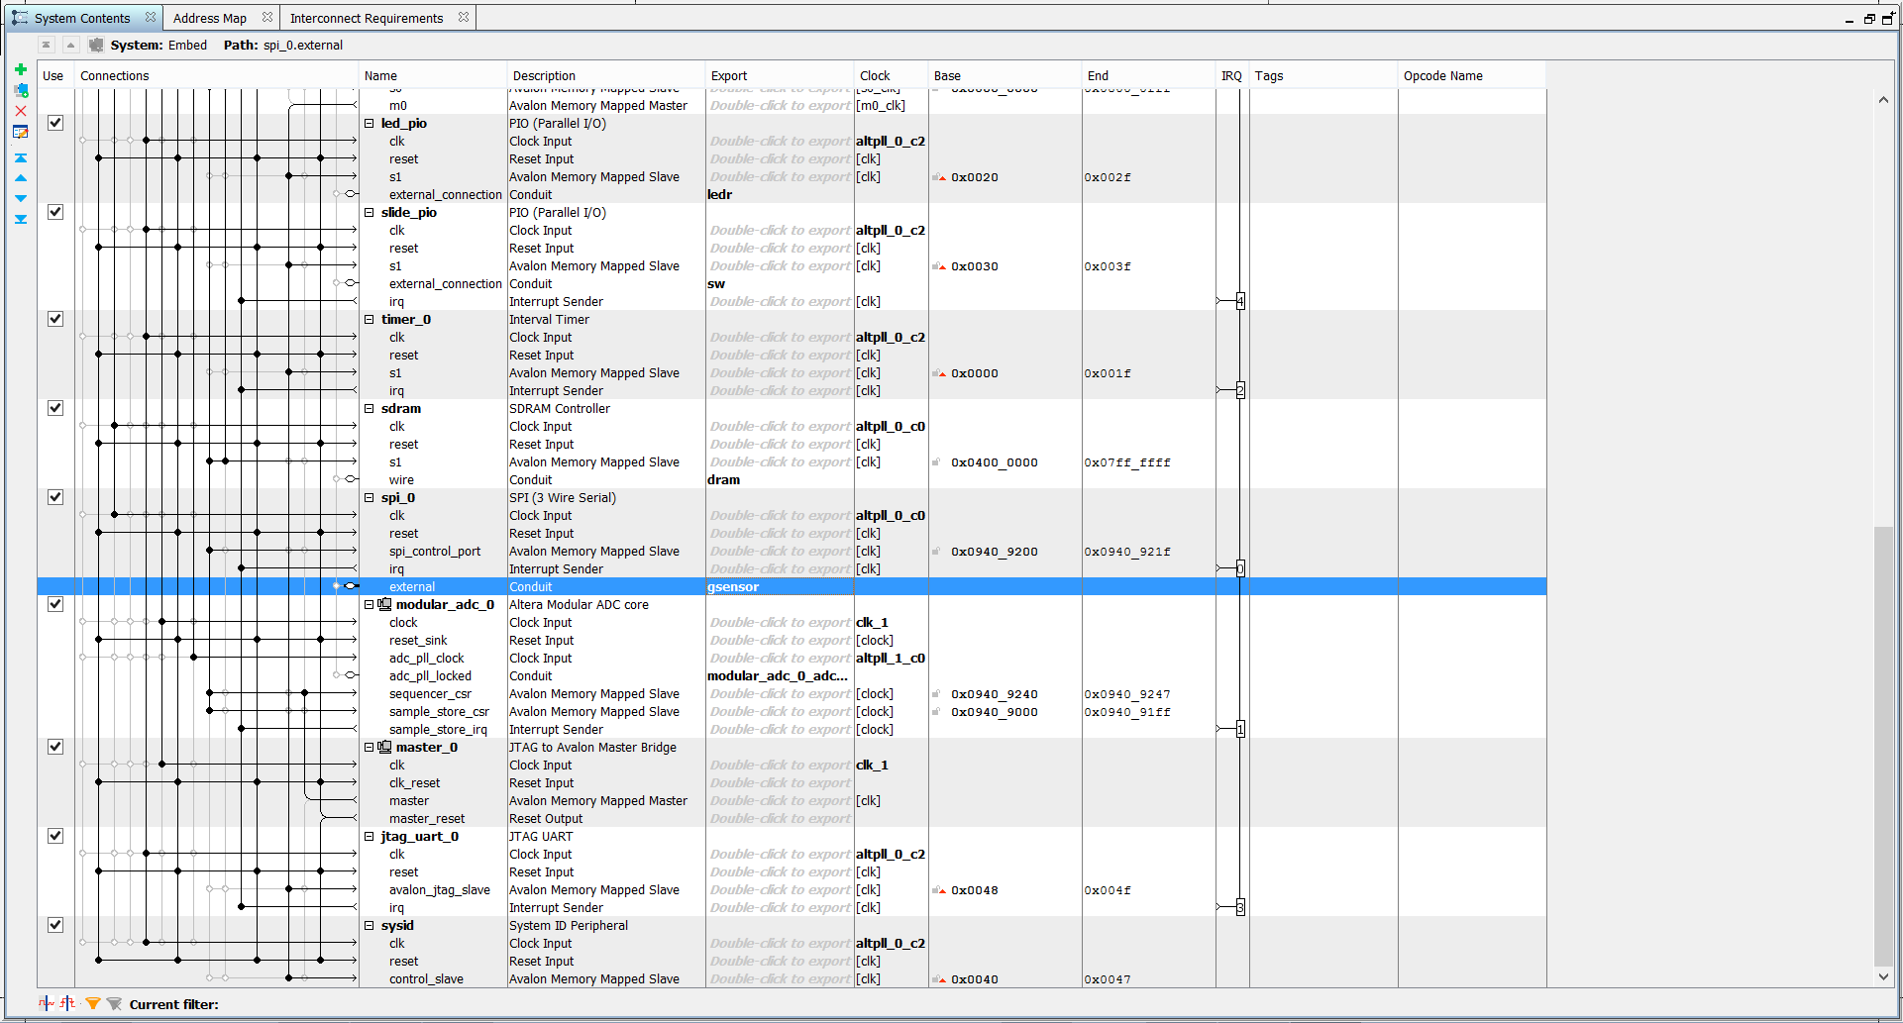

1. Click Generate HDL. Be sure the Create block symbol file box is checked.

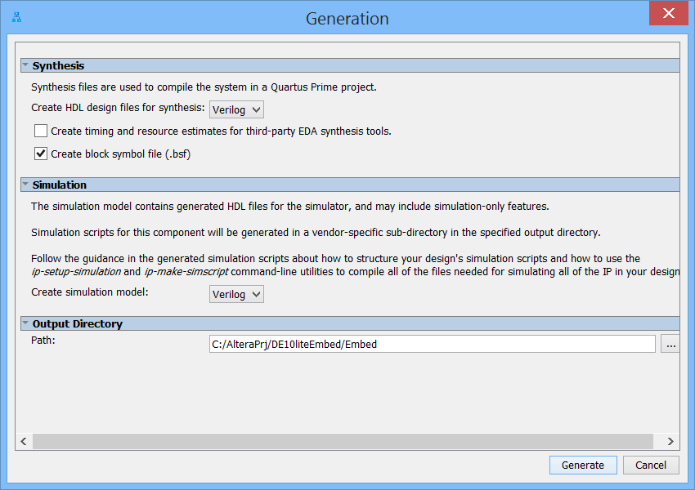

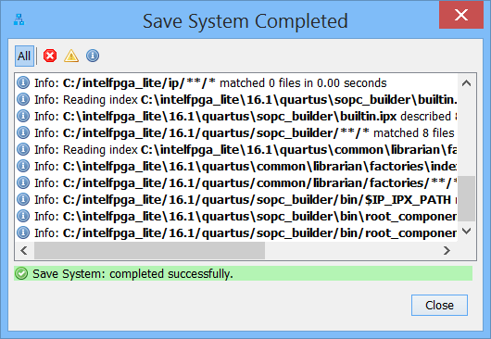

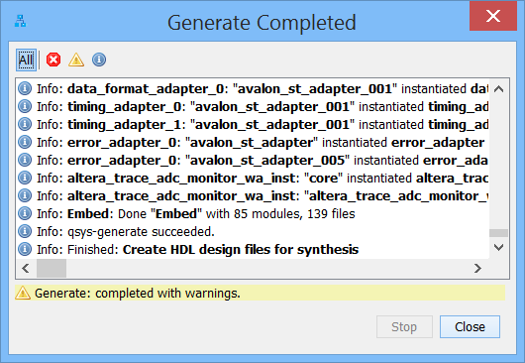

CONGRATULATIONS!! You have just built your custom processor Qsys system!

Now we can complete the Quartus project by adding the generated Qsys system to the top-level entity. We then Compile in the Quartus software to perform analysis, synthesis, fitting, place and route as well as timing analysis. At the end of the compilation, an FPGA image or SRAM object file (*.SOF) will be generated. The FPGA image can be downloaded to the DE10-Lite, at which point the on-board FPGA will function as a processor custom-made for your application.

An IP variation file is a file with extension of *.qip that is generated by Qsys systems (or also by standalone IP Catalog block). The *.qip file keeps track of the generated files so that your Quartus project can know what files are needed for FPGA compilation.

1. Save the Qsys system, and exit Qsys.
2. Back in Quartus, you may see a message to add the Embed.qip and Embed.sip files:

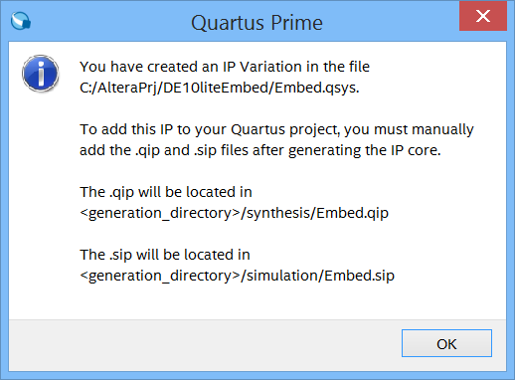

Do so by selecting Project – Add/Remove Files, and browse to

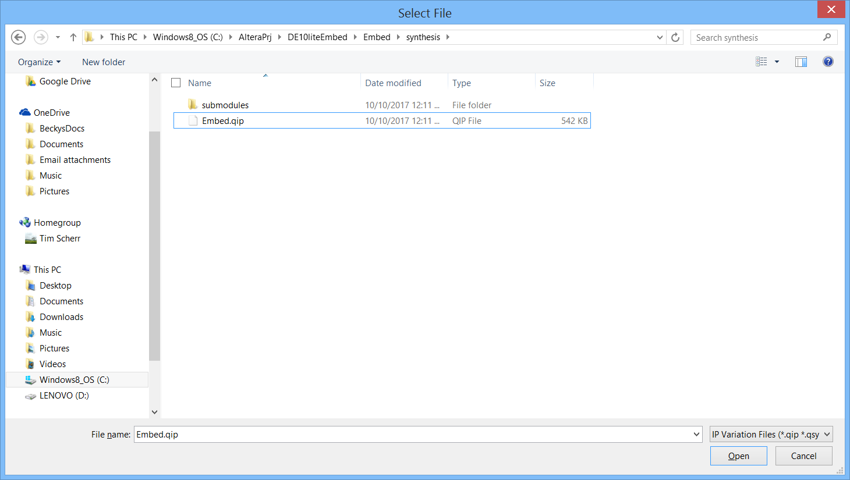

Click open, then apply and OK to add the .qip file.

## Instantiate the Qsys design into the top-level Verilog file.

The design uses several Verilog files which each define a design entity. The different design entities will need to be connected together to create our FPGA design. While the Verilog design entities can be connected together with Verilog code, another option exists in the Quartus software. Although is possible to create symbols for Verilog files and then be connected together using the Quartus schematic editor, this time we will use instantiation of the Qsys system into the top level Verilog file.

1. Now from the File Menu select Open, double click on Embed, and then select Embed_inst.v. Click on Open. This file should now be open in the main window; it was created by Qsys to aid in instantiating the nios2 processor system into your top level Verilog file.

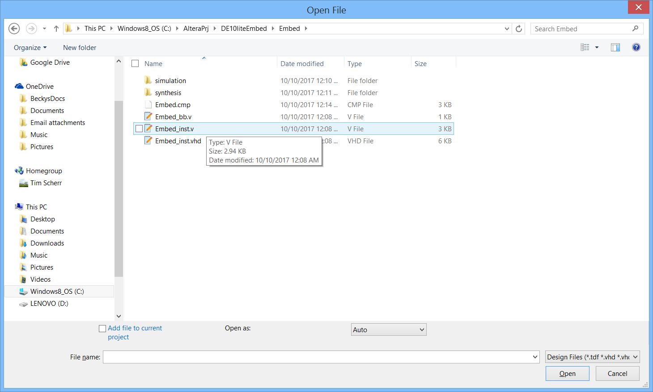

1. Click in this file, and hit control A and control C. Go back to DE10_LITE_Default.v, and paste this in before the endmodule. Now you will need to complete the instantiation by specifying the port signal connections. You will need to change Embed_u0 to u3 or another number to avoid conflicts with other instantiated units.

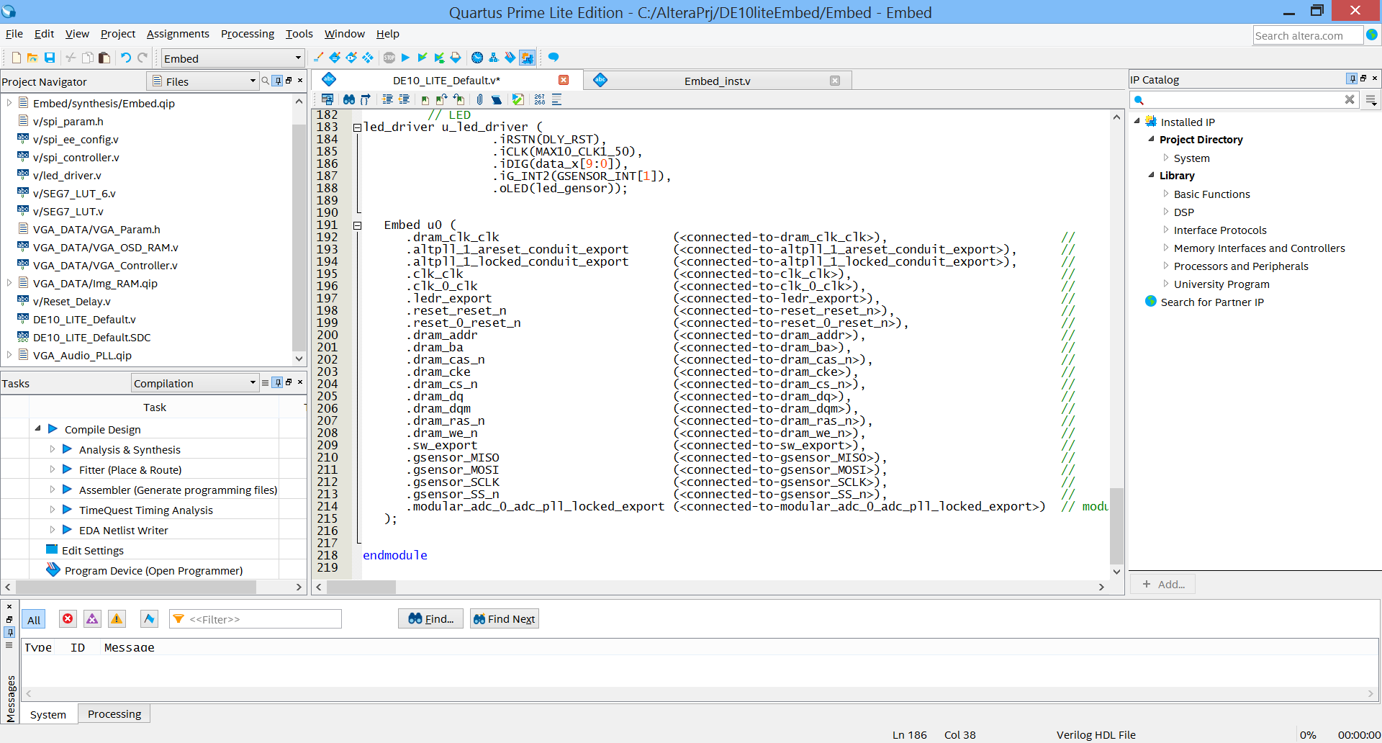

1. Replace all the connected-to parenthetic expressions as follows:

|  |  |
| --- | --- |
| From | To |
| <connected-to-dram_clk_clk> | DRAM_CLK |
| <connected-to-clk_clk> | MAX10_CLK1_50 |
| <connected-to-clk_0_clk> | ADC_CLK_10 |
| <connected-to-ledr_export> | LEDR |
| <connected-to-reset_reset_n> | ARDUINO_RESET_N |
| <connected-to-reset_0_reset_n> | ARDUINO_RESET_N |
| <connected-to-dram_addr> | DRAM_ADDR |
| <connected-to-dram_ba> | DRAM_BA |
| <connected-to-dram_cas_n> | DRAM_CAS_N |
| <connected-to-cke> | DRAM_CKE |
| <connected-to-cs_n> | DRAM_CS_N |
| <connected-to-dq> | DRAM_DQ |
| <connected-to-dqm> | DRAM_LDQM |
| <connected-to-ras_n> | DRAM_RAS_N |
| <connected-to-we_n> | DRAM_WE_N |
| connected-to-sw_export | SW |
| connected-to-gsensor_MISO | GSENSOR_SDI |
| connected-to-gsensor_MOSI | GSENSOR_SDO |
| connected-to-gsensor_SCLK | GSENSOR_SCLK |
| connected-to-gsensor_SS_n | GSENSOR_CS_N |
| connected-to-modular_adc_0_adc_pll_locked_export | ARDUINO_IO[1] |
| connected-to-altpll_1_areset_conduit_export | ARDUINO_IO[2] |
| connected-to-altpll_1_locked_conduit_export | ARDUINO_IO[3] |

1. You will also need to comment out the LEDR assignment statement and spi_ee_config block. Add an assign DRAM_UDQM = DRAM_LDQM;
2. Go to the **File** menu and select **Save** to save the changes you have made to the top-level Verilog file. Run an Analysis and Elaboration (or Analysis & Synthesis).

CONGRATULATIONS!!

**You’ve completed the design entry your custom processor system!**

# Placing and Routing the Design

Section Objective: In this section you will do a full compilation on your Embedded System design. An sdc file was provided and included in the project, and Qsys also generates constraints, so we have not entered timing constraints as one normally would.

1. Double click on Compile Design in the Task window. You should see a result something like this, with all the green checkmarks in the Task window:

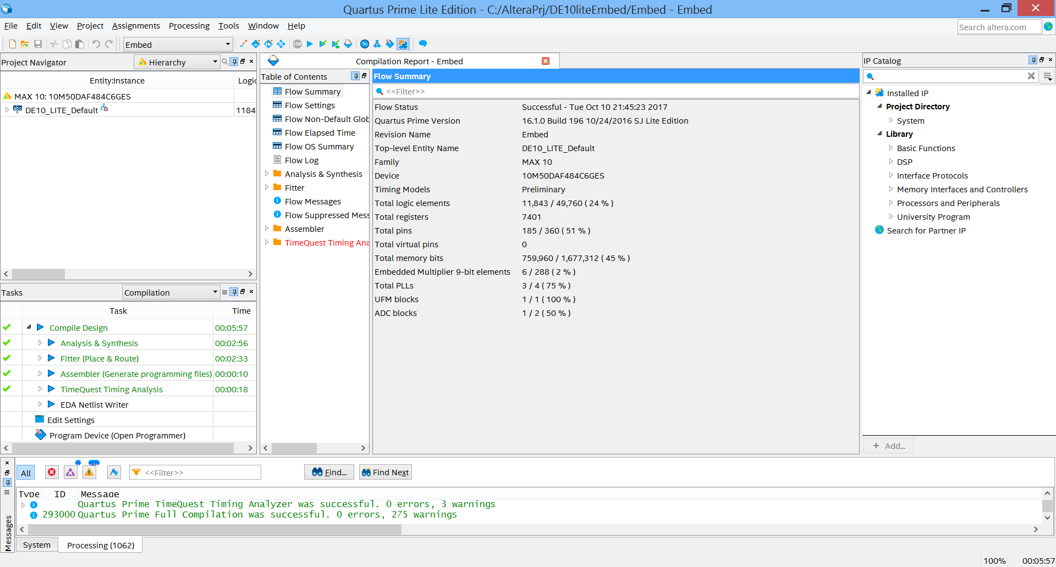

1. When compilation complete, look at the Flow Messages. Note that there are tabs at the top of the messages window that allow you to filter by message type.
2. Look at the TimeQuest Timing Analyzer, Slow 1200mV 85C Model, Fmax Summary to determine the Fmax. Not that the TimeQuest result is in red because we have not yet constrained all the ports. This is not a concern for now.
3. Look at the Flow summary to determine the total registers (Flip-Flops) and % utilization of logic elements.

**CONGRATULATIONS!!**

**You have just placed and routed your FPGA design.**

# Programming the Hardware and Testing the Design

The MAX10 is unique to Altera in that it has internal FLASH memory for configuration, and so there are 2 ways to program it. On is with JTAG as with other FPGAs using a .sof file directly to the SRAM configuration cells, and the other also uses JTAG but programs the configuration flash memory, which is transferred to the SRAM configuration cells on power up. JTAG programming requires a programming cable, like a USB Blaster II or Ethernet Blaster II.



## Programming the DE10-lite

After Compilation, do the following to program the board:

1) Connect the USB cable to your DE10-Lite kit.

2) Plug the other end of the USB cable to a USB port of your computer.

3) Launch the Quartus Programmer, via the icon or through the Tools menu (**Tools -> Programmer**)

4) Setup the programming hardware. To do this, click the hardware setup button in the upper left corner of the programmer, and select the hardware you want to use. Choose USB Blaster in the Hardware Setup Dialog.

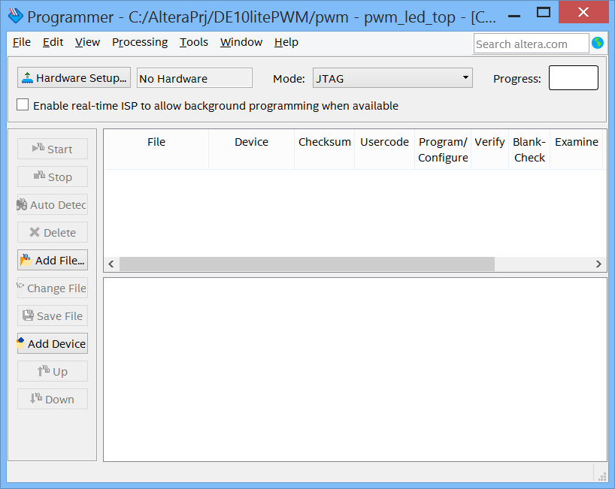

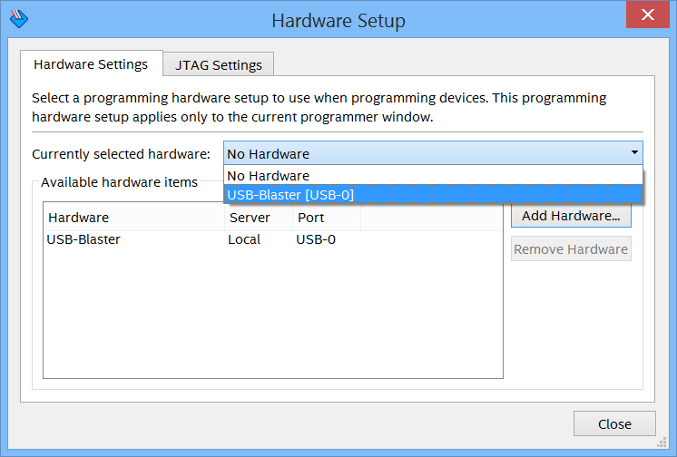

Close the Dialog Box and your setup should appear as this:



A programming device must have drivers installed and be detected correctly to be listed. Next select the programming mode – the most common is JTAG. The JTAG chain can consist of both non-Altera and Altera devices.

Once the hardware is setup, a toolbar in the programmer provides all the commands needed to control the programming of devices. For example, the order of programming devices on the chain can be arranged. Other common operations include Auto detect, in which the chain is scanned and devices found is reported, and change file, which selects a new file to program into the selected target device. Clicking on Auto Detect makes the programmer show the device chain:

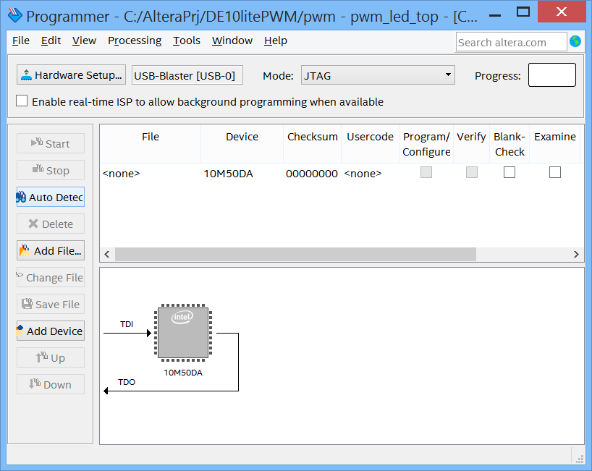

You can also verify a device after it has been programmed, or blank check a device, erase a device, or set a security bit if available.

5) To select the programming file, click Add File, in this case Embed.sof.

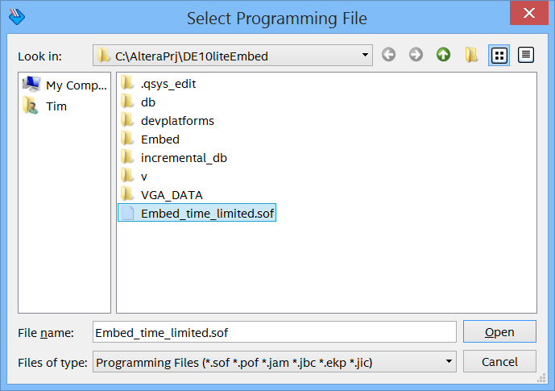

Click Open. Back in the programming window, you may have to delete any other entries that are listed.

6) When all the devices are defined and options set correctly, click on Start in the upper left. The progress bar shows the status of the programming and the messages windows provides detailed status, and information about any errors that may occur. When the progress bar reaches 100%, the programming is complete.

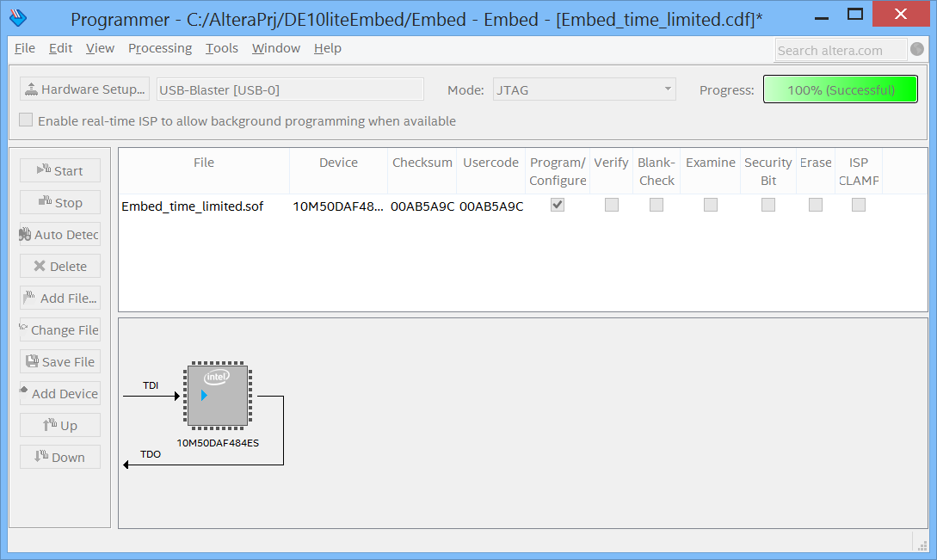

Unless you have a license for the Nios II processor, you will obtain a message about a time-limited megafunction. This message indicates that since you do not have a license for the Nios II processor, operation will occur in “OpenCore Plus” evaluation mode. OpenCore Plus allows for tethered or time-limited evaluation prior to purchasing a license.

o ***PLEASE NOTE:*** *OpenCore Plus evaluation mode prevents us from programming the flash of the MAX 10 device and evaluation must occur by programming the FPGA SRAM from the Quartus Programmer each time the kit is powered up using the .sof file.*

If you are running with a time-limited SOF file, then a window pops up on the Quartus Programmer. Just leave this up and ***do not press “Cancel”*** until you are finished using the hardware design that you just downloaded. Closing this dialog will halt the Nios II CPU inside the FPGA.

Preparation for Software Build

The Nios II software build tool requires certain component names to be exact, different than what has been created thus far. To be compliant with the EDS, do the following:

1. In Qsys, rename onchip_memory2_0 to onchip_ram.
2. Also rename jtag_uart_0 to jtag_uart.
3. Double-click on the nios2 component, and on the Vectors tab, change the Reset vector memory to onchip_ram.s1, and the Exception Vector memory to onchip_ram.s1.
4. Save the Qsys system.
5. Select Generate HDL, and then click Generate as before.
6. In Quartus, Compile the design as in section 4. Check to be certain you do not have hold or setup violations. If this is the case, you may have to adjust compiler settings. You should not have to run Timequest.
7. Open the programmer, and program the FPGA with the Embed_time_limited.sof file.

# 6. Build the Software Application

**Module Objective**

In this module you use the Nios II Software Build Tools (SBT) for Eclipse to develop the software application that will run on your system. You will create a new software application project, add the software source files to the project, configure the project and build it. The result of the build is an executable (ELF). The application will be downloaded into memory from where it will be executed.

Before you begin with the tools, unzip the EmbedSoft.zip file into the project directory. This should create a directory called Source.

Launch the Nios II Software Build Tools for Eclipse

Launch the Nios II SBT from the **Start -> All Programs -> Intel FPGA 16.1.0.196 Lite Edition -> (64-bit) -> Nios II 16.1 Software Build Tools for Eclipse** or alternatively it can be launched from the **QSys -> Tools** menu.

## 6.1 Initialize Eclipse workspace

When Eclipse first launches, a dialogue box appears asking what directory it should use for its workspace. It is useful to have a separate Eclipse workspace associated with each hardware project that is created in QSys.

▪ **Browse** to the directory that you created the Quartus II project in and click **Make New Folder** to create a folder for your software project. Name the folder “**eclipse_workspace**”.

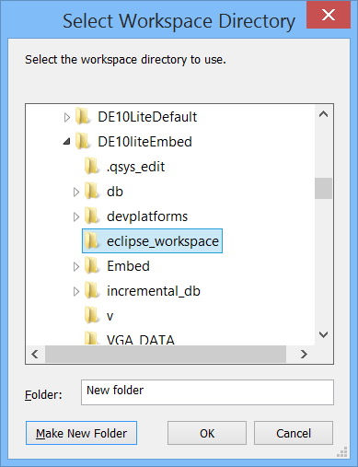

After selecting the workspace directory, click “**OK**” and Eclipse will launch and the workbench will appear in the Nios II perspective.

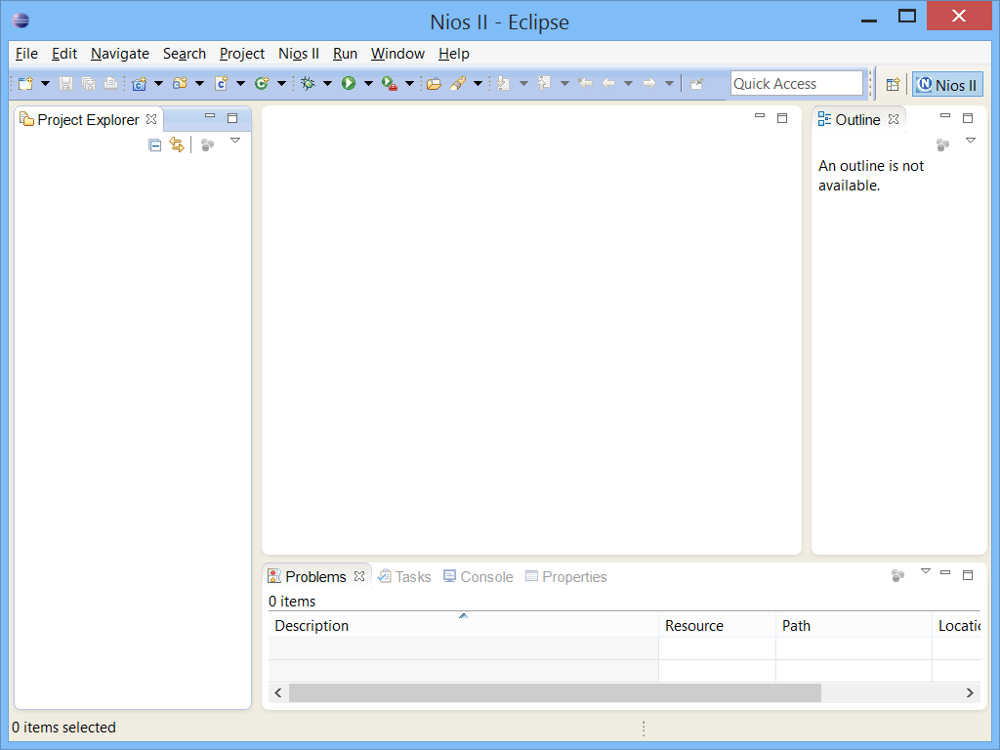

## 6.2 Create a new software project in the SBT

Select **File -> New** -> **Nios II Application and BSP from Template**.

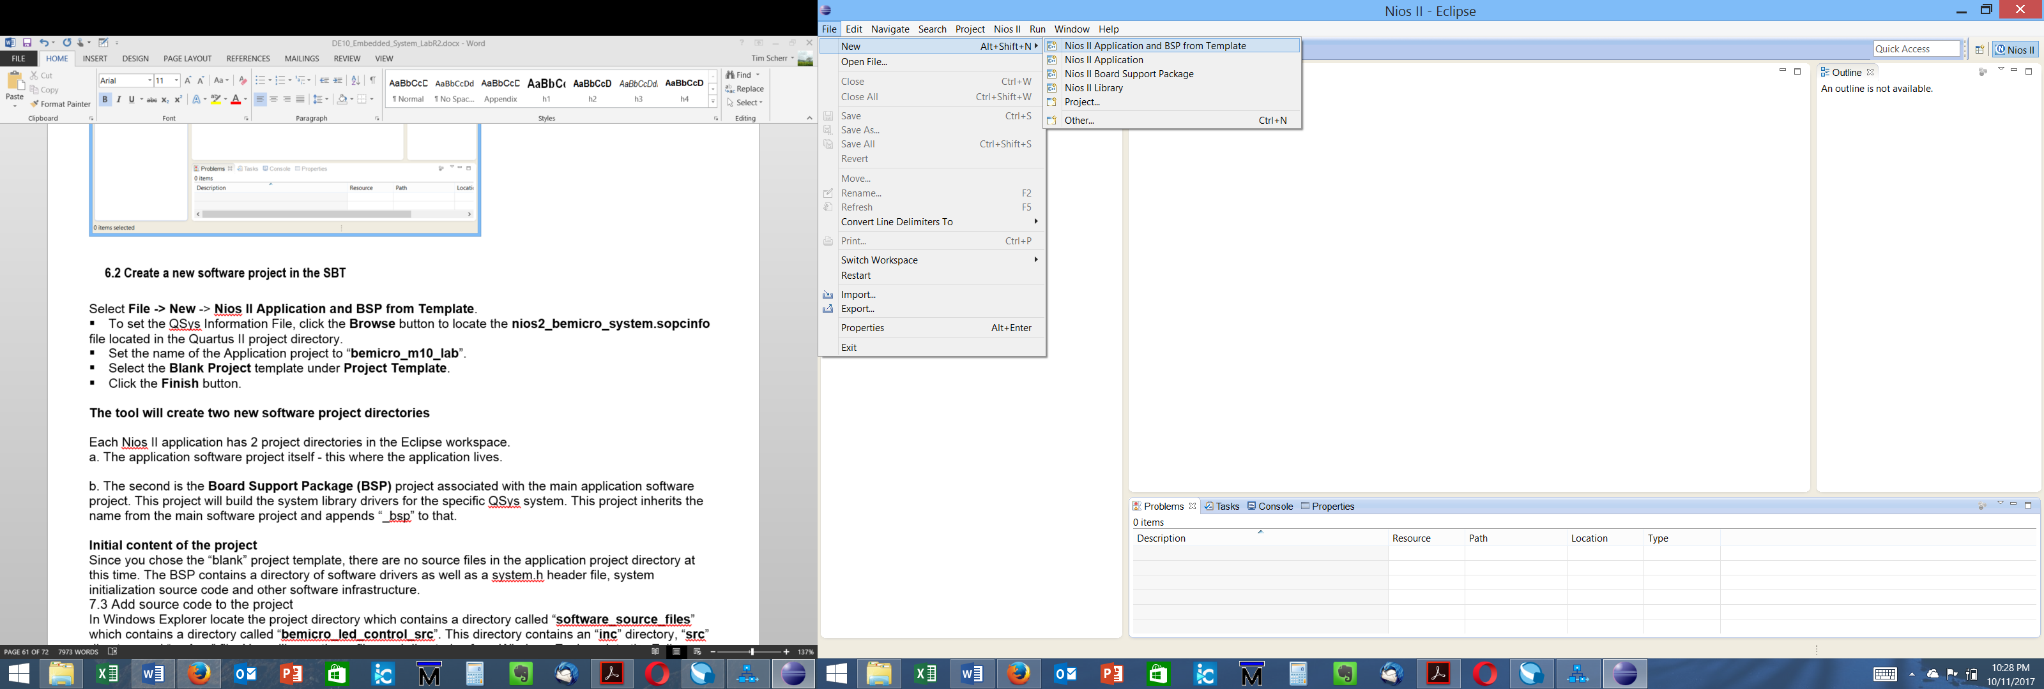

▪ To set the QSys Information File, click the **Browse** button to locate the **Embed.sopcinfo** file located in the Quartus project directory.

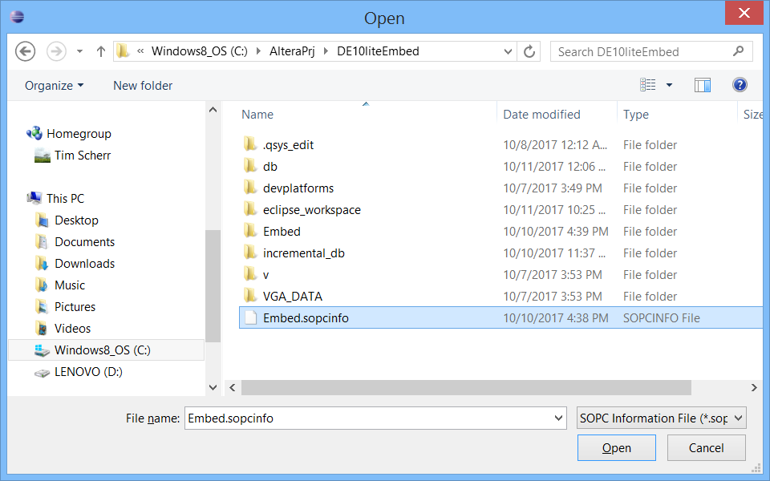

▪ Set the name of the Application project to “**Embed_System**”.

▪ Select the **Blank Project** template under **Project Template**.

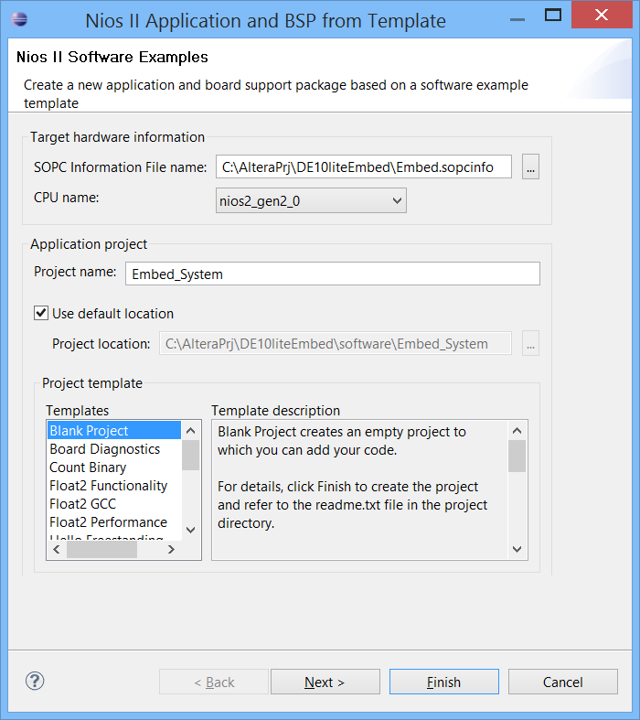

▪ Click the **Finish** button.

The tool will create two new software project directories

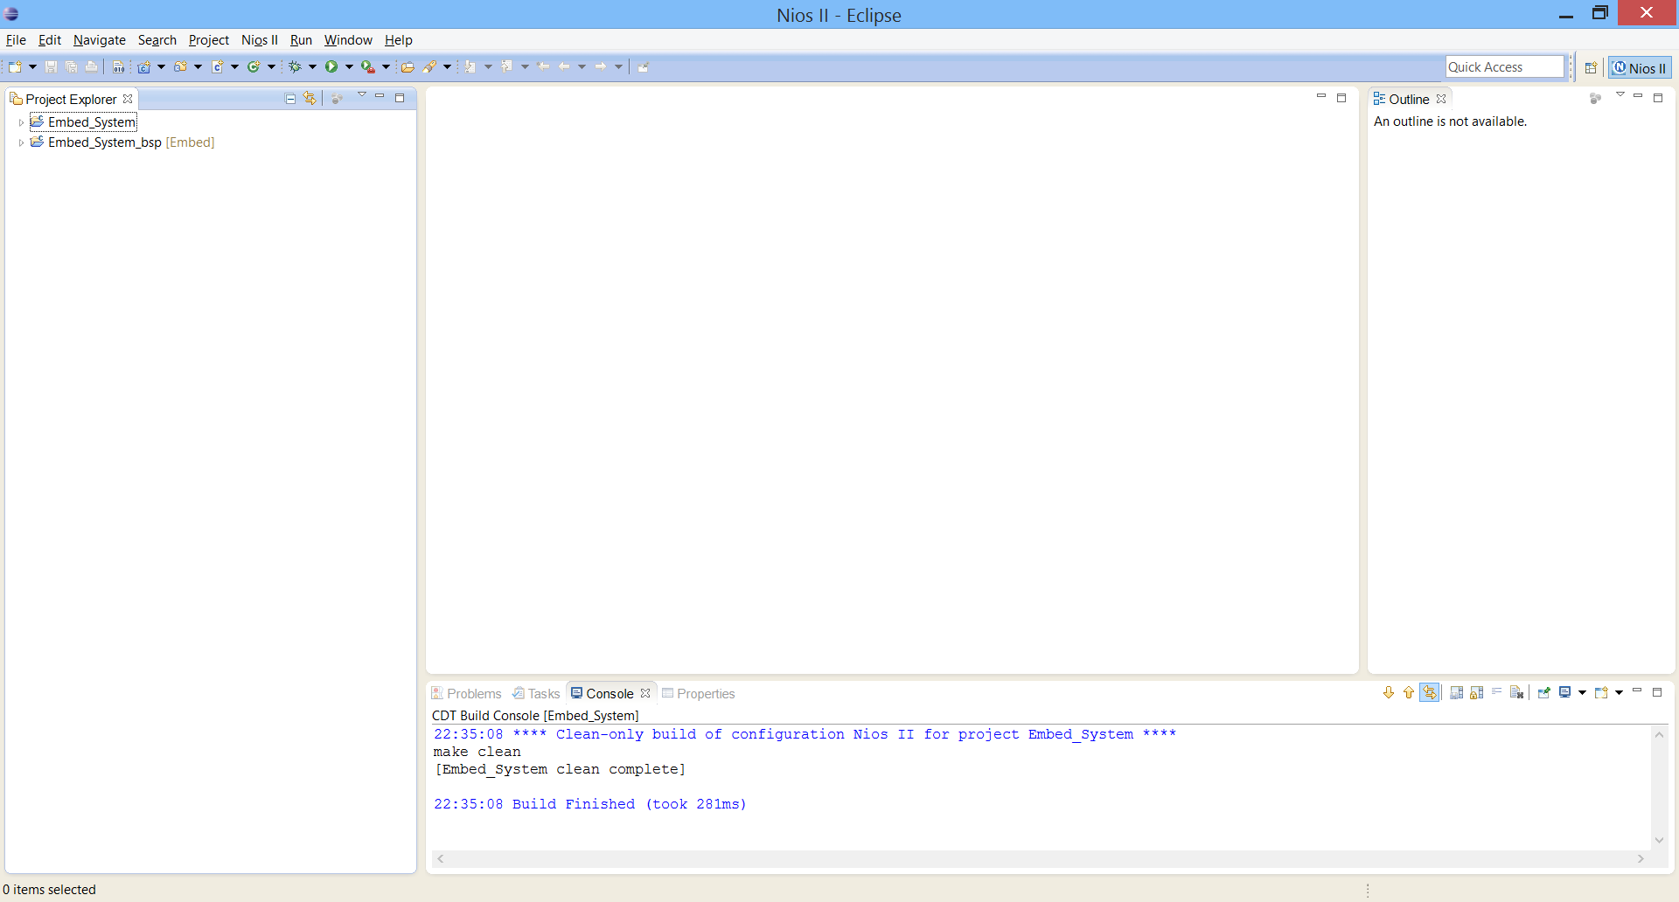

Each Nios II application has 2 project directories in the Eclipse workspace.

a. The application software project itself - this is where the application lives.

b. The second is the **Board Support Package (BSP)** project associated with the main application software project. This project will build the system library drivers for the specific QSys system. This project inherits the name from the main software project and appends “_bsp” to that.

**Initial content of the project**

Since you chose the “blank” project template, there are no source files in the application project directory at this time. The BSP contains a directory of software drivers as well as a system.h header file, system initialization source code and substantial other software infrastructure.

## 6.3 Add source code to the project

In Windows Explorer locate the project directory which contains a directory called “**source**”. This directory contains an “**inc**” directory, “**src**” directory and “**main.c**” file. You will copy these files and directories from Windows Explorer into the Eclipse software project directory, “Embed_System”.

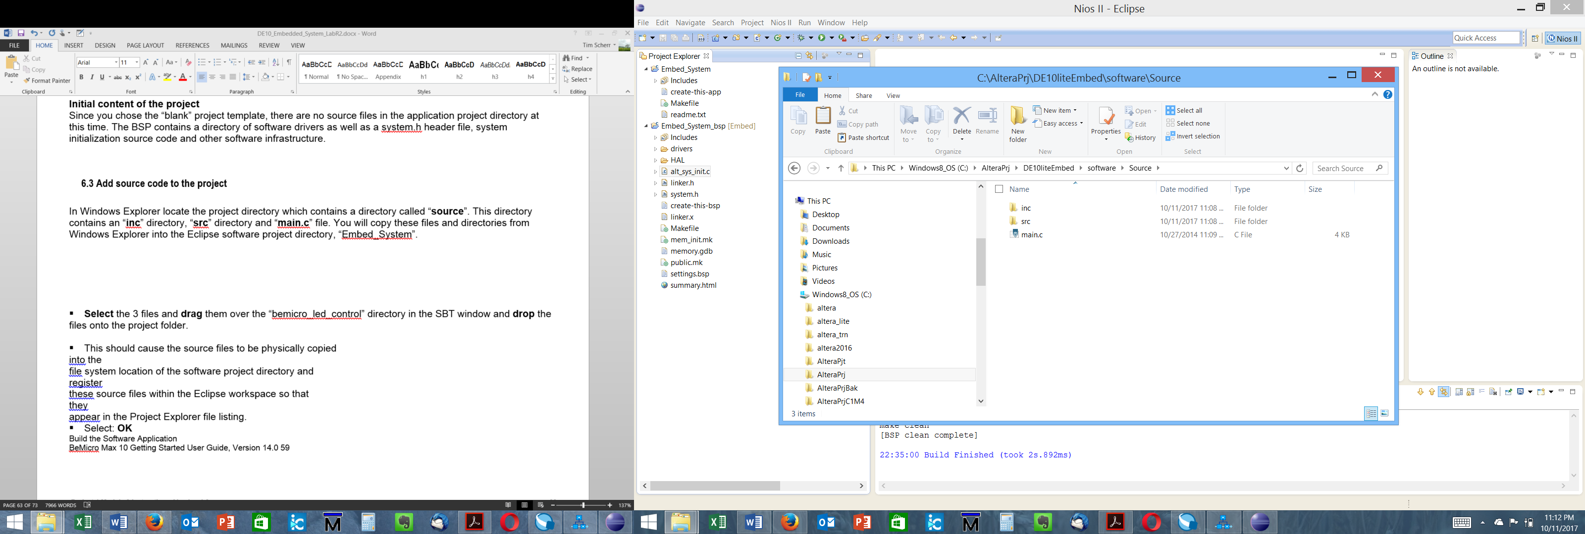

▪ **Select** the 3 files and **drag** them over the “Embed_System” directory in the SBT window and **drop** the files onto the project folder.

▪ This should cause the source files to be physically copied into the file system location of the software project directory and register these source files within the Eclipse workspace so that they appear in the Project Explorer file listing.

▪ Select: OK if it asks you to Copy files and folders.

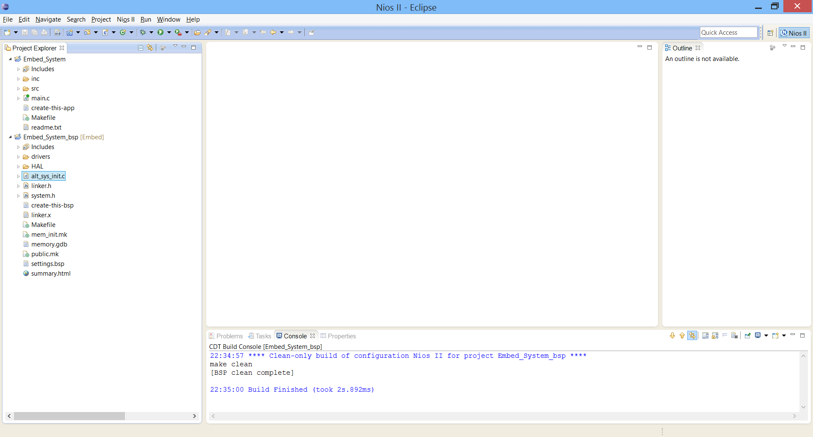

## 6.4 Configure Board Support Package

▪ Configure the board support package to specify the properties of this software system by using the BSP Editor tool. These properties include what interface should be used for stdio and stderr messages, which memory should stack and heap be allocated in and whether an operating system or network stack should be included with this BSP.

▪ Right click on the **Embed_System_bsp** project and select **Nios II -> BSP Editor…** from the right-click menu.

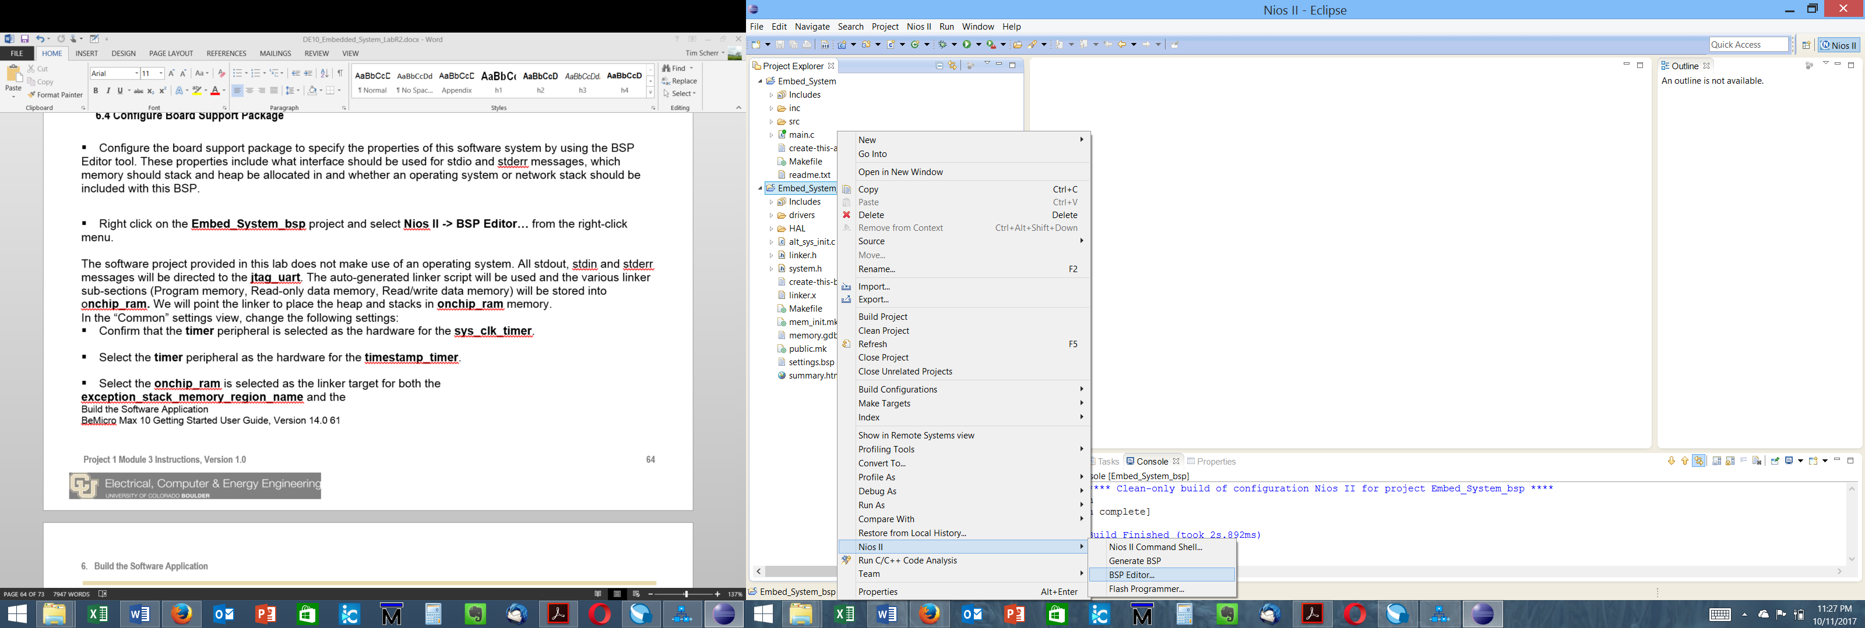

The software project provided in this lab does not make use of an operating system. All stdout, stdin and stderr messages will be directed to the **jtag_uart**. The auto-generated linker script will be used and the various linker sub-sections (Program memory, Read-only data memory, Read/write data memory) can be stored into sdram or onchip RAM in **onchip_ram.** We will point the linker to place the stack and exception vectors in **onchip_ram** memory.

In the “Common” settings view, change the following settings:

▪ Confirm that the **timer_0** peripheral is selected as the hardware for the **sys_clk_timer**.

▪ Select the **timer_0** peripheral as the hardware for the **timestamp_timer**.

▪ Select the **onchip_ram** is selected as the linker target for both the **exception_stack_memory_region_name** and the **interrupt_stack_memory_region_name**.

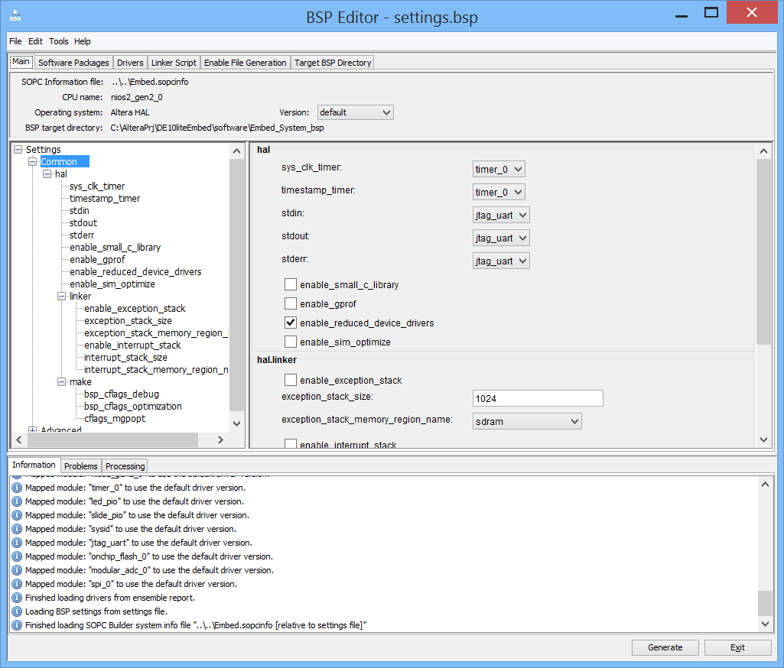

You may wish to click on the **Drivers** tab to observe how the BSP Editor gives you control over what drivers will be built into your Board Support Package. Similarly, you may wish to look over the **Linker Script** tab to observe how the BSP Editor provides you with a mechanism to adjust what memory regions the linker will utilize. In the case of this lab, we have two volatile memories in the system, so we will use this handy tool to adjust all the stack memory region to on chip ram instead of the sdram. It would be possible to assign all the memory regions to onchip ram, but to do so we would have to make the onchip ram larger than 16k.

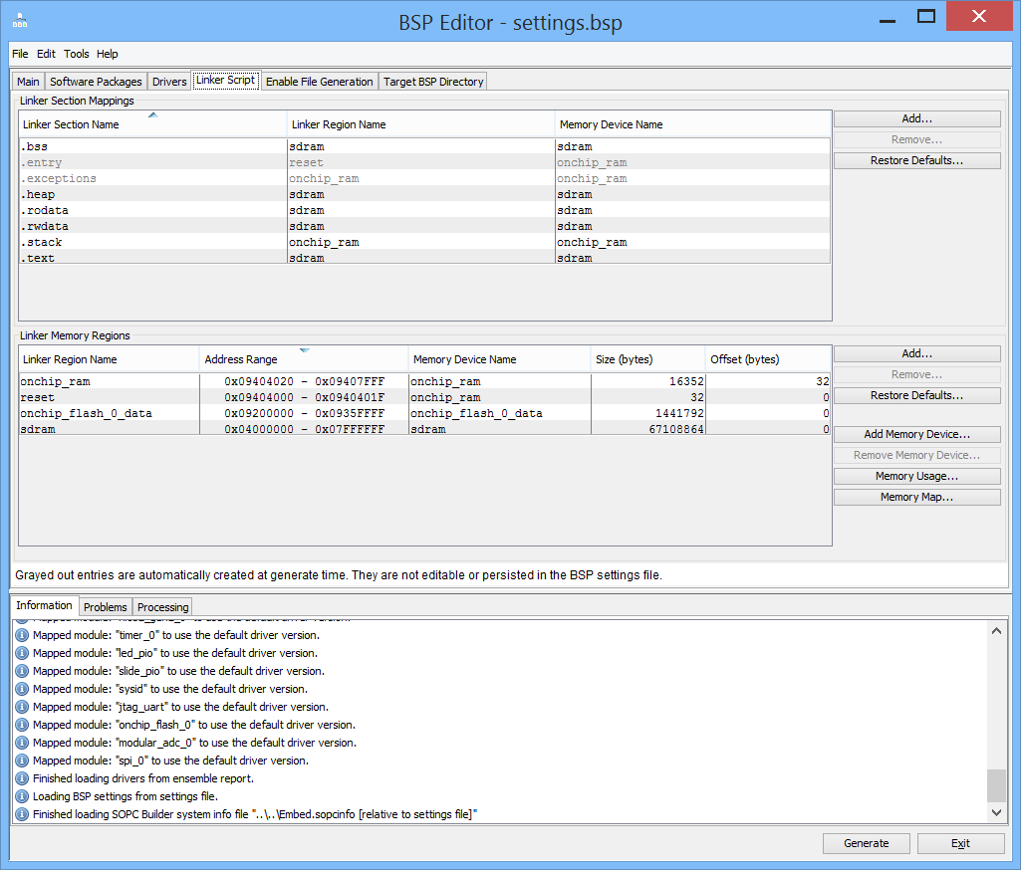

▪ Select **File** -> **Save** to save the board support package configuration to the **settings.bsp** file.

▪ Click the **Generate** button to update the BSP.

▪ When the Generate has completed, select **File** -> **Exit** to close the BSP Editor.

## 6.5 Configure BSP Project Build Properties

In addition to the board support package settings configured using the BSP Editor, there are other compilation settings managed by the Eclipse environment such as compiler flags and optimization level.

▪ **Right click** on the **Embed_System_bsp** software project and select **Properties** from the right-click menu.

▪ On the left-hand menu, select the **Nios II BSP Properties** tab

▪ During compilation, the code may have various levels of optimization which is a tradeoff between code size and performance. Change the **Optimization level** setting to **Level 2**.

▪ To keep the software footprint compact, choose **Reduced device drivers**.

▪ Since our software does not make use of C++, **uncheck** “**Support C++**”.

▪ Click **Apply**. Click **OK**.

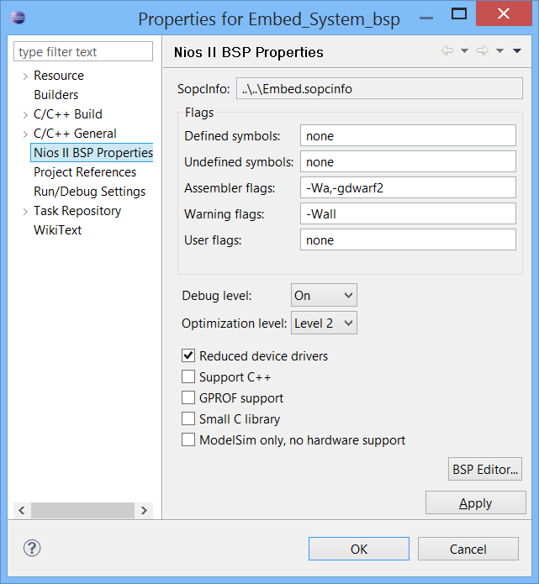

## 6.6 Configure Application Project Build Properties

Just as you configured the optimization level for the BSP project, you should set the optimization level for the application software project “Embed_System” as well.

▪ **Right click** on the **Embed_System** software project and select **Properties** from the right-click menu.

▪ On the left-hand menu, select the **Nios II Application Properties** tab

▪ Change the **Optimization level** setting to **Level 2**.

▪ Click **Apply**. Click **OK**.

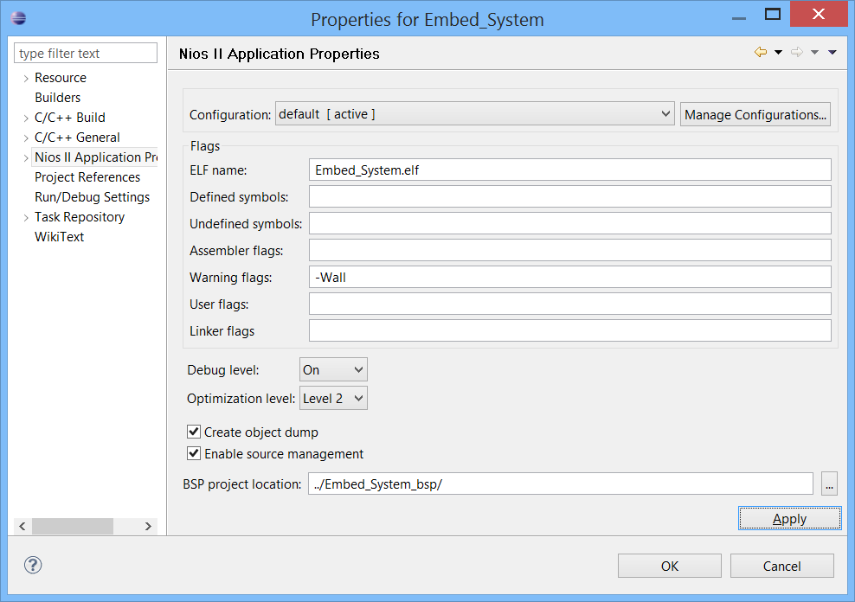

## 6.7 Build the software project

▪ **Right click** the **Embed_System_bsp** software project and choose **Build Project** to build the board support package.

▪ When that build completes, **right click** the **Embed_System** application software project and choose **Build Project** to build the Nios II application.

These 2 steps will compile and build the associated board support package, then the actual application software project itself. The result of the compilation process will be an Executable and Linked Format file for the application, the (*.elf) file.

## 6.8 Run the software application on the target

To run any application on the target hardware, two images are needed

* The FPGA hardware image SRAM Object File <.SOF>.
* The software executable the <.ELF>.

In the previous module you already downloaded the .SOF, so the FPGA is primed and ready to run the software application. Keeping the DE10-Lite kit still plugged into the USB port, you will download the application via the USB-JTAG link. To run the software project on the Nios II processor:

* **Right click** on the software project directory and choose **Run As** and **Nios II Hardware**.

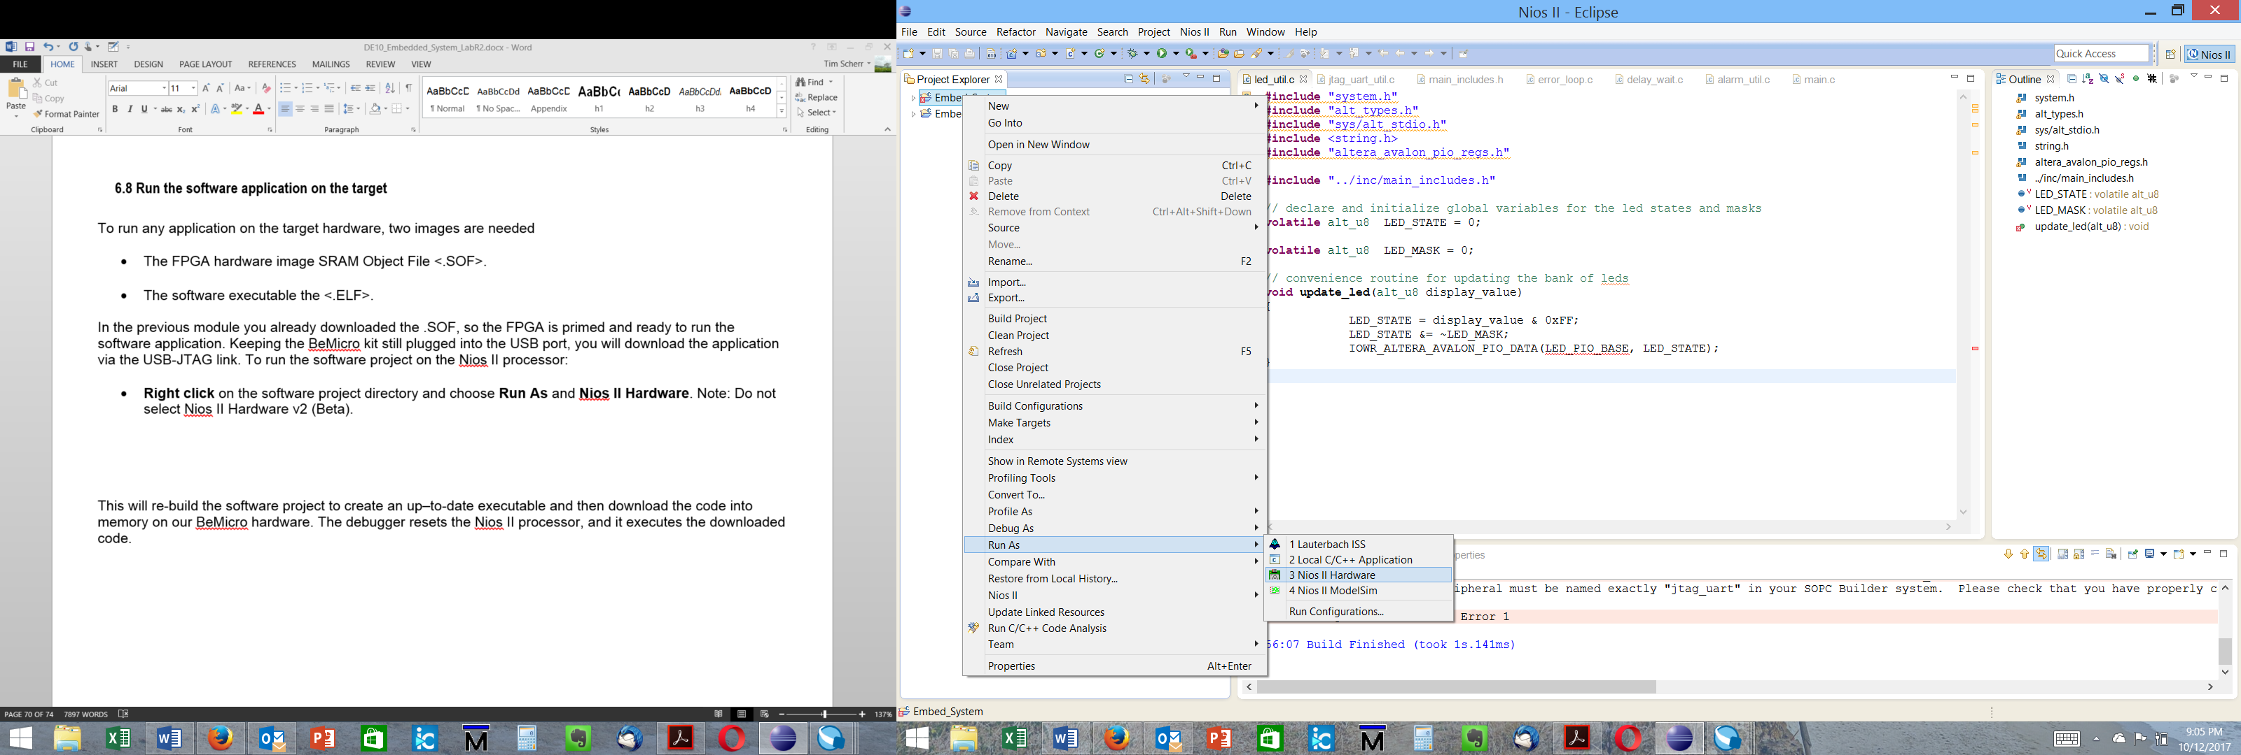

This will re-build the software project to create an up–to-date executable and then download the code into memory on our DE10-Lite hardware. The debugger resets the Nios II processor, and it executes the downloaded code.

You may see a window indicating no connection was found:

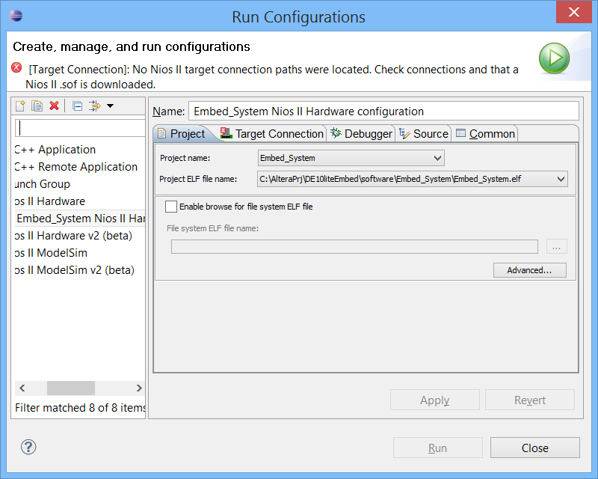

Note: Do not select Nios II Hardware v2 (Beta). Click on the target connections tab, Click on Refresh Connections and then hit Run,

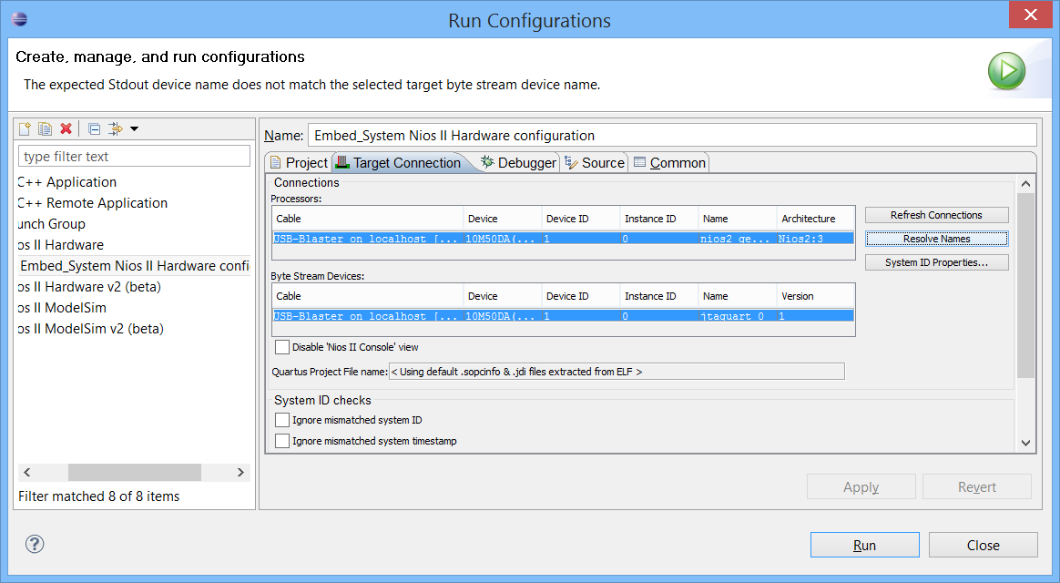

## 6.9 Software Application Output

Once the application starts executing, it will relay the messages back to the Nios SBT via the JTAG UART interface and the messages from this interface will be placed into a new “**Nios II Console**” pane within the Eclipse GUI.

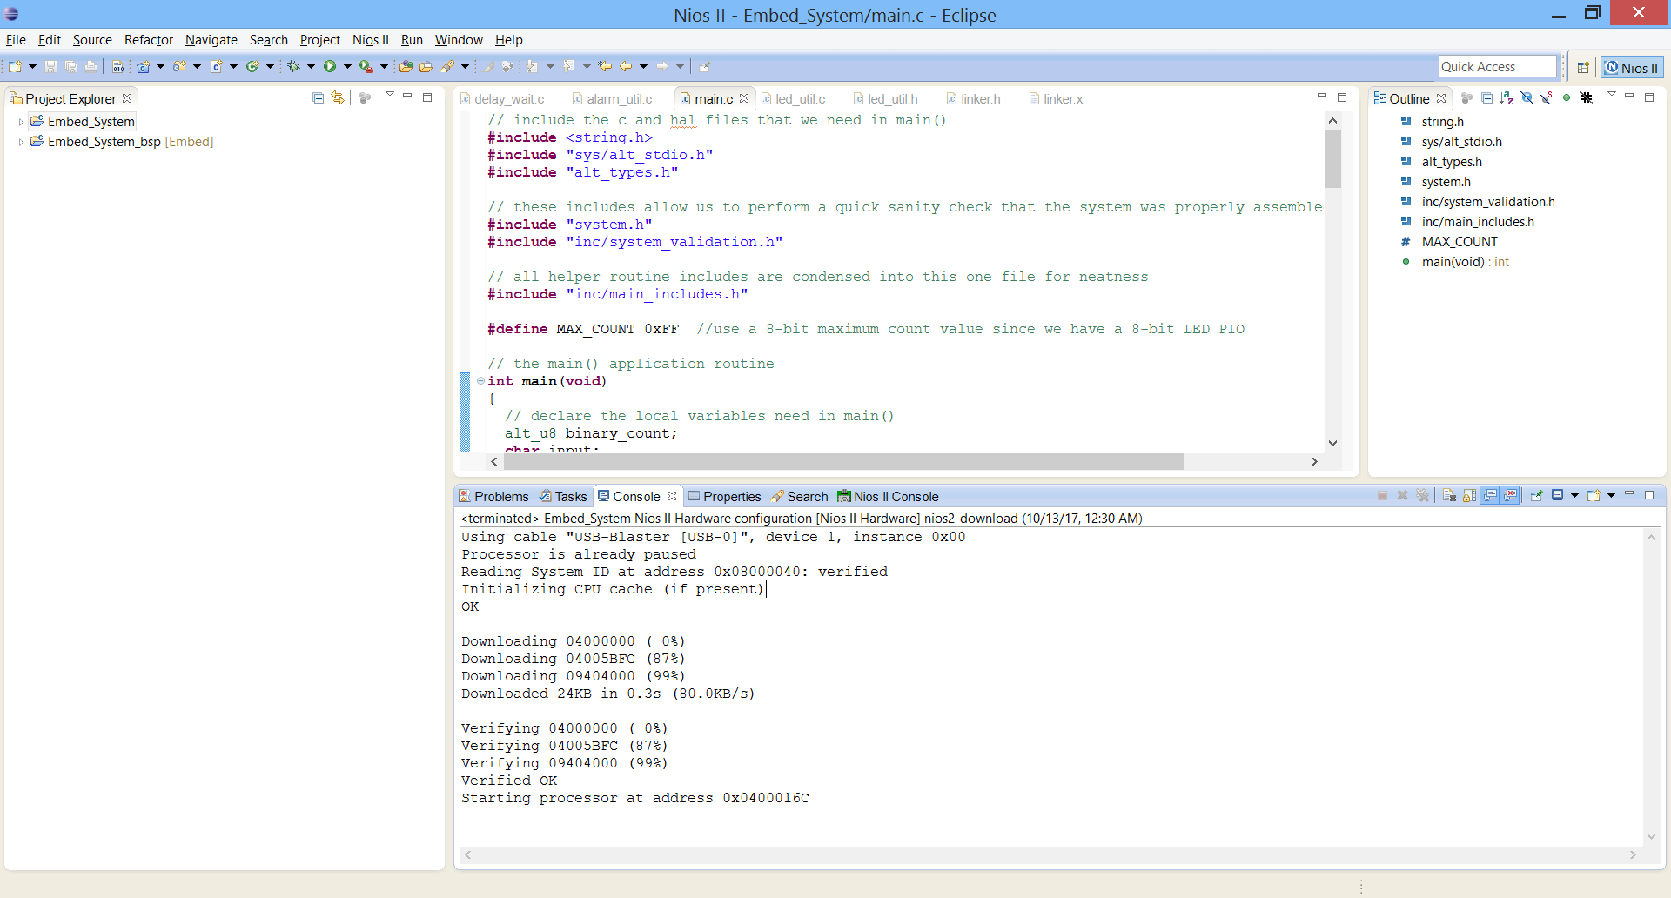

If the application is executing successfully, the console output should appear as shown below:

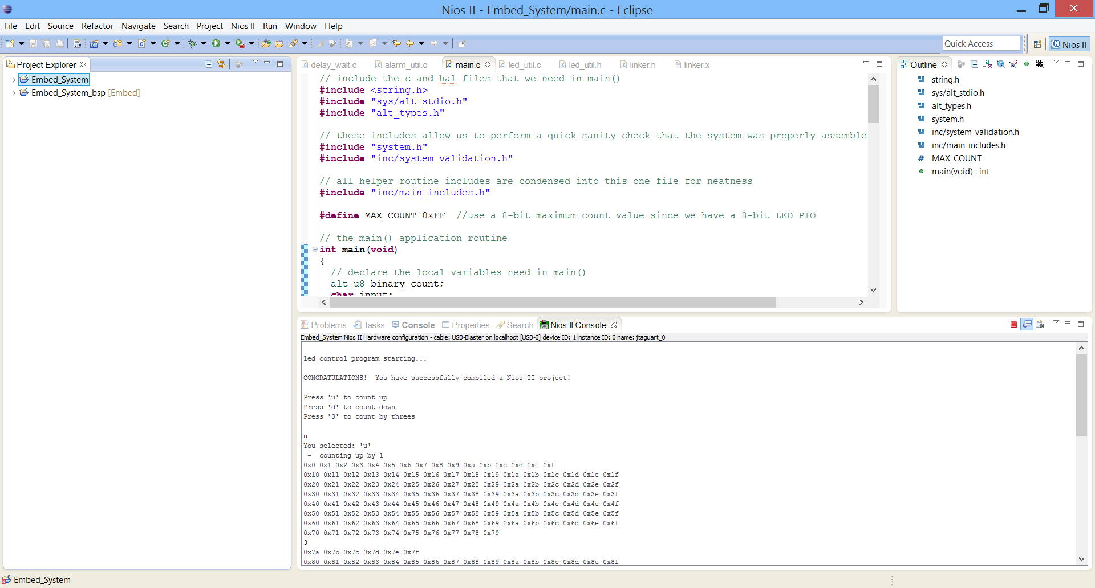

## 6.10 Interact with the Software Application

Once you have the led_control application running on the Nios II processor, you can interact with the demo by using your keyboard to control the program flow.

## 6.11 Edit the Application

You can optionally modify the led_util.c source file to change the software such that the counting LEDs are inverted.

▪ Open the file led_util.c and locate the following subroutine:

update_ledg( )

▪ In the beginning of the subroutine add the following line:

*display_value = ~ display_value;*

Once this is rebuilt, the application can be rerun to see the change in LEDs.

CONGRATULATIONS!!

**You have just built the software application, downloaded it to the target and run the application on the target.**

**Bonus Opportunity: Write an application for the NIOS that reads the accelerometer and drives a value proportional to its output on the LEDs.**

Questions:

1. Is the PWM of the LEDs implemented in hardware or in software?
2. Is the control of the 7-segment LEDs done by hardware or by software?
3. How much memory is required to run your Nios II program? Can you fit it into the onchip RAM if you redesign the onchip RAM block?
4. Your Nios II processor is running at what clock speed? How much faster can it run in your MAX10 design?